# Loop Over DataFrame (2) in Python

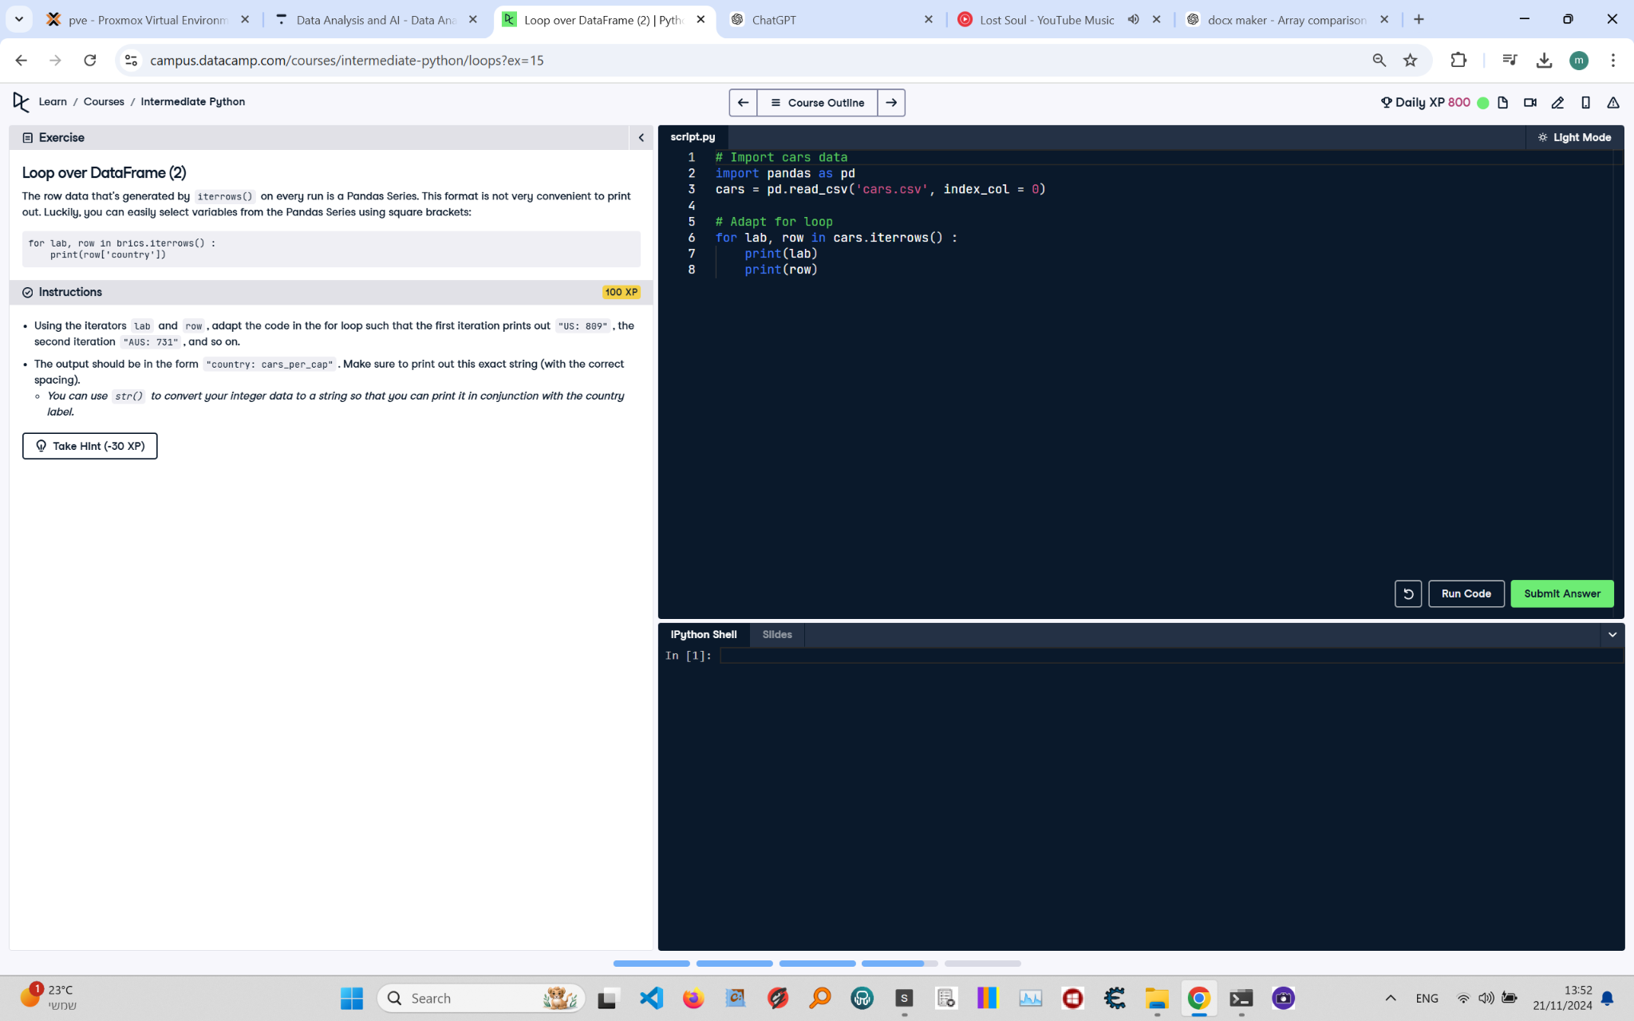

**Question:**

The row data that's generated by `iterrows()` on every run is a Pandas Series. This format is not very convenient to print out. Luckily, you can easily select variables from the Pandas Series using square brackets:  
  
```python  
for lab, row in brics.iterrows():  
 print(row['country'])  
```  
  
**Instructions:**  
Using the iterators `lab` and `row`, adapt the code in the for loop such that the first iteration prints out:  
`US: 809`, the second iteration `AUS: 731`, and so on.  
  
The output should be in the form `country: cars_per_cap`. Make sure to print out this exact string (with the correct spacing).  
  
- You can use `str()` to convert your integer data to a string so that you can print it in conjunction with the country label.

**Answer:**

Here is the Python code that solves the problem:

# Import pandas  
import pandas as pd  
  
# Load the cars DataFrame  
cars = pd.read_csv('cars.csv', index_col=0)  
  
# Iterate over rows of cars  
for lab, row in cars.iterrows():  
 print(f"{lab}: {row['cars_per_cap']}")

**Explanation:**

1. **Importing pandas**: The `pandas` library is imported to handle the DataFrame.  
2. **Loading the DataFrame**: The `cars` DataFrame is loaded from a CSV file (`cars.csv`) with the first column set as the index using `index_col=0`.  
3. **Iterating over rows**: The `iterrows()` method is used to iterate over the rows of the DataFrame. On each iteration:  
 - `lab` contains the row label (country code).  
 - `row` contains the contents of the row as a Series.  
4. **Printing formatted output**: The `print()` function uses an f-string to format the output as `country: cars_per_cap`, where `country` is the row label and `cars_per_cap` is the value from the column `cars_per_cap`. The integer value is converted to a string implicitly within the f-string.