# Loop Over DataFrame in Python

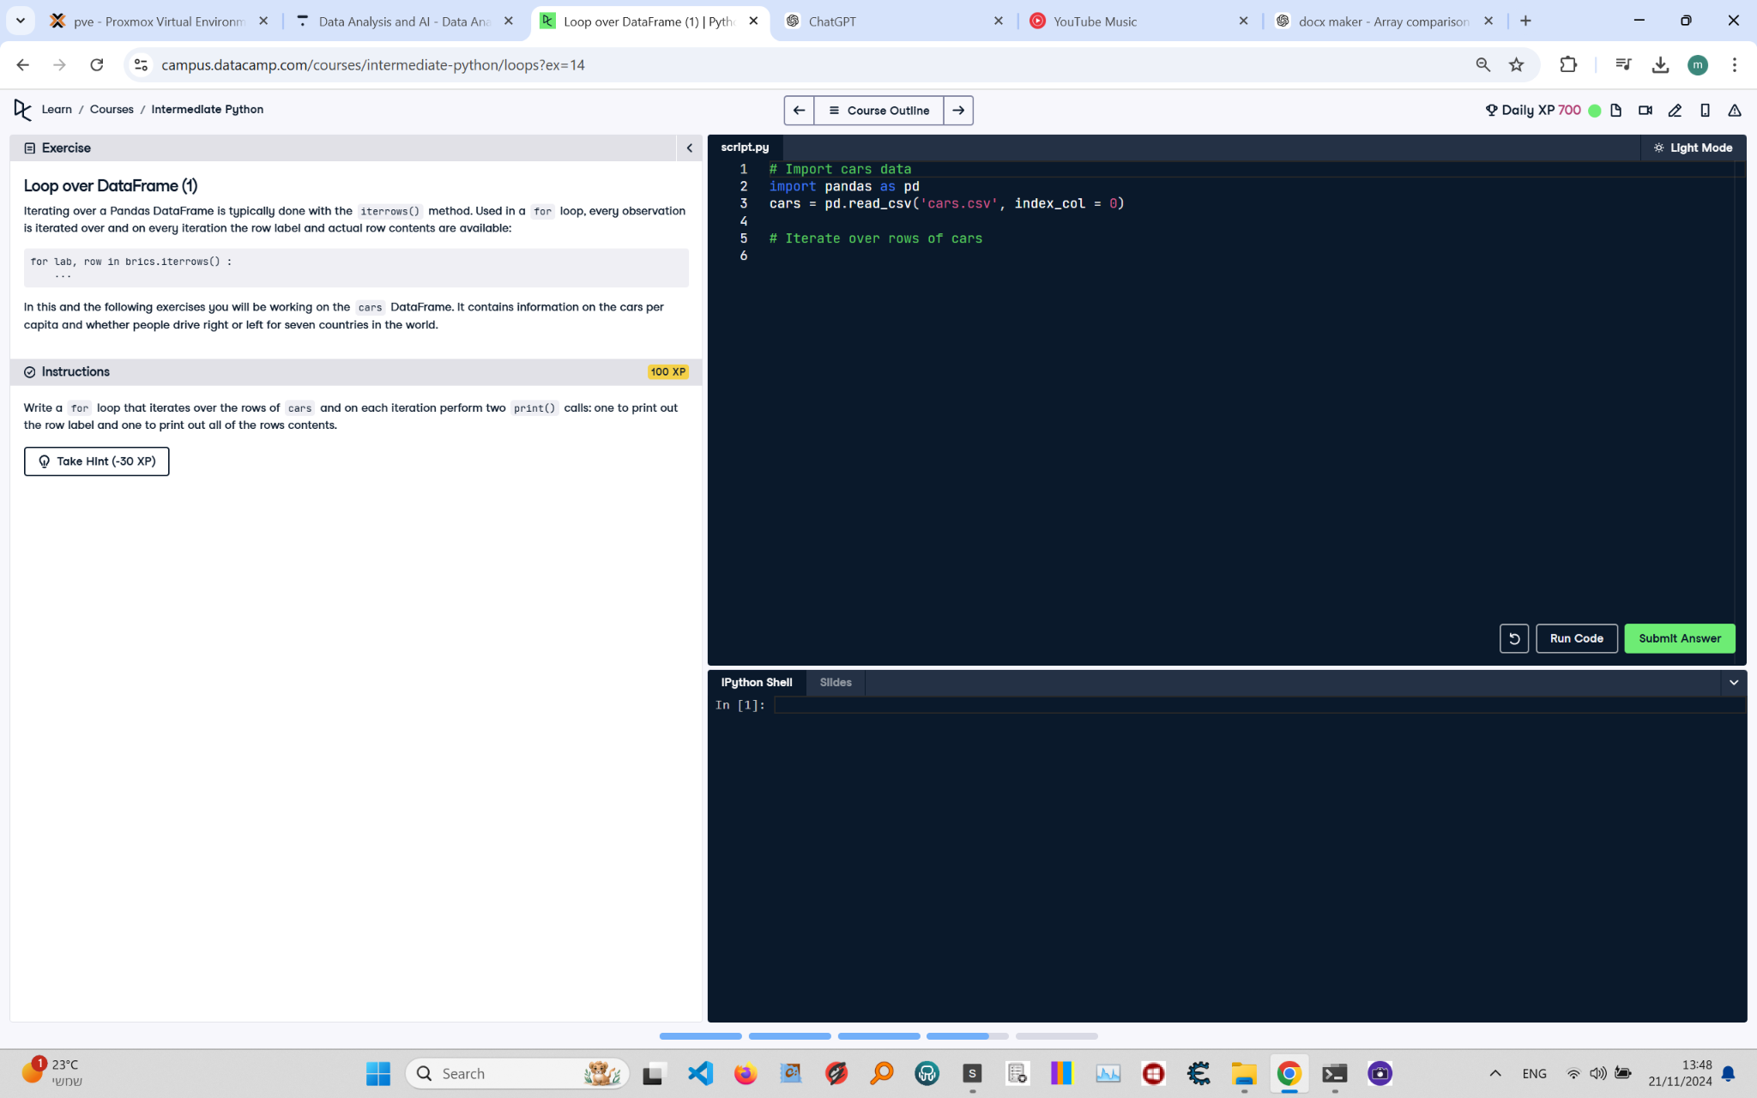

**Question:**

Iterating over a Pandas DataFrame is typically done with the `iterrows()` method. Used in a `for` loop, every observation is iterated over and on every iteration the row label and actual row contents are available:  
  
```python  
for lab, row in brics.iterrows():  
 ...  
```  
  
In this and the following exercises you will be working on the `cars` DataFrame. It contains information on the cars per capita and whether people drive right or left for seven countries in the world.  
  
**Instructions:**  
Write a `for` loop that iterates over the rows of `cars` and on each iteration performs two `print()` calls: one to print out the row label and one to print out all of the row's contents.

**Answer:**

Here is the Python code that solves the problem:

# Import pandas  
import pandas as pd  
  
# Load the cars DataFrame  
cars = pd.read_csv('cars.csv', index_col=0)  
  
# Iterate over rows of cars  
for label, row in cars.iterrows():  
 print(label) # Print row label  
 print(row) # Print row contents

**Explanation:**

1. **Importing pandas**: The `pandas` library is imported to handle the DataFrame.  
2. **Loading the DataFrame**: The `cars` DataFrame is loaded from a CSV file (`cars.csv`) with the first column set as the index using `index_col=0`.  
3. **Iterating over rows**: The `iterrows()` method is used to iterate over the rows of the DataFrame. On each iteration:  
 - `label` contains the row label (from the index column).  
 - `row` contains the contents of the row as a Series.  
4. **Printing row information**:  
 - The first `print()` call outputs the row label.  
 - The second `print()` call outputs the contents of the row.