# Loop Over a List in Python

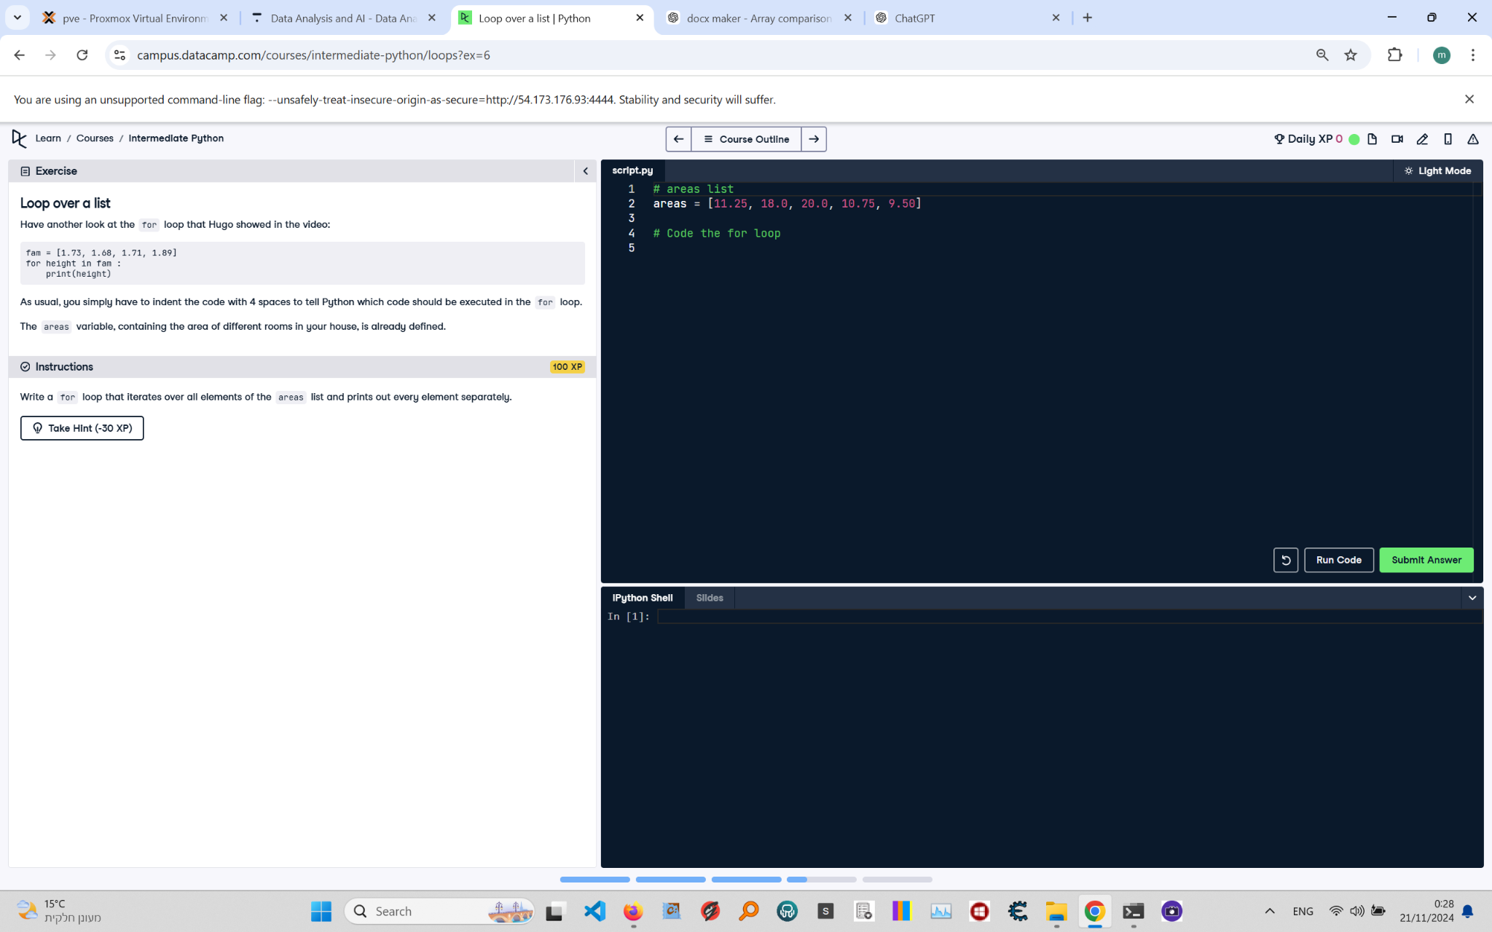

**Question:**

Have another look at the `for` loop that Hugo showed in the video:  
  
```python  
fam = [1.73, 1.68, 1.71, 1.89]  
for height in fam:  
 print(height)  
```  
  
As usual, you simply have to indent the code with 4 spaces to tell Python which code should be executed in the `for` loop. The `areas` variable, containing the area of different rooms in your house, is already defined.  
  
**Instructions:**  
Write a `for` loop that iterates over all elements of the `areas` list and prints out every element separately.

**Answer:**

Here is the Python code that solves the problem:

# areas List  
areas = [11.25, 18.0, 20.0, 10.75, 9.50]  
  
# Code the for loop  
for area in areas:  
 print(area)

**Explanation:**

1. **Initialization**: The `areas` list is defined, containing the areas of different rooms in a house.  
2. **For loop**: The `for` loop iterates over each element in the `areas` list.  
3. **Print statement**: Inside the loop, the `print(area)` statement outputs the value of the current element in the list.  
4. **Execution**: The loop runs once for each element in the `areas` list, printing each value separately.