# Loop Over List of Lists in Python

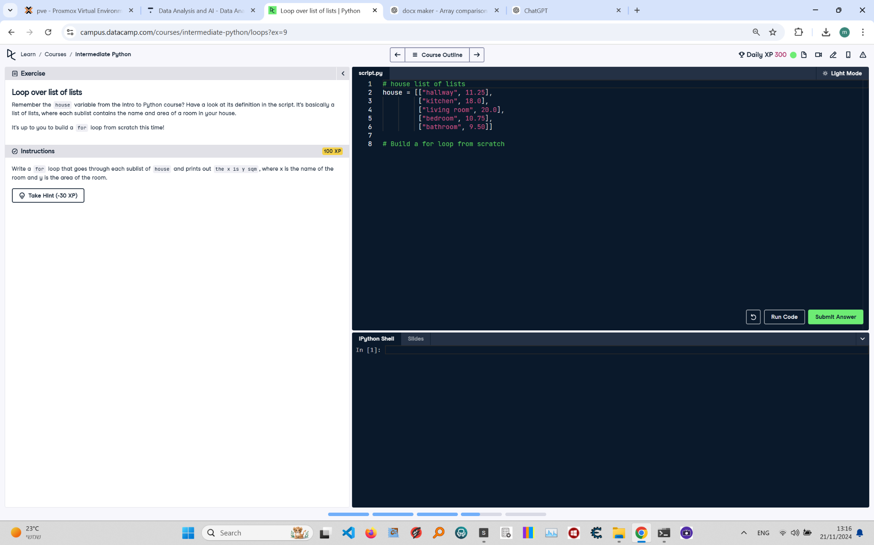

**Question:**

Remember the `house` variable from the Intro to Python course? Have a look at its definition in the script. It's basically a list of lists, where each sublist contains the name and area of a room in your house.  
  
**Instructions:**  
Write a `for` loop that goes through each sublist of `house` and prints out `the x is y sqm`, where `x` is the name of the room and `y` is the area of the room.

**Answer:**

Here is the Python code that solves the problem:

# house list of lists  
house = [["hallway", 11.25],  
 ["kitchen", 18.0],  
 ["living room", 20.0],  
 ["bedroom", 10.75],  
 ["bathroom", 9.50]]  
  
# Build a for loop from scratch  
for room in house:  
 print(f"the {room[0]} is {room[1]} sqm")

**Explanation:**

1. **Initialization**: The `house` list of lists is defined, where each sublist contains the name and area of a room.  
2. **For loop**: The `for` loop iterates over each sublist in the `house` list.  
3. **Accessing elements**: Within the loop, `room[0]` accesses the name of the room, and `room[1]` accesses the area of the room.  
4. **Print statement**: The `print()` function uses an f-string to format the output as `the x is y sqm`, where `x` is the room name and `y` is the area.  
5. **Execution**: The loop runs once for each sublist in the `house` list, printing the formatted string for each room.