# While: Warming Up in Python

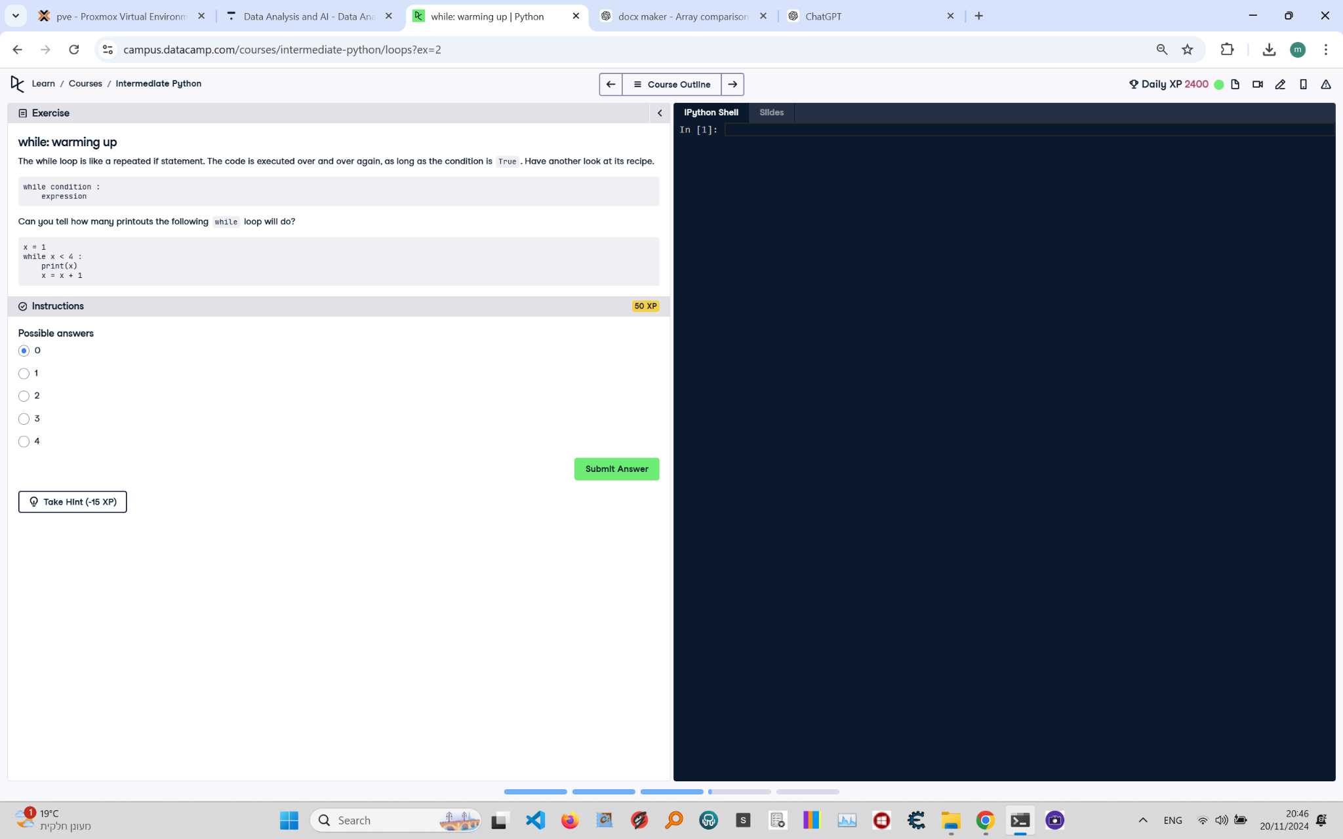

**Question:**

The `while` loop is a repeated `if` statement. The code is executed over and over again, as long as the condition is `True`. Can you tell how many printouts the following `while` loop will do?  
```python  
x = 1  
while x < 4:  
 print(x)  
 x = x + 1  
```  
Possible answers:  
1. 0  
2. 1  
3. 2  
4. 3  
5. 4

**Answer:**

The correct answer is **3**.

**Explanation:**

1. **Initialization**: The variable `x` is initialized to 1.  
2. **First iteration**: The condition `x < 4` is checked. Since `x = 1`, the condition is `True`. The value of `x` is printed, and then `x` is incremented to 2.  
3. **Second iteration**: The condition `x < 4` is checked again. Since `x = 2`, the condition is `True`. The value of `x` is printed, and then `x` is incremented to 3.  
4. **Third iteration**: The condition `x < 4` is checked again. Since `x = 3`, the condition is `True`. The value of `x` is printed, and then `x` is incremented to 4.  
5. **Termination**: The condition `x < 4` is checked again. Since `x = 4`, the condition is `False`. The loop terminates.  
6. **Conclusion**: The loop prints `x` three times: `1`, `2`, and `3`.