# Aliasing in SQL: Exercise and Corrected Answer

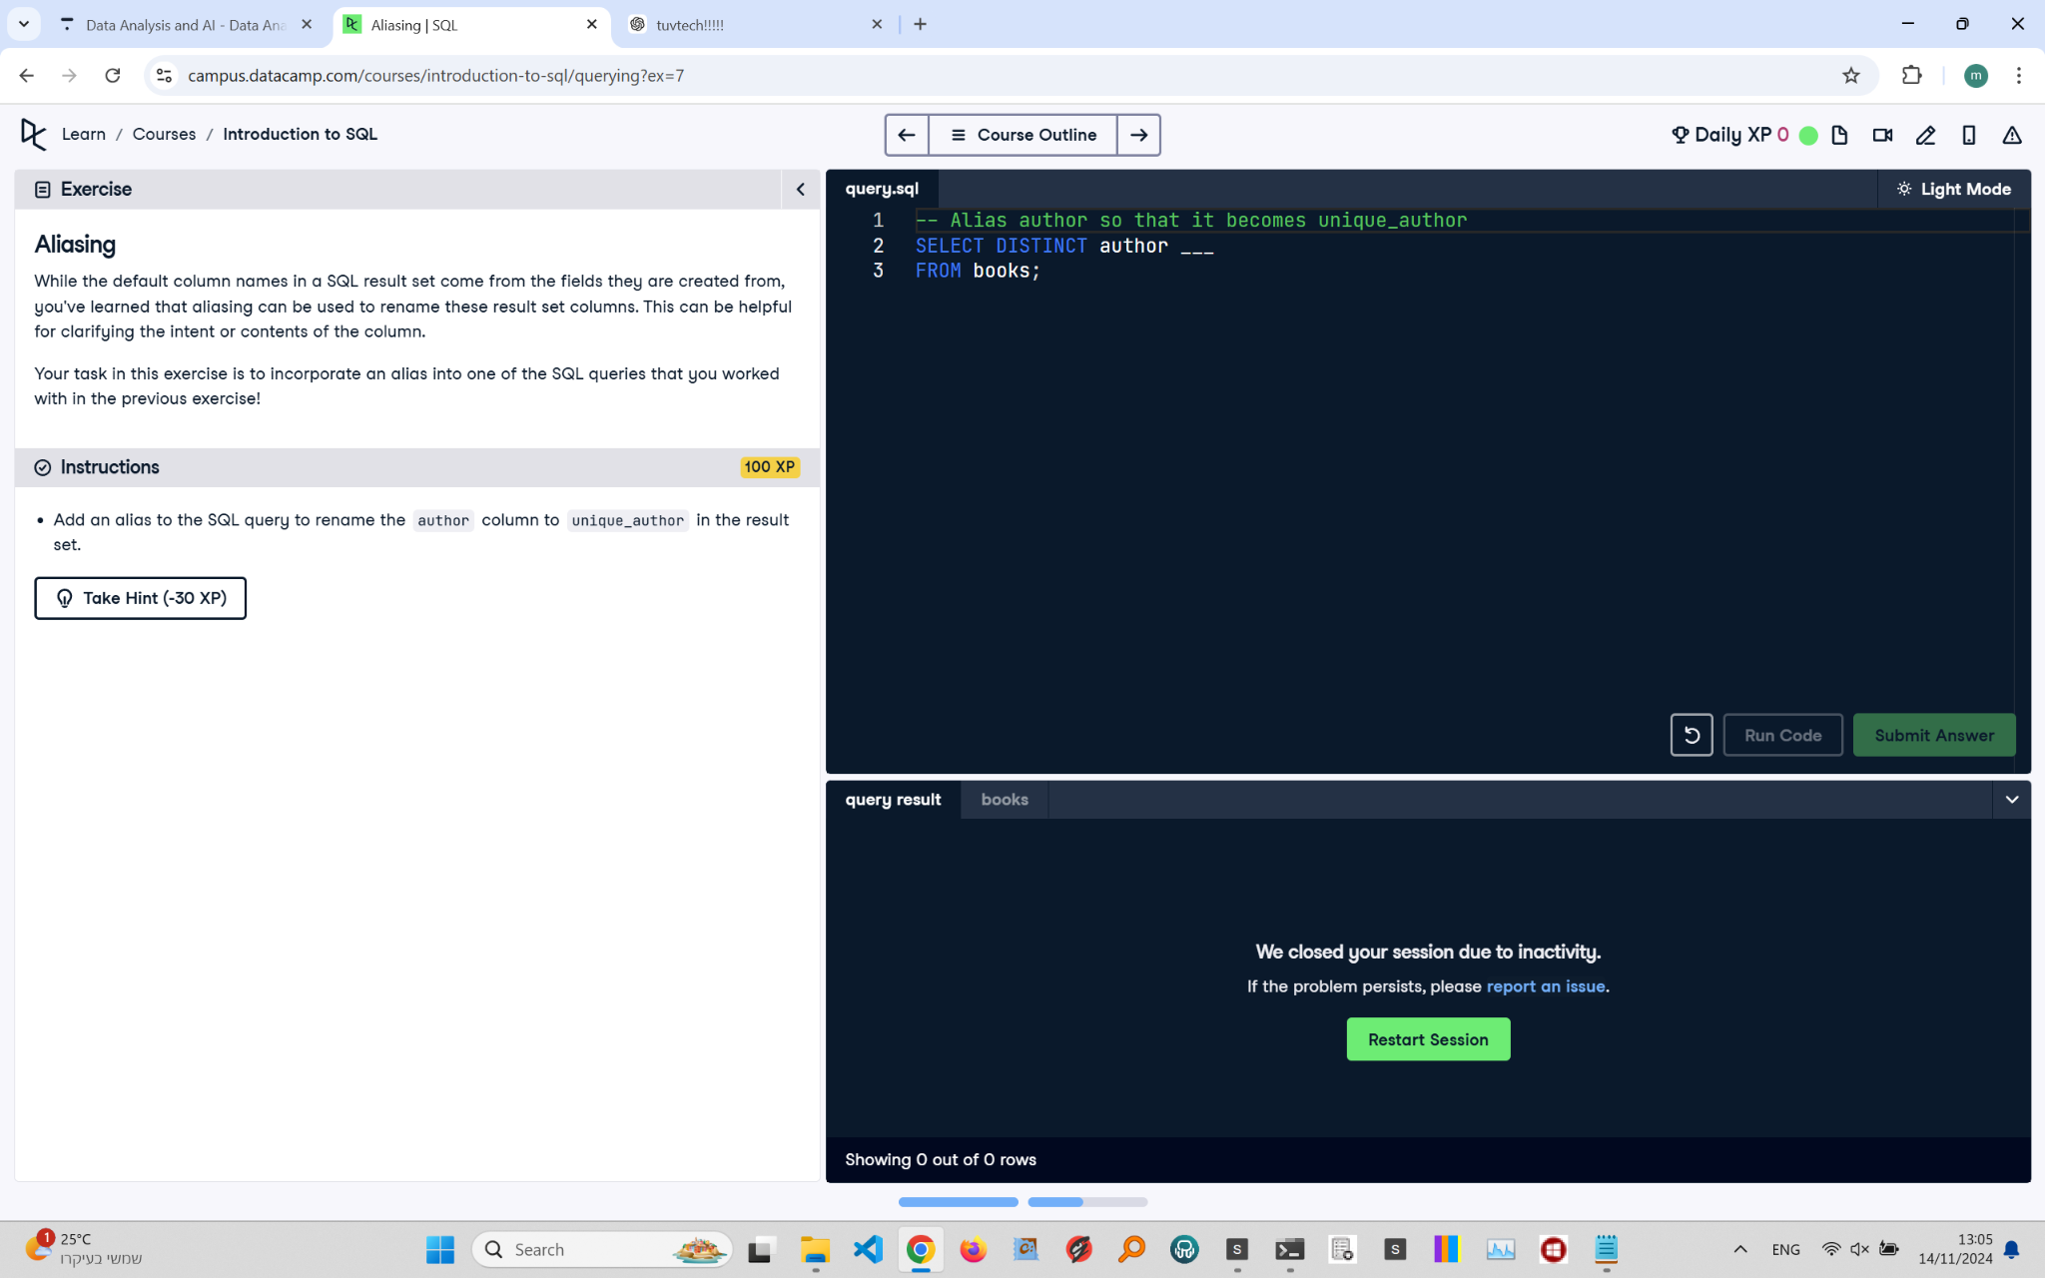

## Exercise Explanation:

In this exercise, you will learn how to use aliasing in SQL to rename columns in the result set. Aliasing can be helpful for clarifying the intent or contents of the column.

## Instructions:

1. Add an alias to the SQL query to rename the 'author' column to 'unique_author' in the result set.

## Corrected Full Answer:

To select unique authors from the 'books' table and alias the 'author' column as 'unique_author':

SELECT DISTINCT author AS unique_author FROM books;

## Answer Explanation:

Aliasing in SQL is done using the AS keyword. By writing 'author AS unique_author', the result set will display the 'author' column under the name 'unique_author'. This helps make the output clearer and more descriptive, improving readability and understanding of the data.