# Comparing Flavors: SQL Server vs. PostgreSQL

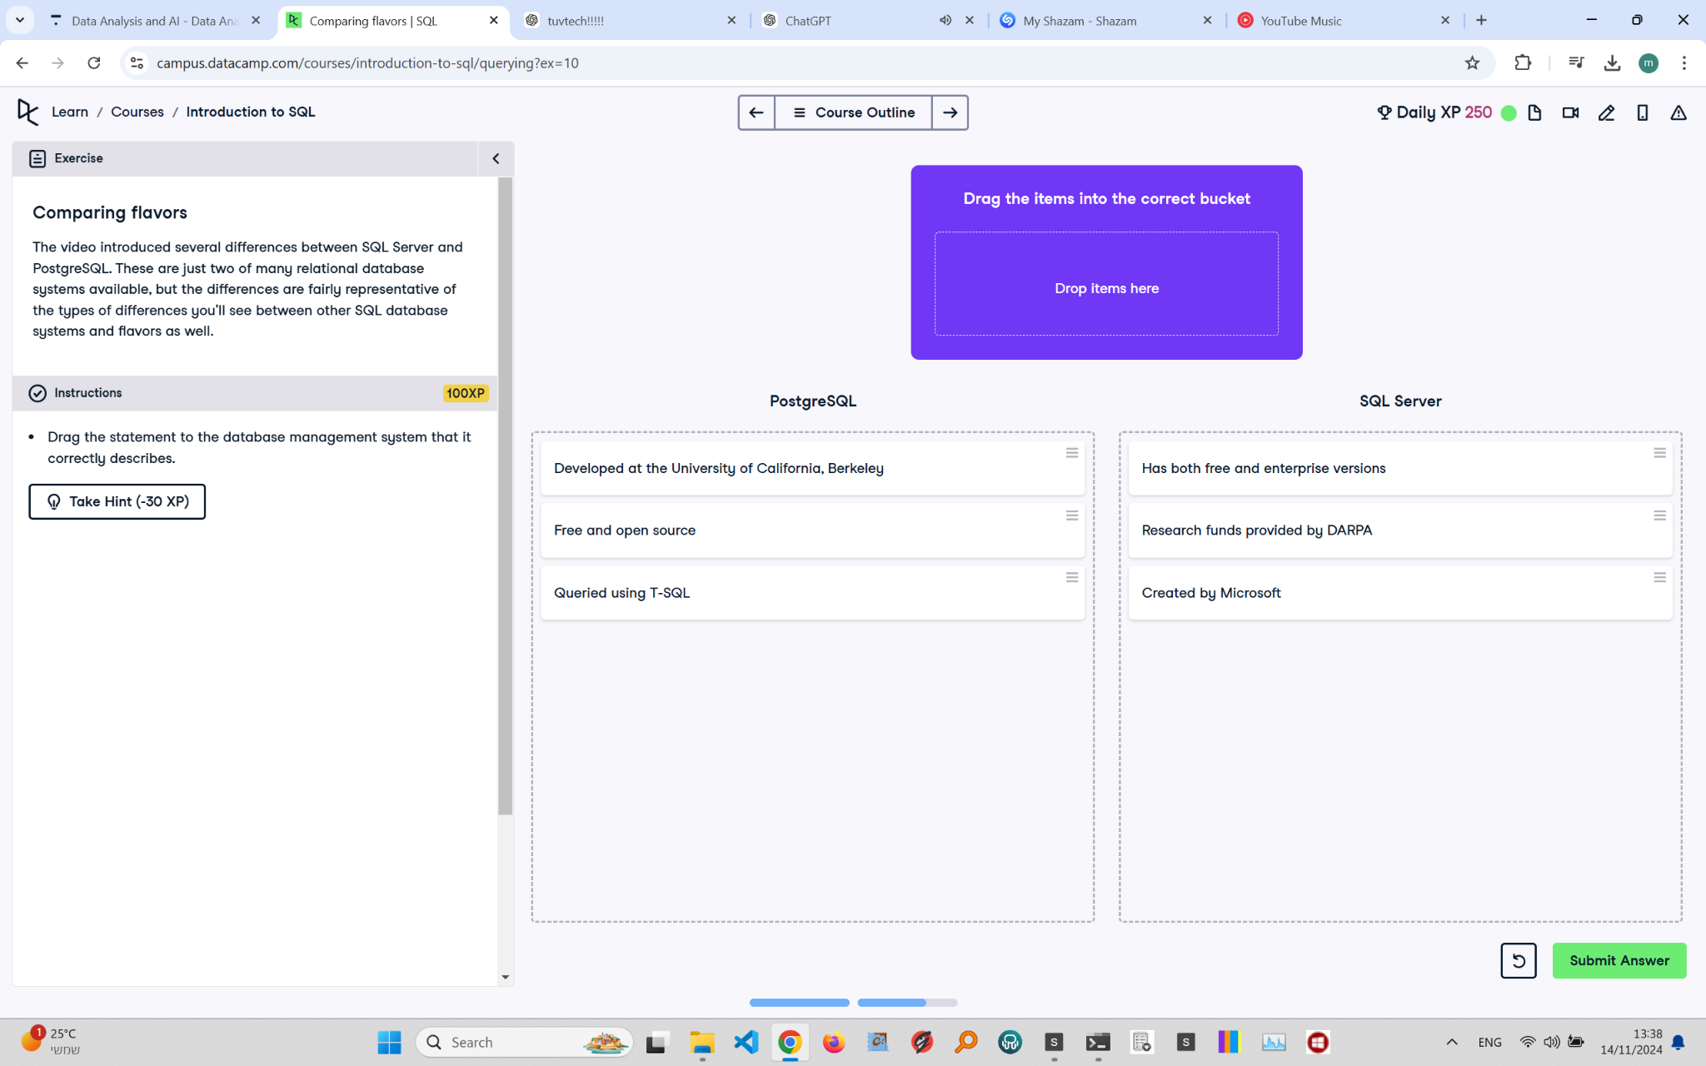

## Exercise Explanation:

This exercise compares key features of two popular relational database management systems: SQL Server and PostgreSQL. You need to match the statements with the correct database system.

## PostgreSQL:

1. Developed at the University of California, Berkeley
2. Free and open source

3. Research funds provided by DARPA

## SQL Server:

1. Has both free and enterprise versions  
2. Created by Microsoft  
3. Queried using T-SQL

## Explanation of Matches:

PostgreSQL was developed at the University of California, Berkeley, and is known for being free and open source. SQL Server, on the other hand, is a product of Microsoft and offers both free (Express) and enterprise versions. It also received research funding from DARPA, which supported early development efforts.