# Limiting Results in PostgreSQL: Exercise and Correct Answer

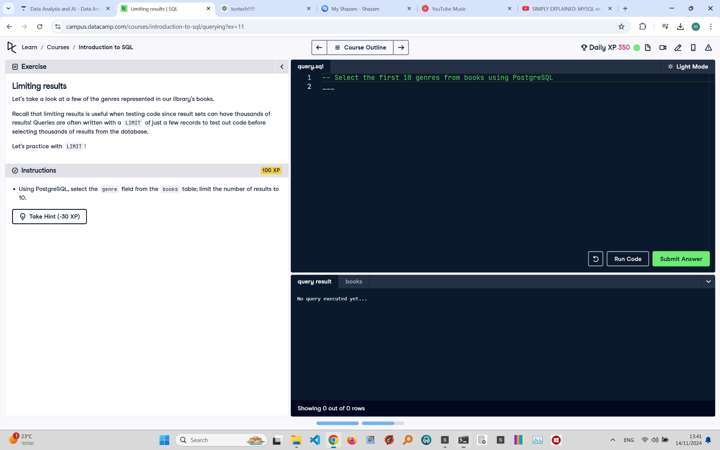

## Exercise Explanation:

In this exercise, you will practice using the LIMIT clause in PostgreSQL to restrict the number of rows returned by a query. This is particularly useful when dealing with large datasets and testing queries.

## Instructions:

1. Using PostgreSQL, select the 'genre' field from the 'books' table and limit the number of results to 10.

## Corrected Full Answer:

-- Select the first 10 genres from books using PostgreSQL

SELECT genre

FROM books

LIMIT 10;

## Answer Explanation:

The LIMIT clause restricts the number of rows returned by the query to 10. This allows for efficient testing and viewing of a small subset of data. Using SELECT genre FROM books LIMIT 10 retrieves the first 10 genres from the 'books' table, helping manage large result sets.