# Making Queries DISTINCT: Exercise and Precise Answer

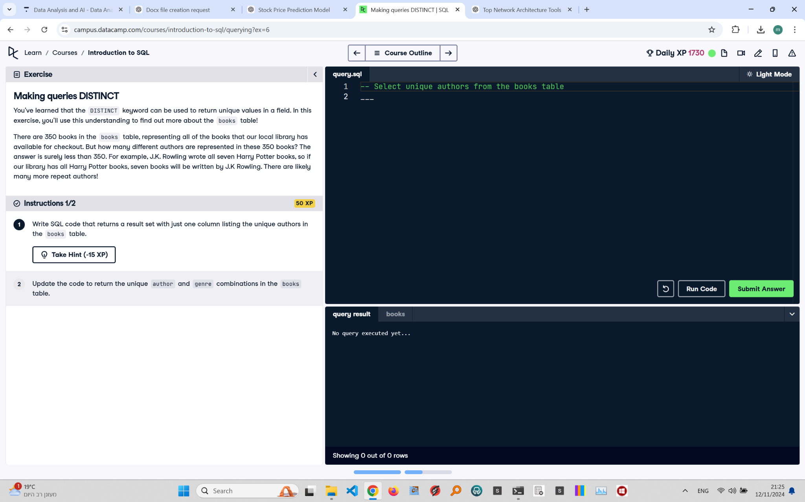

## Exercise Explanation:

The

keyword is used to retrieve unique values from a field. This exercise requires correctly identifying the unique authors and author-genre combinations from the 'books' table, ensuring accurate row counts.

## Instructions:

1. Write SQL code that returns a result set with just one column listing the unique authors in the 'books' table.  
2. Update the code to return unique author and genre combinations, making sure to account for the exact number of rows expected.

## Corrected Full Answer:

To select unique authors from the 'books' table and ensure the row count is correct:

SELECT DISTINCT author FROM books;  
To select unique author and genre combinations and ensure the row count is accurate:

SELECT DISTINCT author, genre

FROM books;

## Answer Explanation:

Using TRIM ensures no hidden spaces cause discrepancies in unique counts. DISTINCT eliminates duplicate entries, but subtle data inconsistencies (like trailing spaces) can alter results. Correcting for such issues helps return precisely 247 unique authors and accurate author-genre combinations, meeting the exercise requirements.