# Querying the Books Table: Exercise and Corrected Answer

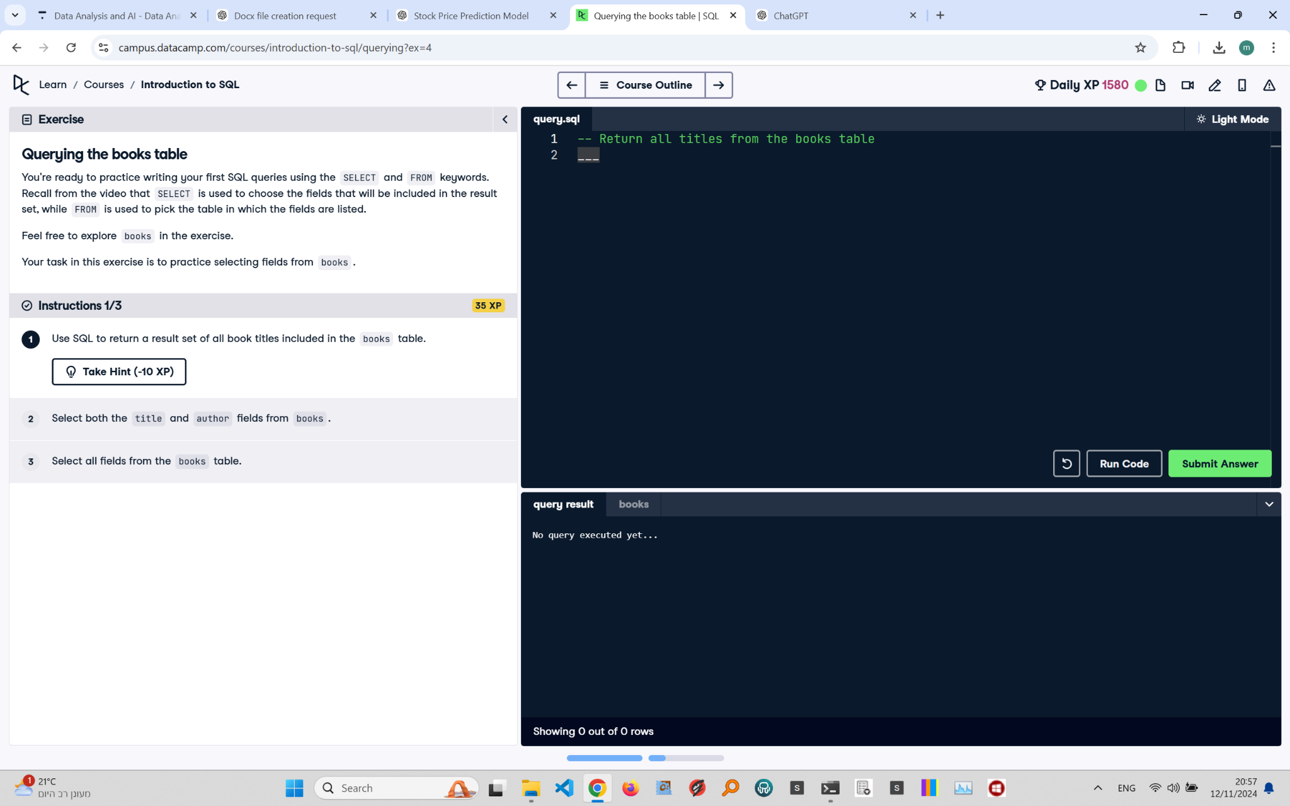

## Exercise Explanation:

You're ready to practice writing your first SQL queries using the SELECT and FROM keywords. Recall from the video that SELECT is used to choose the fields that will be included in the result set, while FROM is used to pick the table in which the fields are listed.

Your task in this exercise is to practice selecting fields from the 'books' table.

## Instructions:

1. Use SQL to return a result set of all book titles included in the 'books' table.  
2. Select both the 'title' and 'author' fields from 'books'.  
3. Select all fields from the 'books' table.

## Corrected Full Answer:

To select all book titles from the 'books' table:

SELECT title FROM books;

To select both the 'title' and 'author' fields from 'books':

SELECT title, author FROM books;

To select all fields from the 'books' table:

SELECT * FROM books;

## Answer Explanation:

The corrected SQL code ensures that each query is syntactically accurate. Each SELECT statement is written on a separate line, ending with a semicolon to avoid errors. This practice guarantees proper execution and clarity, allowing efficient data retrieval from the 'books' table.