# Developing SQL Style: Exercise and Suggestions

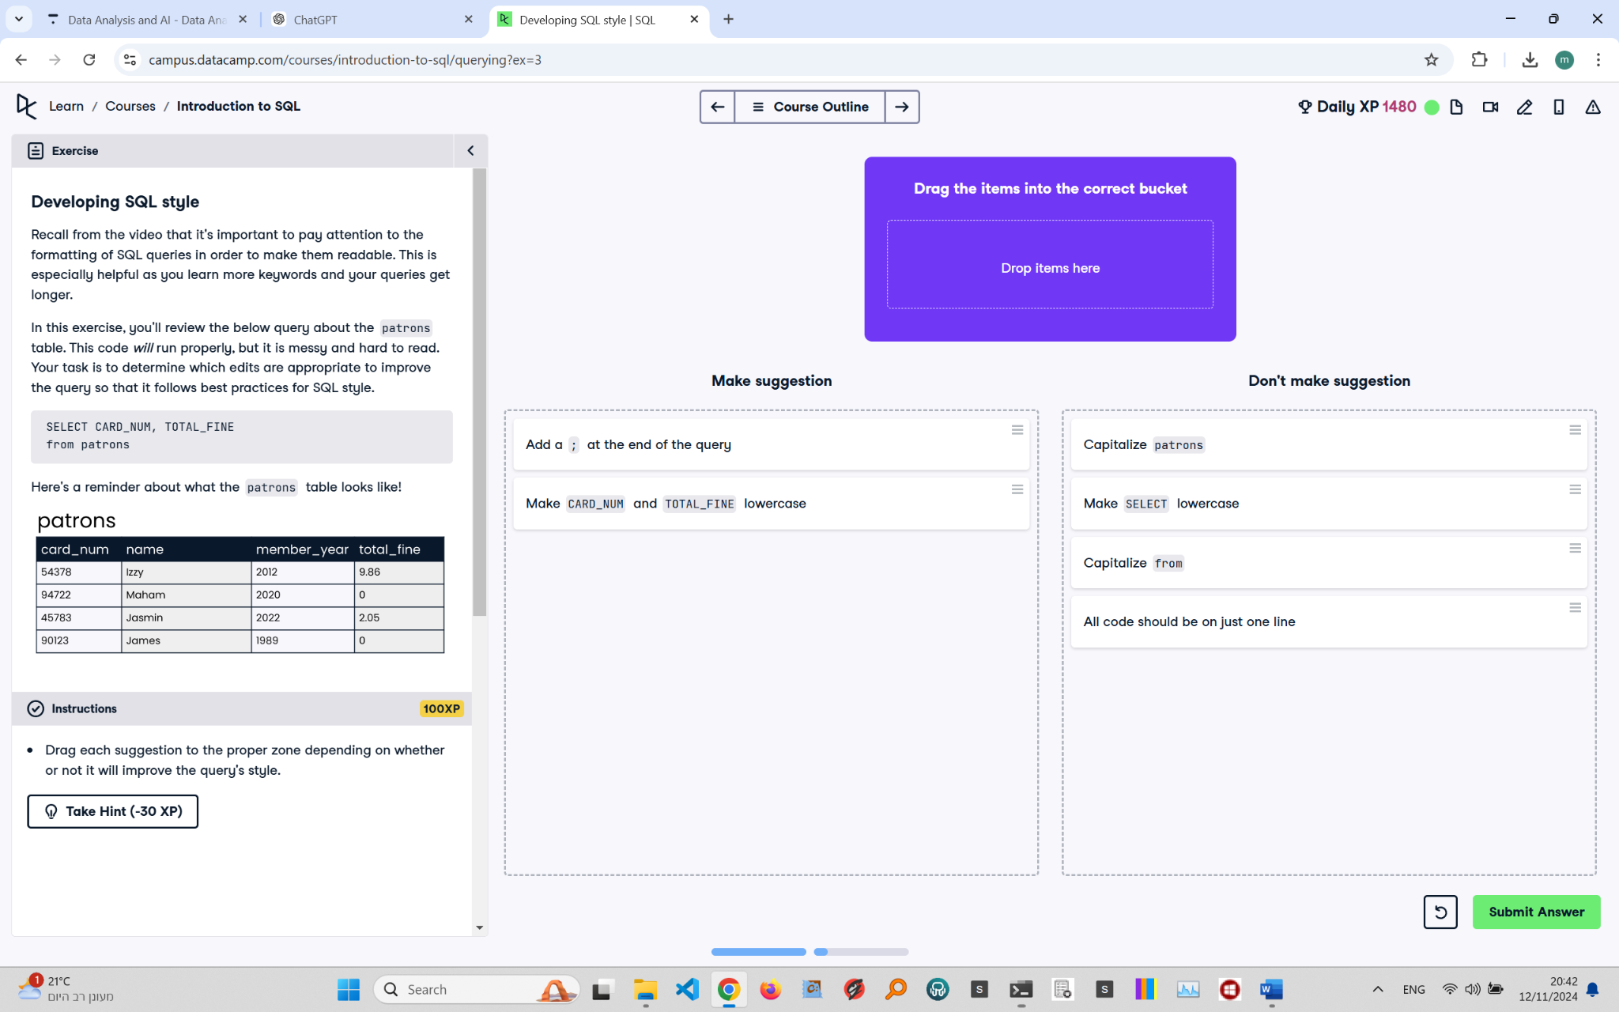

## Exercise Explanation:

This exercise focuses on improving SQL query formatting to enhance readability. Properly formatted queries are easier to understand, especially as you learn more keywords.

## Make These Suggestions:

1. Add a semicolon (;) at the end of the query.  
2. Convert 'CARD_NUM' and 'TOTAL_FINE' to lowercase to follow standard conventions.

## Don't Make These Suggestions:

1. Capitalize 'patrons'.  
2. Make 'SELECT' lowercase.  
3. Capitalize 'from'.  
4. Format all code onto a single line, as it reduces readability.