# SQL Strengths: Question and Explanation

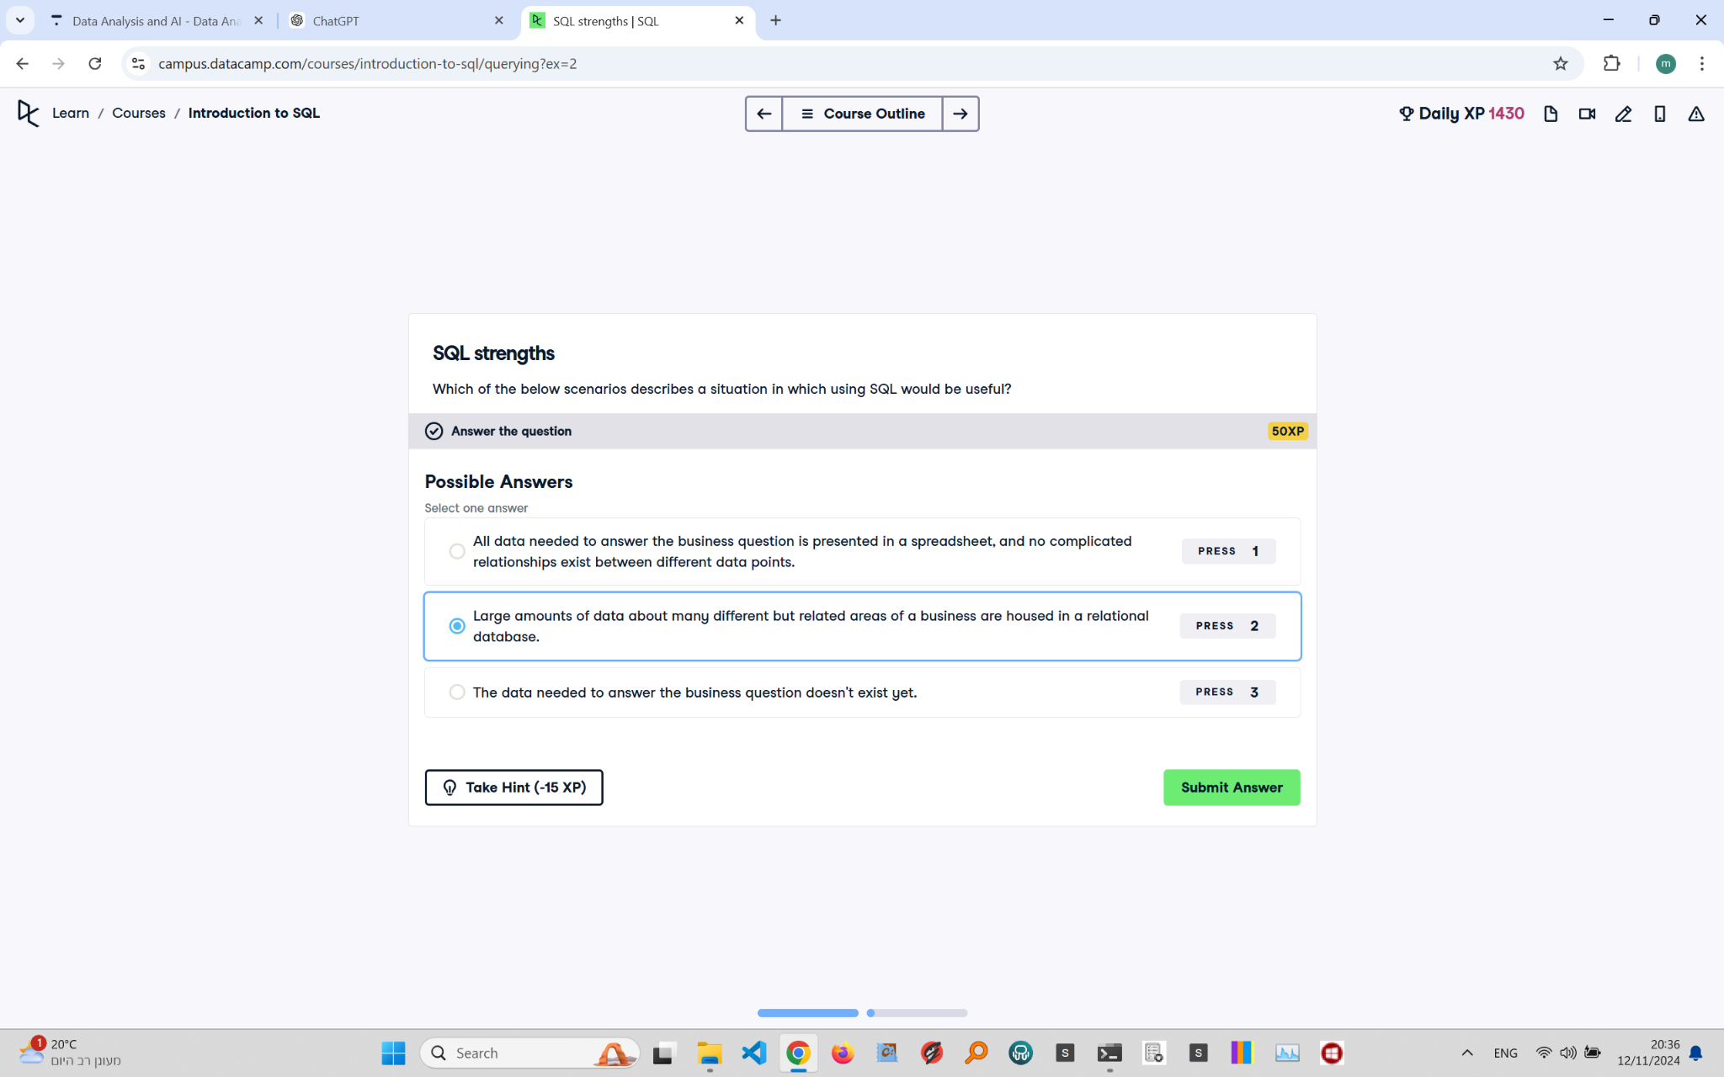

## Question Explanation:

This question asks which scenario would be appropriate for using SQL. The options consider different data situations, and SQL is known for managing large, structured datasets in relational databases.

## Correct Answer:

Large amounts of data about many different but related areas of a business are housed in a relational database.

## Answer Explanation:

SQL excels in handling large datasets with structured relationships. It organizes data in tables linked by keys, making complex queries possible. This relational structure is ideal for managing interconnected data points, optimizing data retrieval, and ensuring data consistency in business contexts.