# Developing SQL Style: Exercise and Suggestions

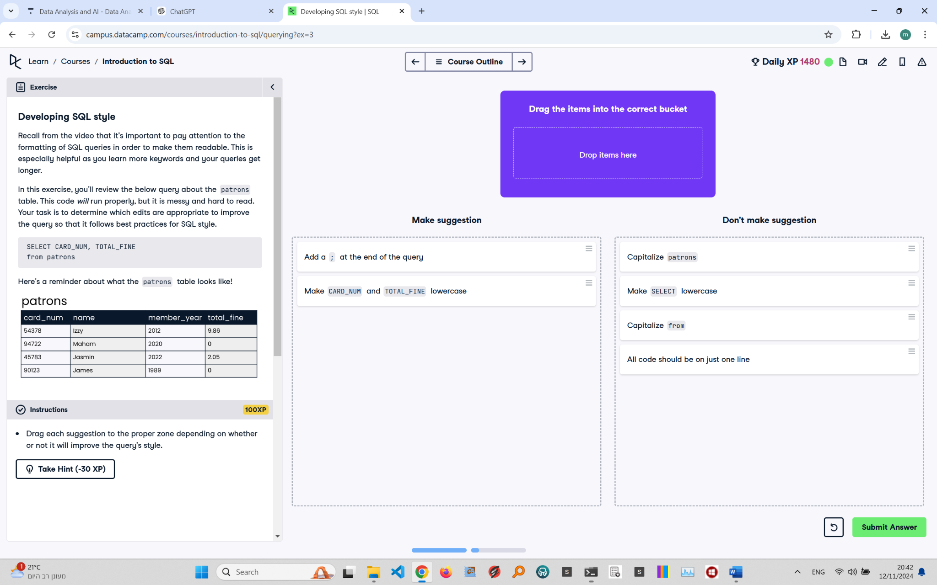

## Exercise Explanation:

In this exercise, the task is to enhance the readability and formatting of the provided SQL query. Proper formatting helps make queries more comprehensible, especially as they become more complex.

## Make These Suggestions:

1. Add a semicolon (;) at the end of the query.  
2. Make CARD_NUM and TOTAL_FINE lowercase for consistency.

## Don't Make These Suggestions:

1. Capitalize 'patrons'.  
2. Make SELECT lowercase.  
3. Capitalize 'from'.  
4. Place all code on a single line, as it reduces readability.