# VIEWing Your Query: Exercise and Complete Answer

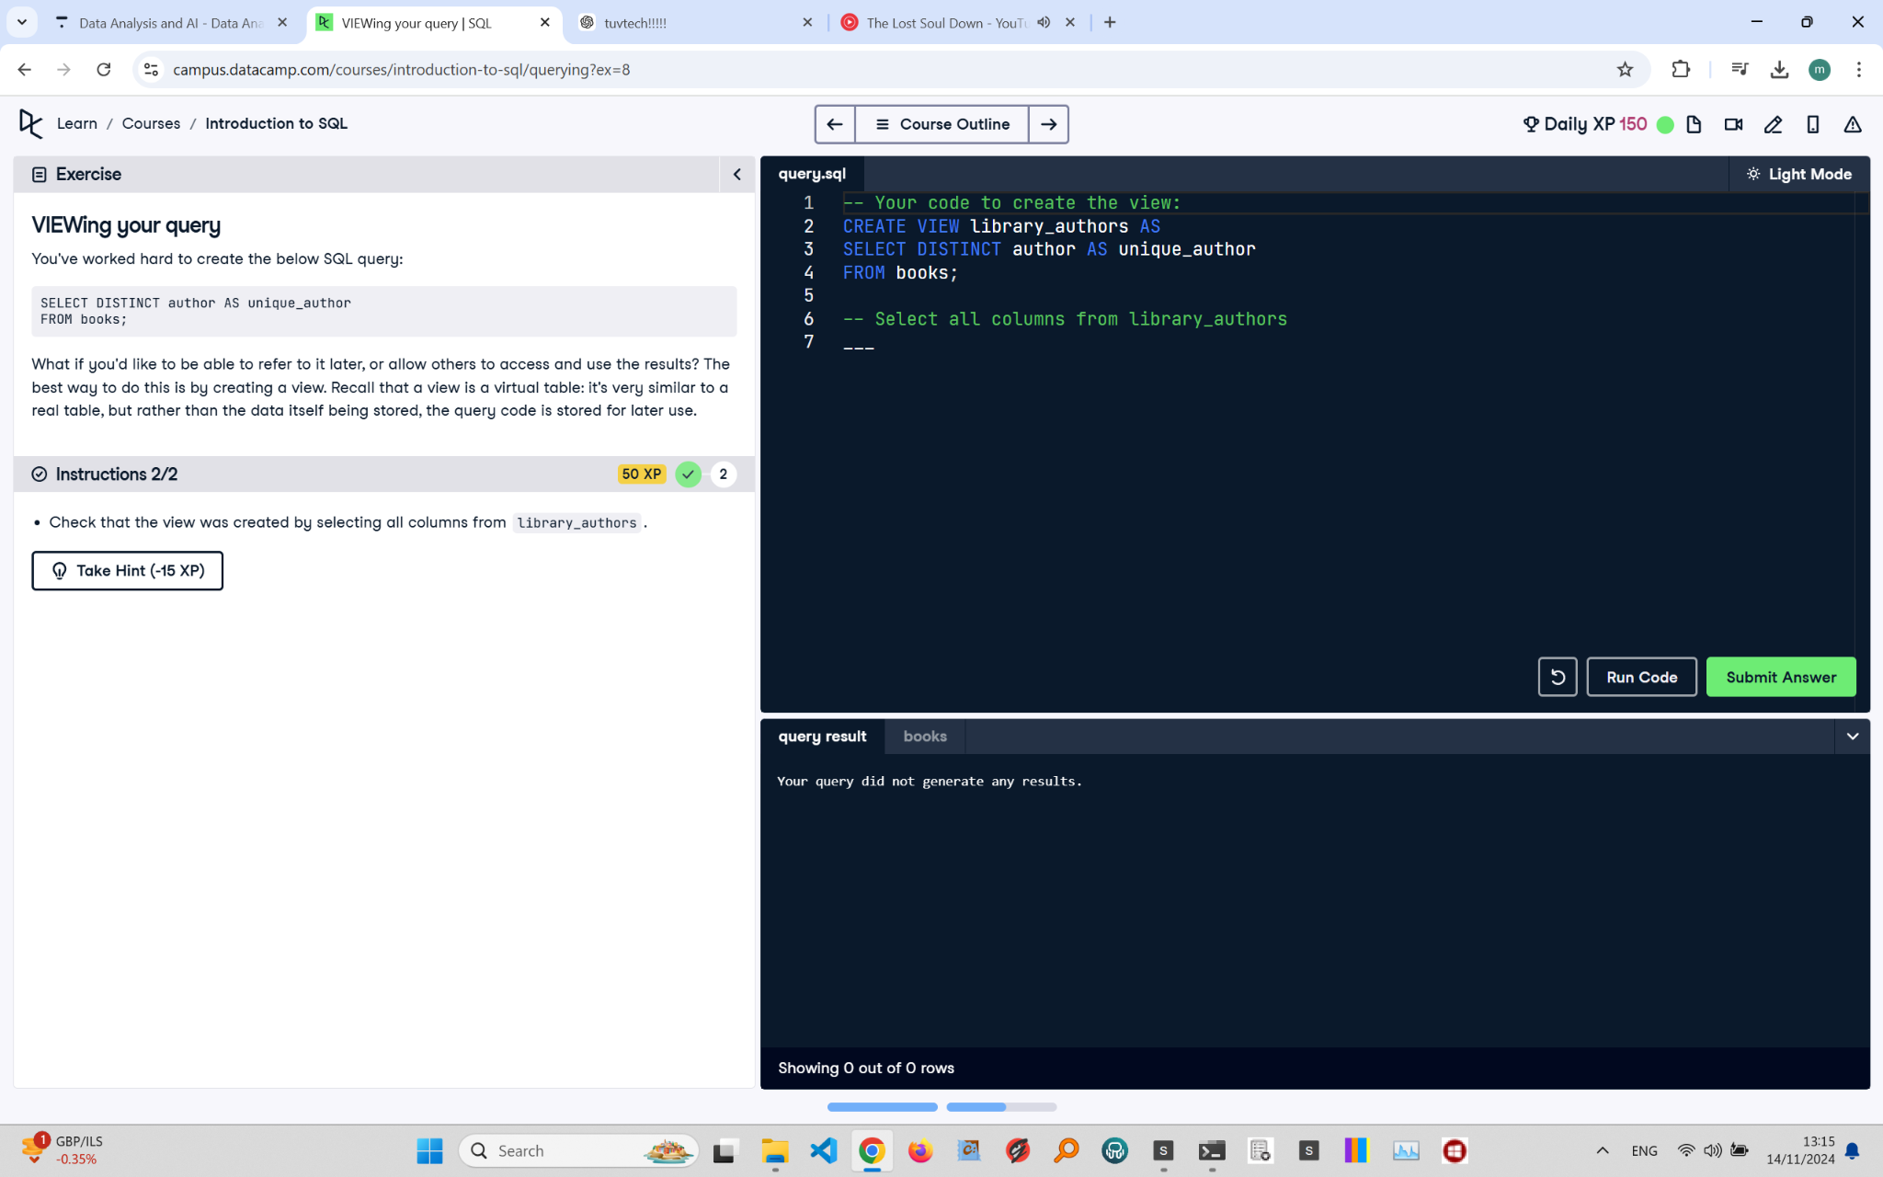

## Exercise Explanation:

In this exercise, you learn to create a view in SQL and then verify that the view has been successfully created by selecting all columns from it. Views store query code for easy reuse.

## Instructions:

1. Add code to create a view named 'library_authors' that stores the query.  
2. Check that the view was created by selecting all columns from 'library_authors'.

## Corrected Full Answer:

-- Your code to create the view:

CREATE VIEW library_authors AS

SELECT DISTINCT author AS unique_author

FROM books;

-- Select all columns from library_authors to check the view

SELECT * FROM library_authors;

## Answer Explanation:

The CREATE VIEW statement defines the view 'library_authors', storing the query for future use. SELECT * FROM library_authors retrieves all columns from the view, confirming it was created correctly. This approach simplifies complex queries and ensures easy access to pre-defined query results in SQL.