# VIEWing Your Query: Exercise and Fixed Answer

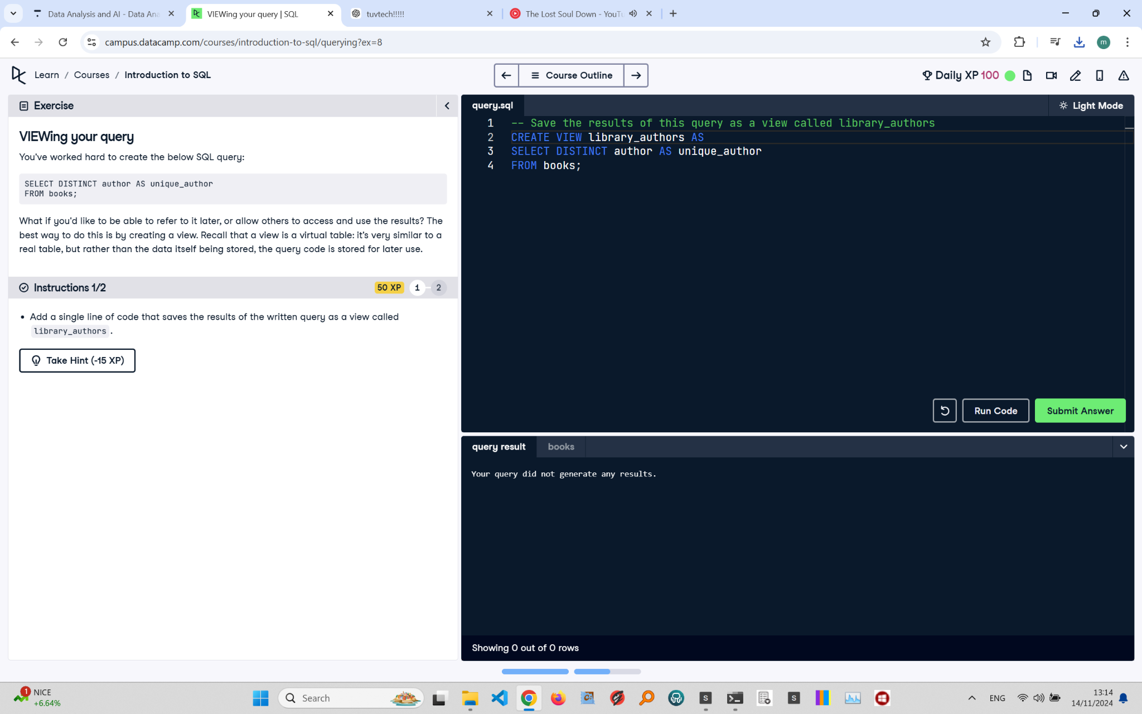

## Exercise Explanation:

This exercise teaches you how to save the results of a query as a view. A view is a virtual table that stores the query code, allowing you to easily retrieve and use the results later.

## Instructions:

1. Add a single line of code that saves the results of the written query as a view called 'library_authors'.

## Corrected Full Answer:

-- Save the results of this query as a view called library_authors

CREATE VIEW library_authors AS

SELECT DISTINCT author AS unique_author

FROM books;

## Answer Explanation:

The CREATE VIEW statement defines a view named 'library_authors'. This view stores the query that selects unique authors from the 'books' table, renaming the 'author' column to 'unique_author'. Views help simplify complex queries and improve data management by providing a virtual, reusable table structure.