# Advantages of Using Databases Over Spreadsheets

Below is the image showing the question on the advantages of databases:

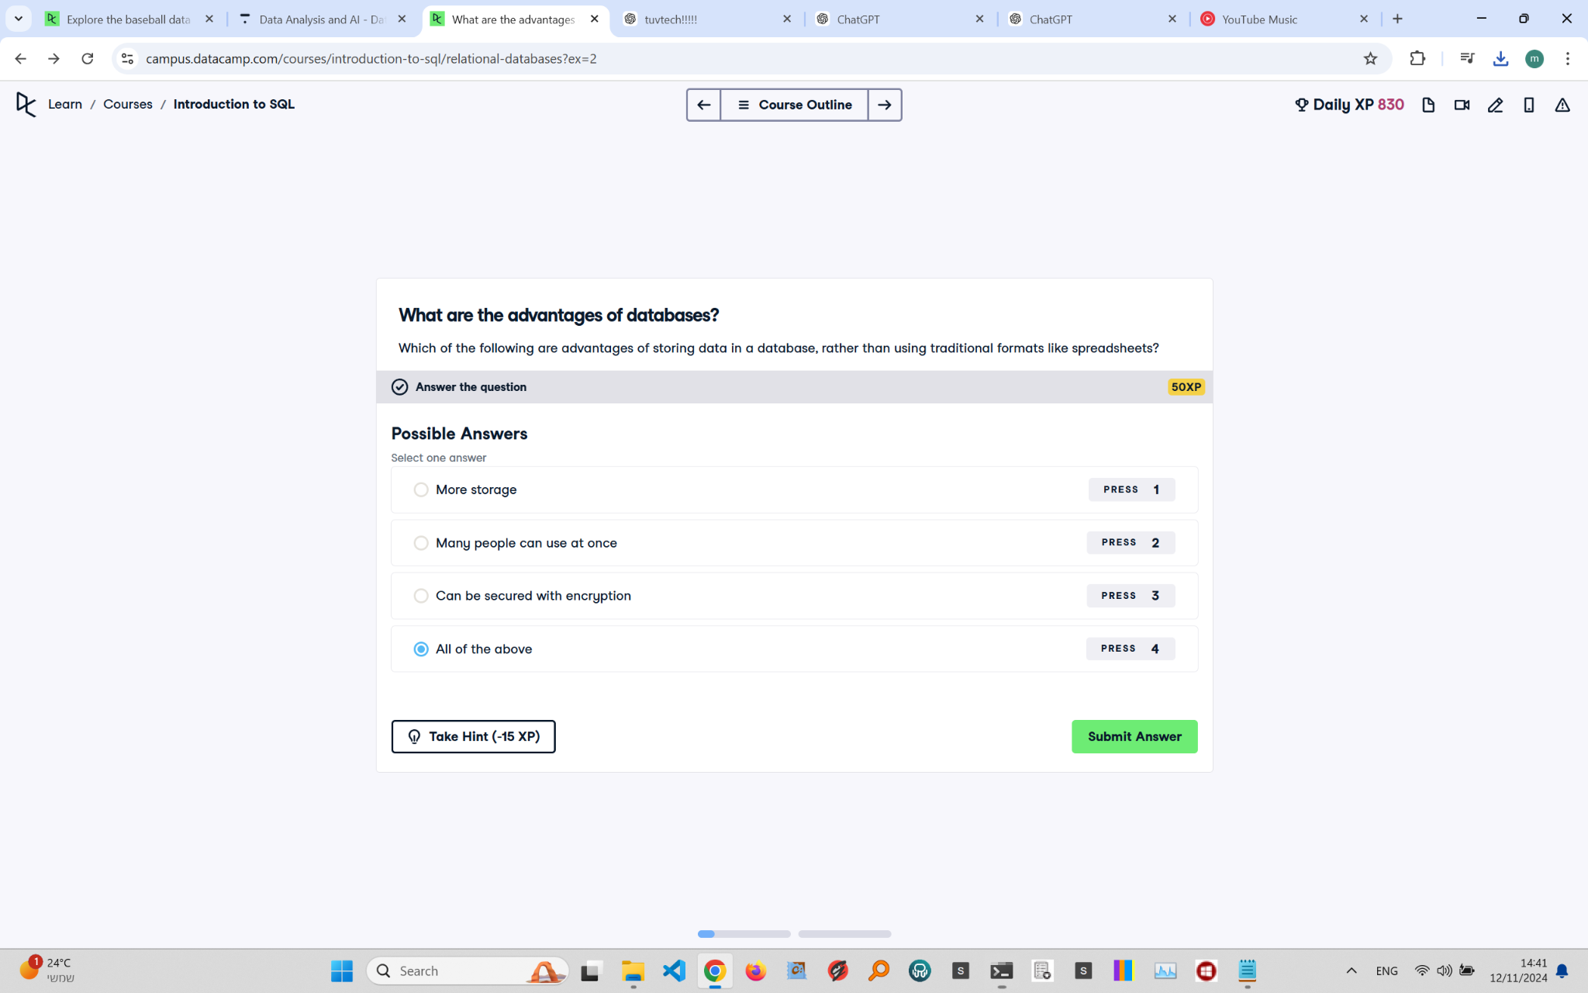

Question Explanation:

The question asks about the advantages of using databases over traditional formats like spreadsheets. Databases offer several key benefits, such as providing more storage capacity, allowing multiple users to access data simultaneously, and offering security features like encryption.

Correct Answer:

All of the above

Explanation:

Databases are designed to handle large volumes of data efficiently, provide mechanisms for concurrent access by multiple users, and include security features like data encryption to protect sensitive information. Therefore, all the listed advantages are correct.