# Choosing a Unique Identifier in SQL

Below is the image showing the question on picking a unique identifier for a table:

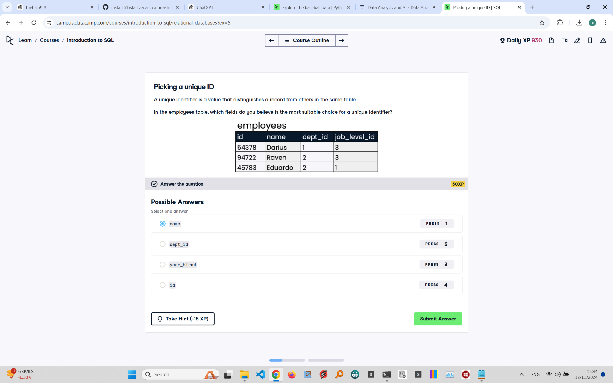

Question Explanation:

The question asks which field in the 'employees' table is the most suitable choice for a unique identifier. A unique identifier is a field that uniquely distinguishes each record in the table, ensuring that no two records have the same value for this field.

Correct Answer:

id

Explanation:

The 'id' field is the most suitable choice for a unique identifier because it is a unique value assigned to each employee, ensuring that every record in the table is distinct. Fields like 'name', 'dept_id', or 'job_level_id' are not guaranteed to be unique, and using them could result in duplicate records.