# Exploring Data in the 'Books' Table Using SQL

Below is the image showing the SQL query to explore the 'books' table:

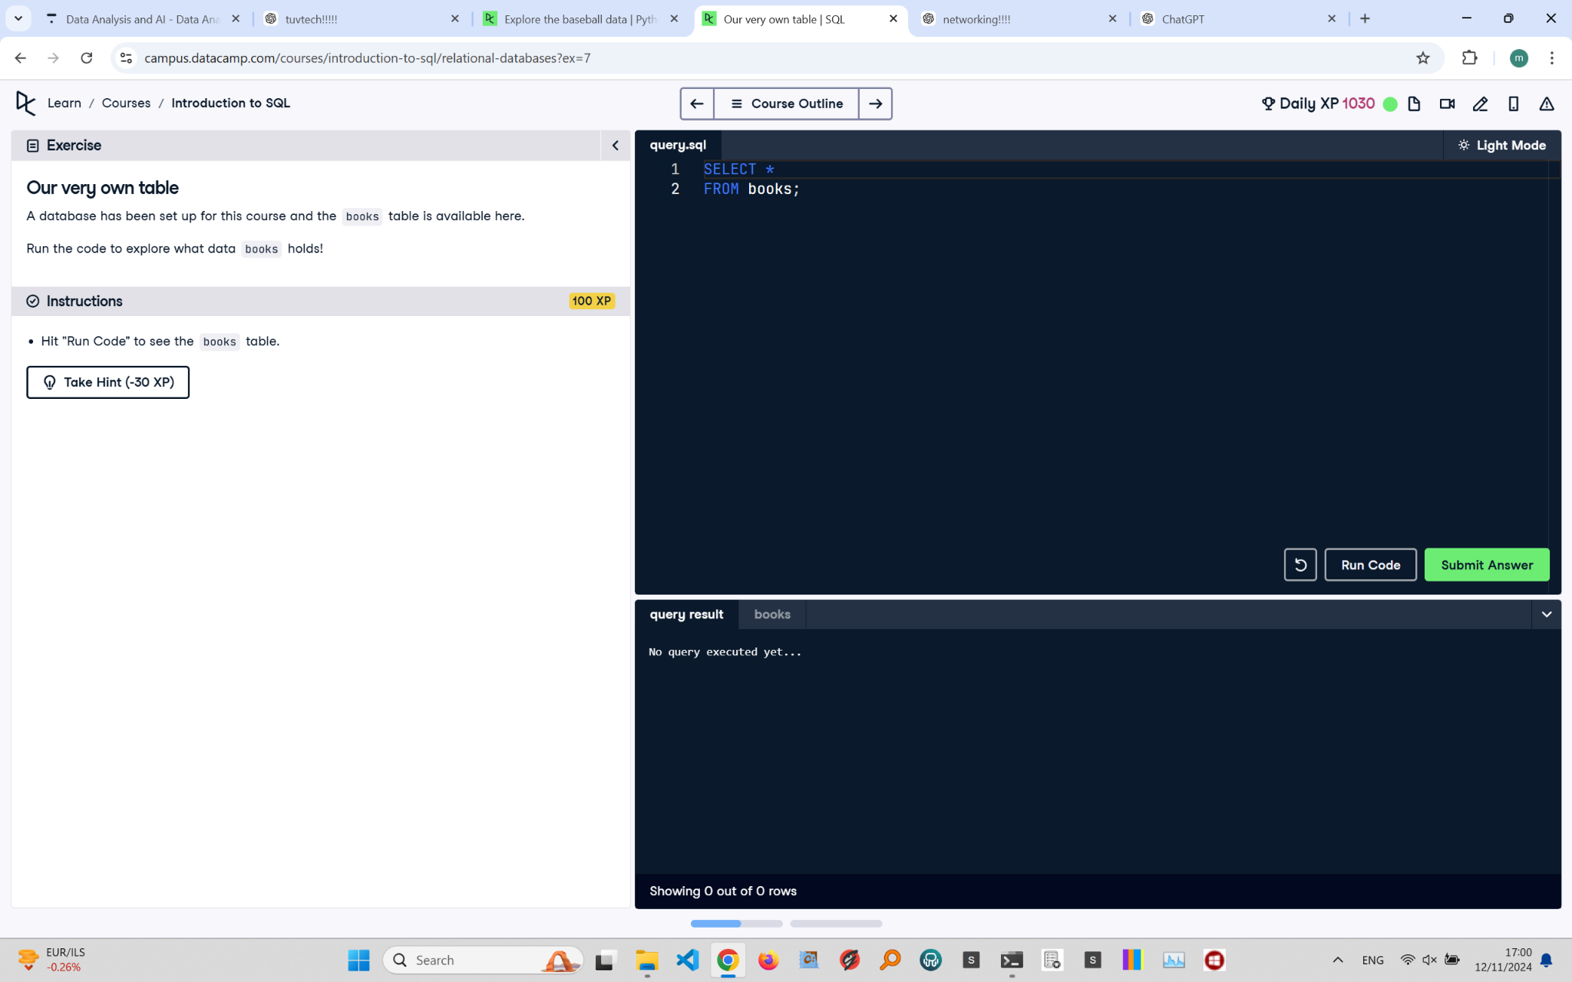

Exercise Explanation:

The task involves running a simple SQL query to view all data in the 'books' table. The 'SELECT * FROM books;' query retrieves all columns and rows from the table, allowing you to examine the data structure and contents.

SQL Query:

SELECT * FROM books;

Explanation:

This query uses the 'SELECT *' statement, which is a common way to retrieve all available data from a table. In this case, it fetches all records and columns from the 'books' table, making it useful for data exploration.