# Identifying False Statements About Database Storage

Below is the image showing the question on identifying the false statement about database storage:

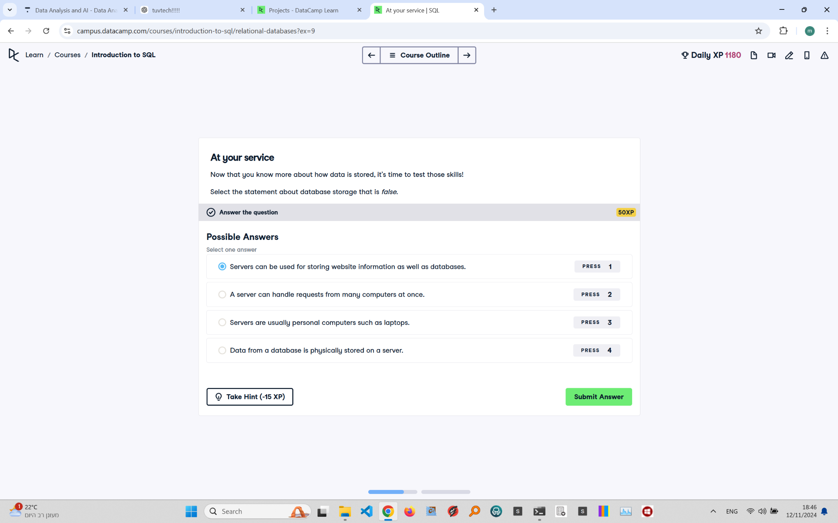

Question Explanation:

The question asks which statement about database storage is false. Servers are typically robust machines designed to handle multiple requests and store large amounts of data, rather than being personal computers like laptops.

Correct Answer:

Servers are usually personal computers such as laptops.

Explanation:

This statement is false because servers are specialized computers that are designed to manage network resources and handle multiple connections simultaneously. They are not typically personal computers like laptops, which are meant for individual use.