# Understanding Database Organization in SQL

Below is the image showing the question on data organization in a database:

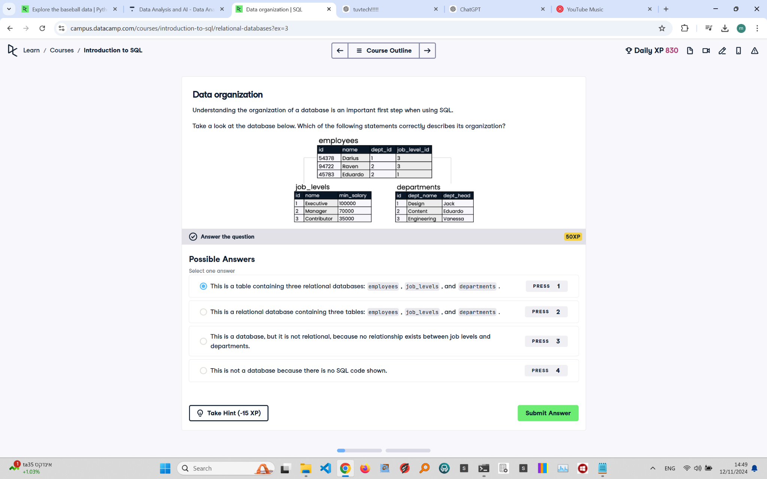

Question Explanation:

The question asks which statement correctly describes the organization of the shown database. The image displays three tables: employees, job_levels, and departments, which are linked using foreign keys, illustrating a relational database structure.

Correct Answer:

This is a relational database containing three tables: employees, job_levels, and departments.

Explanation:

The tables are part of a relational database because they are structured to relate to each other through foreign keys. The 'employees' table has references to 'job_levels' and 'departments', indicating relationships between these tables, which is a defining feature of a relational database.