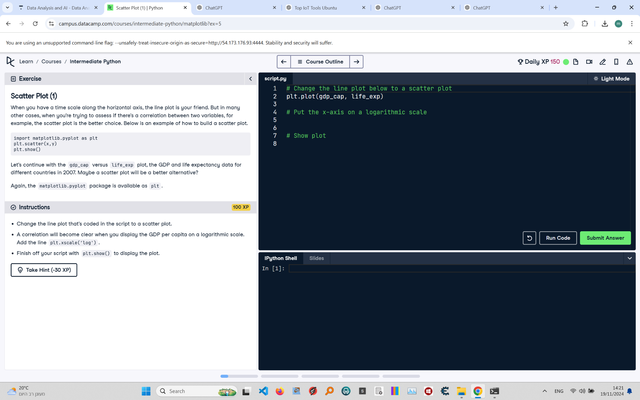

# Scatter Plot (1): Instructions and Explanation

In this task, you are asked to convert a line plot into a scatter plot using the GDP per capita ('gdp_cap') and life expectancy ('life_exp') data for different countries in 2007.  
  
Instructions:  
- Change the line plot to a scatter plot using 'plt.scatter()'.  
- Use 'plt.xscale('log')' to put the x-axis on a logarithmic scale.  
- Use 'plt.show()' to display the plot.

# Full Corrected Answer with Explanations

# Change the line plot to a scatter plot  
plt.scatter(gdp_cap, life_exp)  
# Use plt.scatter() to create a scatter plot of the data  
  
# Put the x-axis on a logarithmic scale  
plt.xscale('log')  
# Set the x-axis to a logarithmic scale to better visualize data distribution  
  
# Show plot  
plt.show()  
# Display the scatter plot to visualize the correlation between GDP and life expectancy