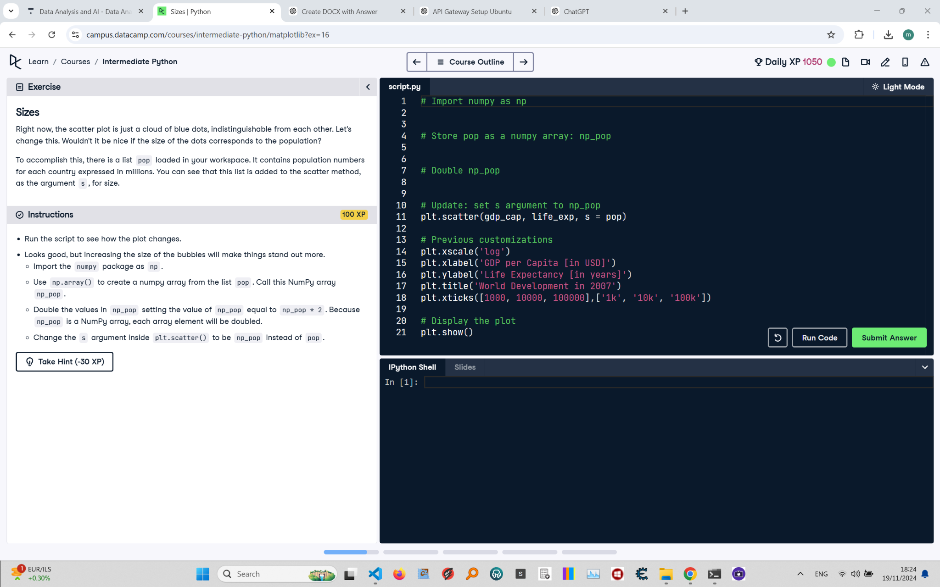

# Sizes: Instructions and Explanation

In this task, you will adjust the scatter plot to make bubble sizes reflect the population. You will use NumPy to manipulate the population data and update the plot accordingly.

# Concise Correct Answer

import numpy as np # Import NumPy  
  
np_pop = np.array(pop) # Convert pop to NumPy array  
np_pop = np_pop * 2 # Double the population values  
  
plt.scatter(gdp_cap, life_exp, s=np_pop) # Update scatter plot with new sizes  
plt.xscale('log')  
plt.xlabel('GDP per Capita [in USD]')  
plt.ylabel('Life Expectancy [in years]')  
plt.title('World Development in 2007')  
plt.xticks([1000, 10000, 100000], ['1k', '10k', '100k'])  
plt.show() # Display the plot