# Loop Over Dictionary in Python

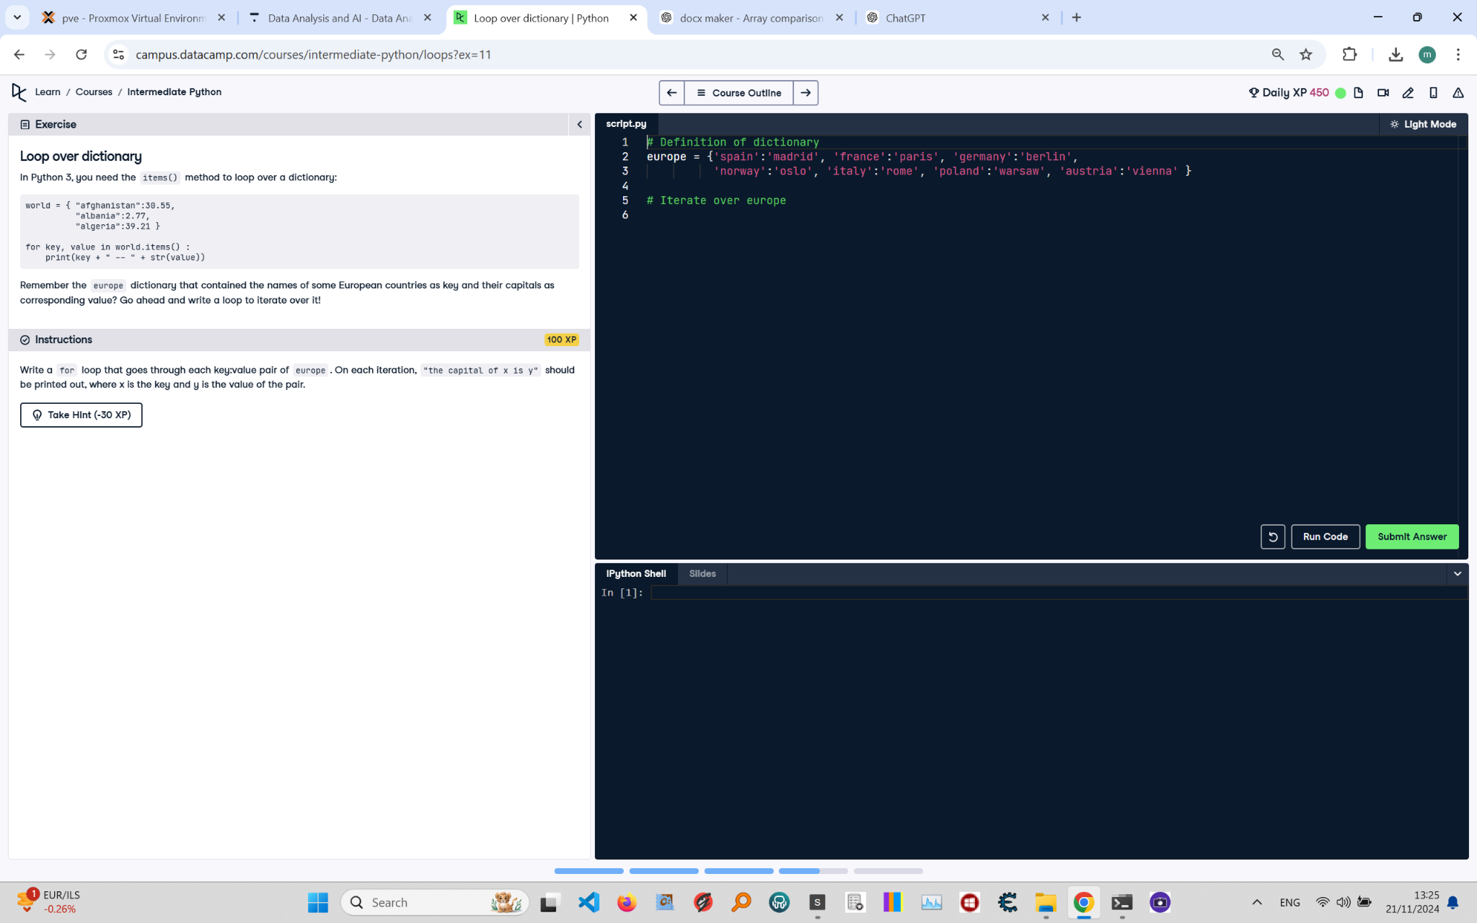

**Question:**

In Python 3, you just need the `items()` method to loop over a dictionary:  
  
```python  
world = {"afghanistan":30.55, "albania":2.77, "algeria":39.21}  
for key, value in world.items():  
 print(key + " -- " + str(value))  
```  
  
Remember the `europe` dictionary that contained the names of some European countries as keys and their capitals as corresponding values? Go ahead and write a loop to iterate over it!  
  
**Instructions:**  
Write a `for` loop that goes through each key-value pair of `europe`. On each iteration, `the capital of x is y` should be printed out, where `x` is the key and `y` is the value of the pair.

**Answer:**

Here is the Python code that solves the problem:

# Definition of dictionary  
europe = {'spain':'madrid', 'france':'paris', 'germany':'berlin',   
 'norway':'oslo', 'italy':'rome', 'poland':'warsaw', 'austria':'vienna'}  
  
# Iterate over europe  
for country, capital in europe.items():  
 print(f"the capital of {country} is {capital}")

**Explanation:**

1. **Initialization**: The `europe` dictionary is defined, containing country names as keys and their capitals as values.  
2. **Using items()**: The `items()` method returns key-value pairs of the dictionary.  
3. **For loop**: The `for` loop iterates over the key-value pairs of the dictionary.  
4. **Print statement**: The `print()` function uses an f-string to format the output as `the capital of x is y`, where `x` is the key (country) and `y` is the value (capital).  
5. **Execution**: The loop runs once for each key-value pair in the dictionary, printing the formatted string for each country and its capital.