# Querying the Books Table: Exercise and Corrected Answer

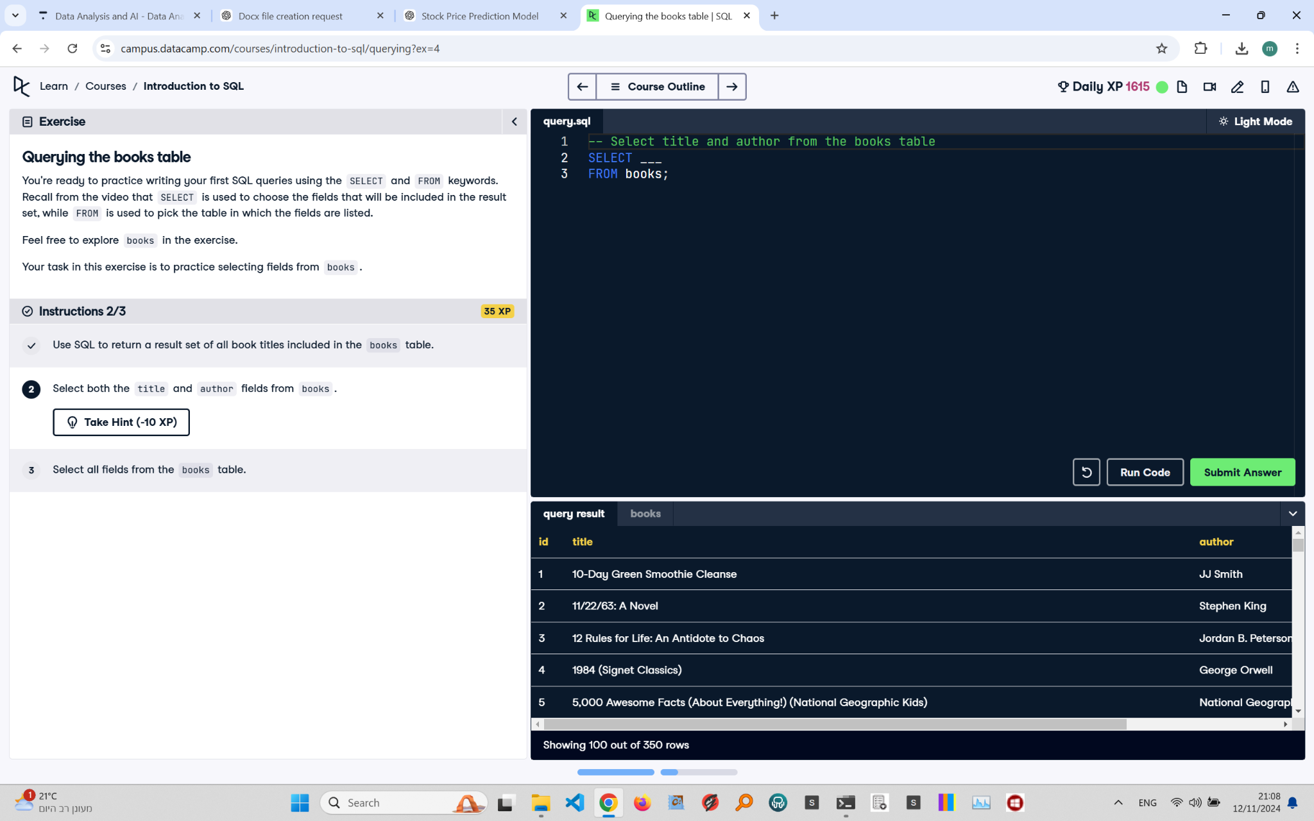

## Exercise Explanation:

This exercise focuses on writing SQL queries using SELECT and FROM keywords. The goal is to practice selecting fields from the 'books' table and retrieving specific data.

## Instructions:

1. Use SQL to return a result set of all book titles included in the 'books' table.  
2. Select both the 'title' and 'author' fields from 'books'.  
3. Select all fields from the 'books' table.

## Corrected Full Answer:

To select all book titles from the 'books' table:

SELECT title FROM books;

To select both the 'title' and 'author' fields from 'books':

SELECT title, author FROM books;

To select all fields from the 'books' table:

SELECT * FROM books;

## Answer Explanation:

The provided SQL code runs without syntax errors. Each query is formatted correctly, with SELECT specifying the columns and FROM identifying the table. Using semicolons at the end of each statement ensures proper execution, making the queries efficient and easy to understand.