# Translating Between SQL Flavors: Exercise and Answer

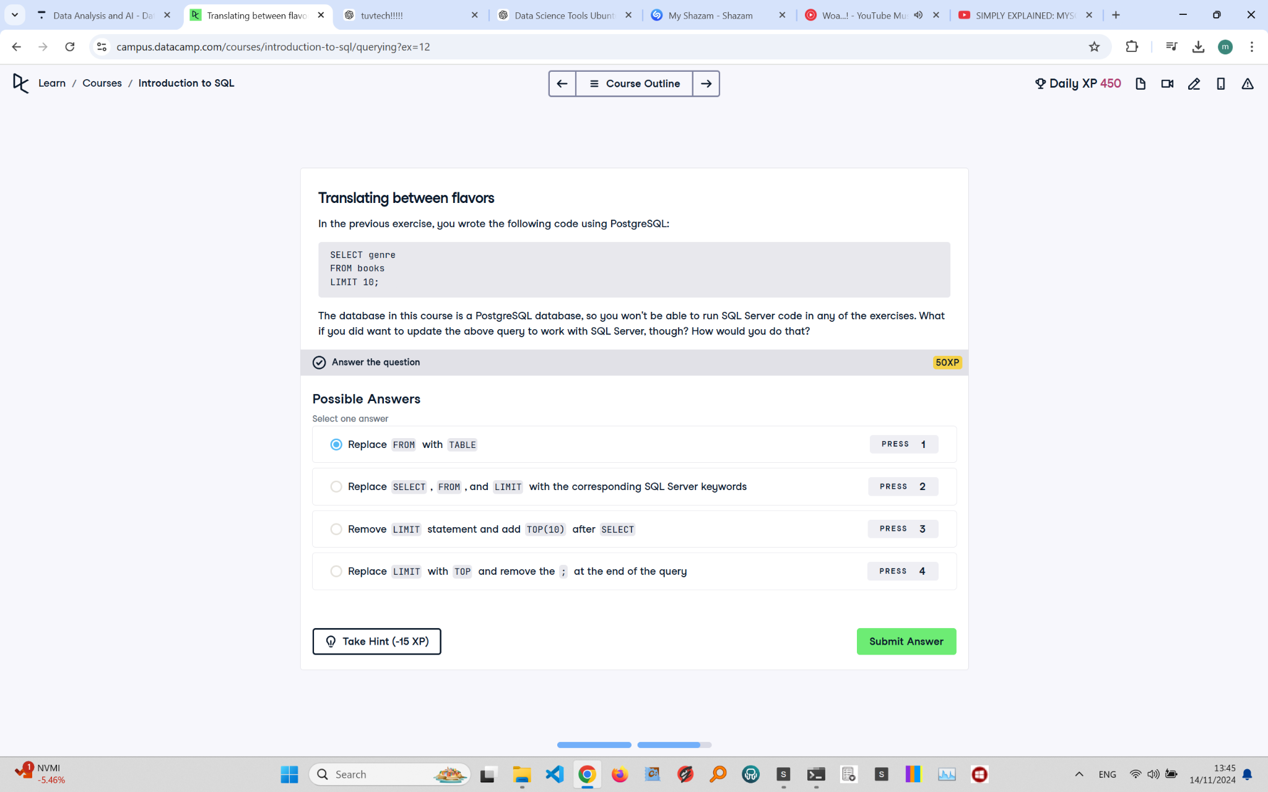

## Exercise Explanation:

This exercise focuses on how to translate a PostgreSQL query to work with SQL Server. Each SQL database has its own syntax, and understanding these differences is crucial for cross-platform compatibility.

## Question:

In the previous exercise, you wrote the following code using PostgreSQL:

SELECT genre  
FROM books  
LIMIT 10;

If you wanted to update the above query to work with SQL Server, how would you do that?

## Correct Answer:

Replace LIMIT with TOP and remove the ; at the end of the query.

## Answer Explanation:

In SQL Server, the TOP keyword is used instead of LIMIT to restrict the number of rows returned. Additionally, SQL Server does not require a semicolon at the end of the query in most cases. This ensures compatibility and correct execution of the query on SQL Server.