[**83. Remove Duplicates from Sorted List**](https://leetcode.com/problems/remove-duplicates-from-sorted-list/)

Easy

Topics

Companies

Given the head of a sorted linked list, *delete all duplicates such that each element appears only once*. Return *the linked list* ***sorted*** *as well*.

**Example 1:**

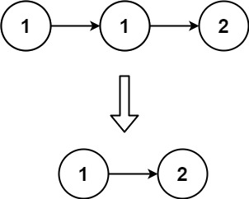**Input:** head = [1,1,2]  
**Output:** [1,2]

**Example 2:**

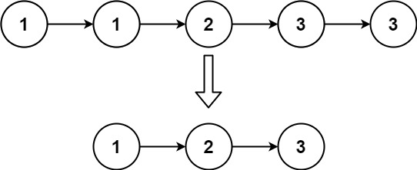**Input:** head = [1,1,2,3,3]  
**Output:** [1,2,3]

**Constraints:**

* The number of nodes in the list is in the range [0, 300].
* -100 <= Node.val <= 100
* The list is guaranteed to be **sorted** in ascending order.

Answer:

class Solution:

def deleteDuplicates(self, head: ListNode) -> ListNode:

curr = head

while curr:

while curr.next and curr.val == curr.next.val:

curr.next = curr.next.next

curr = curr.next

return head