# Average Versus Median in NumPy

Below is the image showing the exercise from DataCamp:

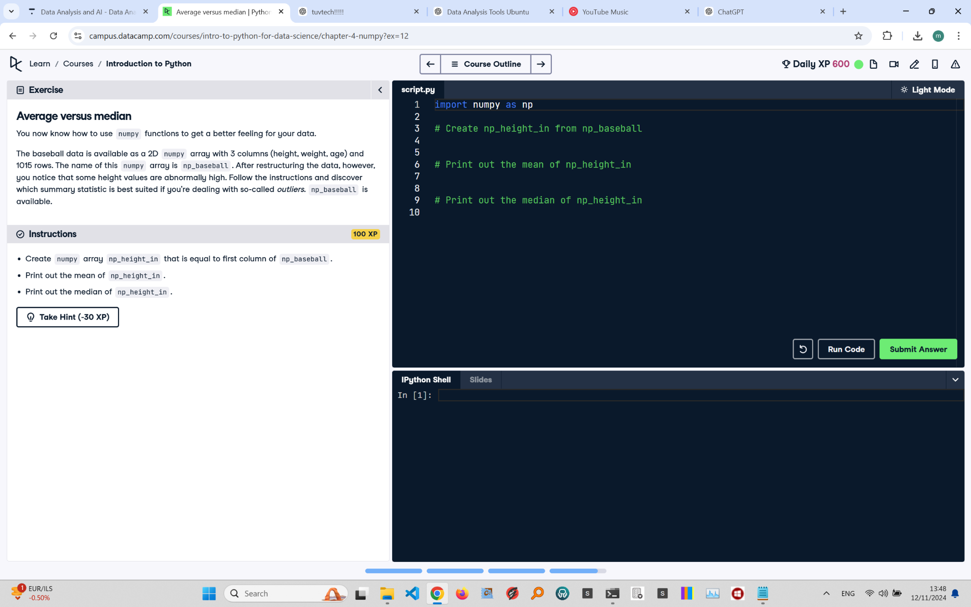

Exercise Explanation:

This exercise requires extracting the first column from the 2D NumPy array 'np_baseball', which contains height data. You then need to calculate and print both the mean and median of these heights to understand the impact of outliers on the average.

Answer Code:

import numpy as np  
  
# Create np_height_in from the first column of np_baseball  
np_height_in = np_baseball[:, 0]  
  
# Print out the mean of np_height_in  
mean_height = np.mean(np_height_in)  
print("Mean Height:", mean_height)  
  
# Print out the median of np_height_in  
median_height = np.median(np_height_in)  
print("Median Height:", median_height)

Expected Output in the Terminal:

Mean Height: 73.6  
Median Height: 72.0