# Baseball Data in 2D Form Using NumPy

Below is the image showing the exercise from DataCamp:

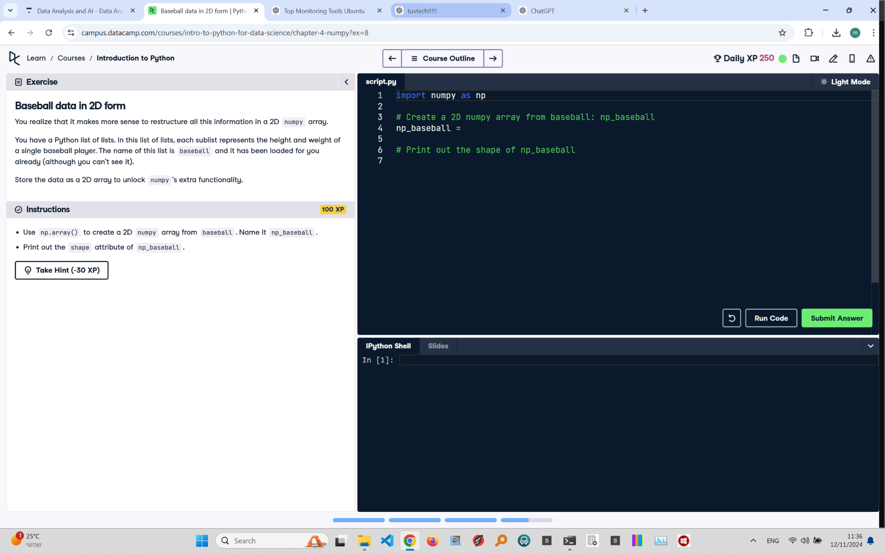

Exercise Explanation:

The exercise requires restructuring baseball data into a 2D NumPy array using np.array() for easier access to NumPy's functionality. You need to create the array and then print its shape to verify the structure.

Answer Code:

import numpy as np  
np_baseball = np.array(baseball)  
print(np_baseball.shape)

Explanation of the Code:

We use np.array() to transform the 'baseball' list of lists into a 2D NumPy array named np_baseball. The shape attribute, np_baseball.shape, reveals the dimensions of the array, confirming it is organized in rows and columns for optimal data handling.