# Creating Your First NumPy Array in Python

Below is the image showing the exercise from DataCamp:

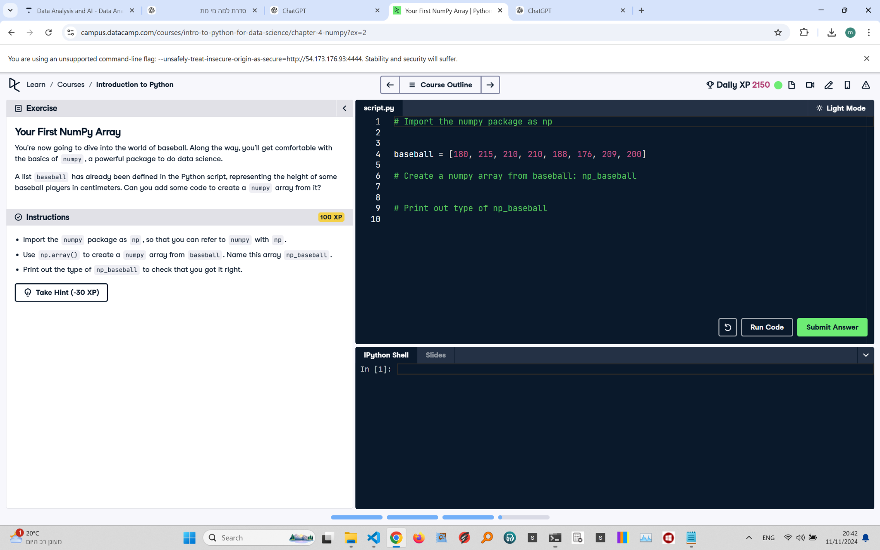

Exercise Explanation:

The exercise asks to use the NumPy package to create an array from the given list 'baseball' and then print the type of the created NumPy array to verify the result.

Answer Code:

import numpy as np  
np_baseball = np.array(baseball)  
print(type(np_baseball))

Explanation of the Code:

We first import NumPy as np, a common convention. The np.array() function is used to convert the 'baseball' list into a NumPy array named np_baseball. Finally, printing type(np_baseball) confirms the successful creation of a NumPy array, which should output <class 'numpy.ndarray'>.