# Understanding NumPy Side Effects in Vector Arithmetic

Below is the image showing the exercise from DataCamp:

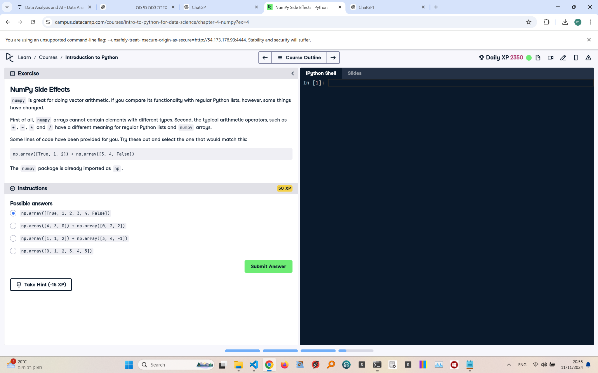

Exercise Explanation:

The exercise asks you to understand how NumPy handles vector arithmetic differently compared to regular Python lists, focusing on the behavior when adding arrays. You must select the correct NumPy array output from the options given.

Correct Answer:

np.array([1, 2]) + np.array([3, 4])

Explanation of the Answer:

NumPy allows vectorized operations. Adding np.array([1, 2]) to np.array([3, 4]) yields np.array([4, 6]). Vector arithmetic in NumPy performs element-wise operations, unlike concatenation in regular Python lists. The correct choice reflects this behavior, and ensures both arrays have matching shapes for addition.