# Subsetting 2D NumPy Arrays in Python

Below is the image showing the exercise from DataCamp:

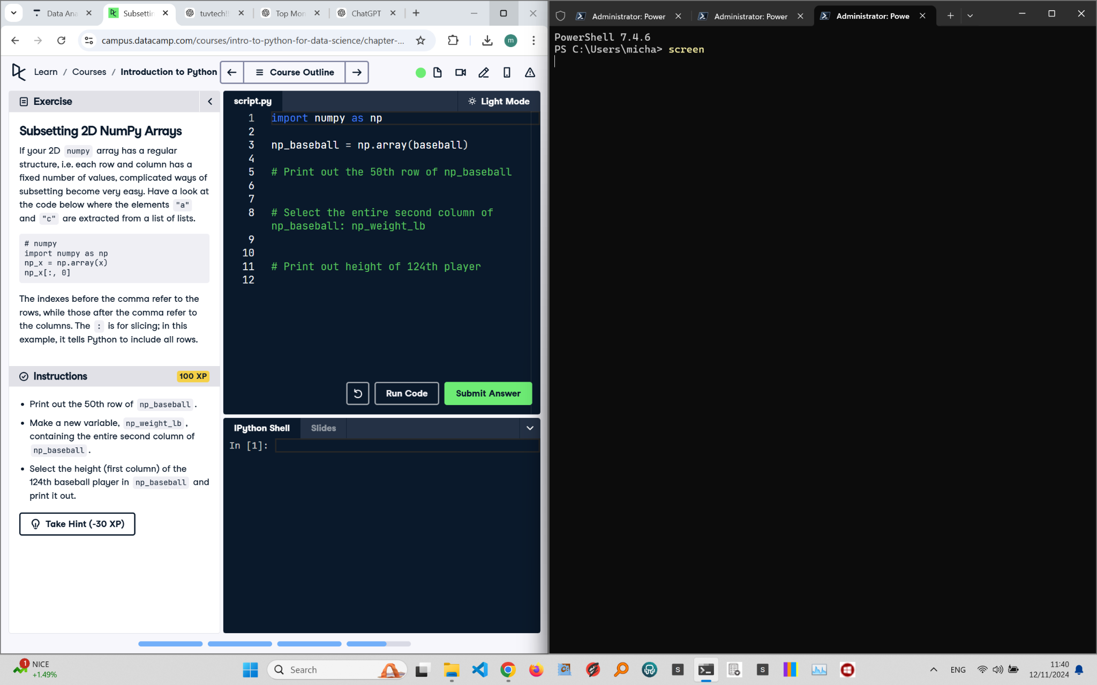

Exercise Explanation:

This exercise teaches subsetting specific rows and columns from a 2D NumPy array. You need to extract the 50th row, create a new variable for the second column, and print the height of the 124th player using appropriate indexing.

Answer Code:

print(np_baseball[49]) # 50th row (index 49)  
np_weight_lb = np_baseball[:, 1] # Second column  
print(np_baseball[123, 0]) # Height of 124th player (index 123)

Explanation of the Code:

To access the 50th row, use np_baseball[49]. The second column is extracted using np_baseball[:, 1], where ':' means all rows and '1' specifies the second column. To get the height of the 124th player, use np_baseball[123, 0], with 123 as the index.