## **Keycloack_create_realm_user_and_Secure_the_first_application**

## **Create a realm**

A alm in Keycloak is equivalent to a tenant. Each realm allows an administrator to create isolated groups of applications and users. Initially, Keycloak includes a single realm, called master. Use this realm only for managing Keycloak and not for managing any applications.

Use these steps to create the first realm.

1. Open the [Keycloak Admin Console](http://localhost:8080/admin).
2. Click the word **master** in the top-left corner, then click **Create Realm**.
3. Enter myrealm in the **Realm name** field.
4. Click **Create**.

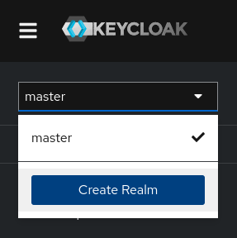

## **Create a user**

Initially, the realm has no users. Use these steps to create a user:

1. Open the [Keycloak Admin Console](http://localhost:8080/admin).
2. Click the word **master** in the top-left corner, then click **myrealm**.
3. Click **Users** in the left-hand menu.
4. Click **Add user**.
5. Fill in the form with the following values:

* **Username**: myuser
* **First name**: any first name
* **Last name**: any last name

1. Click **Create**.

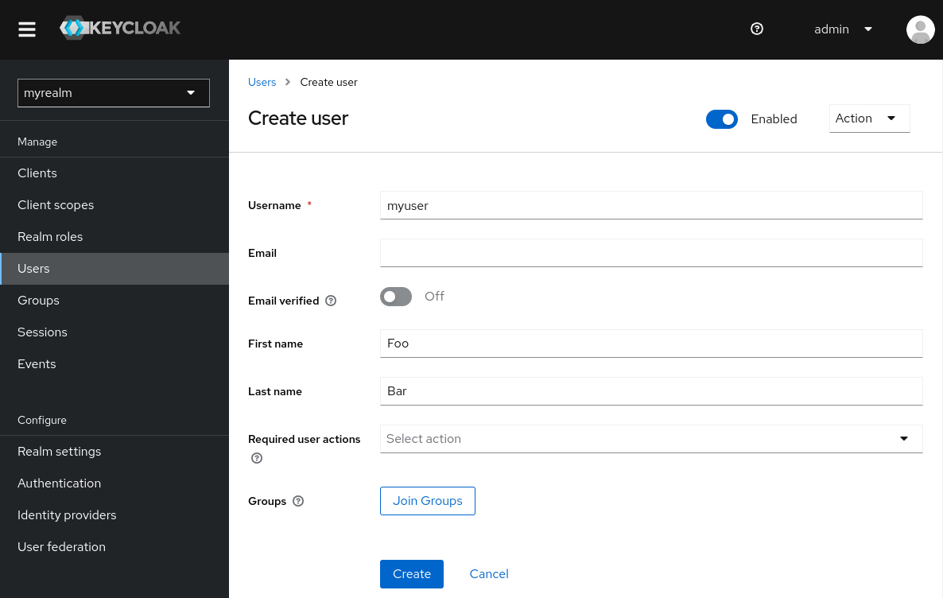

This user needs a password to log in. To set the initial password:

1. Click **Credentials** at the top of the page.
2. Fill in the **Set password** form with a password.
3. Toggle **Temporary** to **Off** so that the user does not need to update this password at the first login.

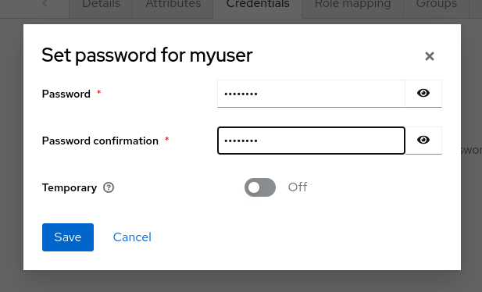

## **Log in to the Account Console**

You can now log in to the Account Console to verify this user is configured correctly.

1. Open the [Keycloak Account Console](http://localhost:8080/realms/myrealm/account).
2. Log in with myuser and the password you created earlier.

As a user in the Account Console, you can manage your account including modifying your profile, adding two-factor authentication, and including identity provider accounts.

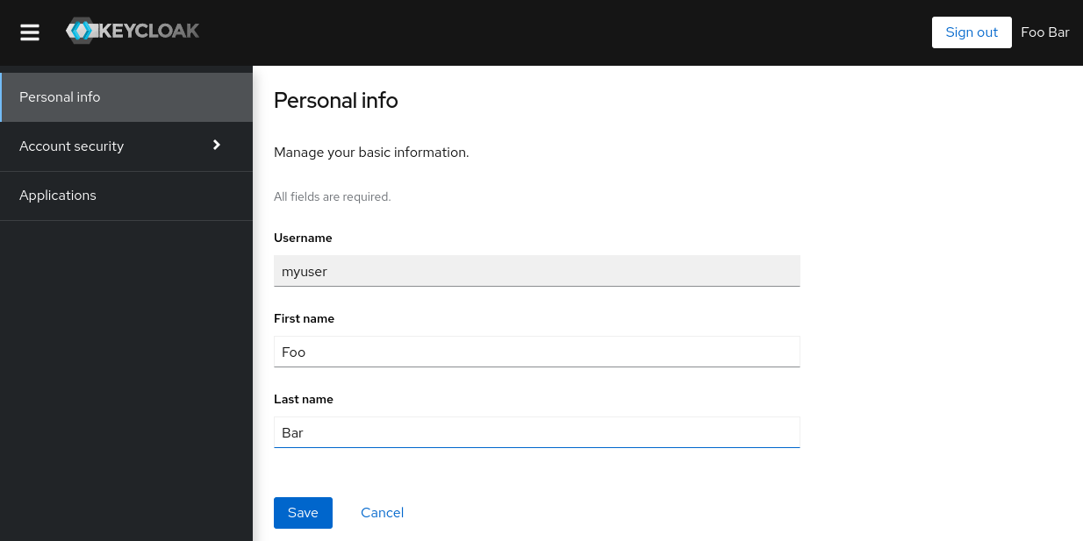

## **Secure the first application**

To secure the first application, you start by registering the application with your Keycloak instance:

1. Open the [Keycloak Admin Console](http://localhost:8080/admin).
2. Click the word **master** in the top-left corner, then click **myrealm**.
3. Click **Clients**.
4. Click **Create client**
5. Fill in the form with the following values:

* **Client type**: OpenID Connect
* **Client ID**: myclient

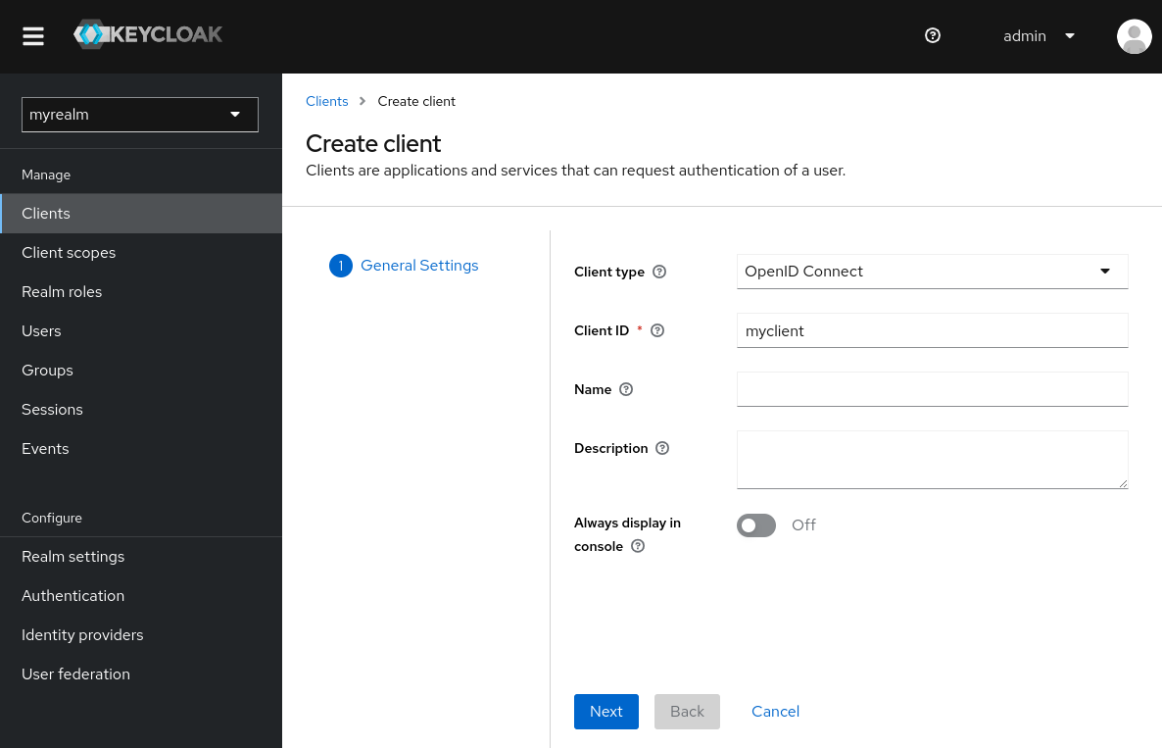

1. Click **Next**
2. Confirm that **Standard flow** is enabled.
3. Click **Next**.
4. Make these changes under **Login settings**.

* Set **Valid redirect URIs** to <https://www.keycloak.org/app/>*
* Set **Web origins** to <https://www.keycloak.org>

1. Click **Save**.

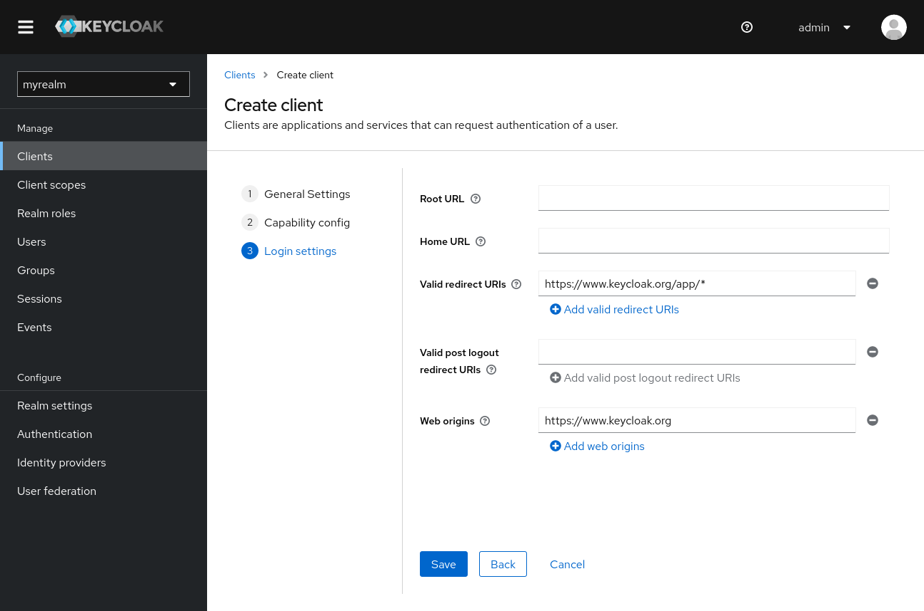

To confirm the client was created successfully, you can use the SPA testing application on the [Keycloak website](https://www.keycloak.org/app/).

1. Open <https://www.keycloak.org/app/>.
2. Click **Save** to use the default configuration.
3. Click **Sign in** to authenticate to this application using the Keycloak server you started earlier.