Binary Decision Diagram Implementation Documentation
Student: Mykhailo Chepara
Assignment: DSA Assignment 6 - Binary Decision Diagrams
Date: May 11, 2025

Algorithm Description

What is a BDD?
A Binary Decision Diagram (BDD) is a data structure used to represent Boolean functions. It's essentially a directed acyclic graph where each node represents a variable of the Boolean function. Each node has two outgoing edges: one for when the variable value is 0 (low_link) and one for when its value is 1 (high_link).

Implementation Approach
My implementation includes three main functions as required:
BDD_create
Creates a reduced BDD for a Boolean function with a specific variable order

BDD_create_with_best_order
Finds the best variable ordering and creates an optimized BDD

BDD_use
Evaluates the BDD for specific input values

BDD Creation Algorithm
The BDD creation consists of the following steps:
- Parse the Boolean expression into separate terms
2. Create terminal nodes (0 and 1)
3. Recursively build the diagram from the root down
4. Apply reduction rules during construction
Code excerpt regarding main reduction logic of the algorithm
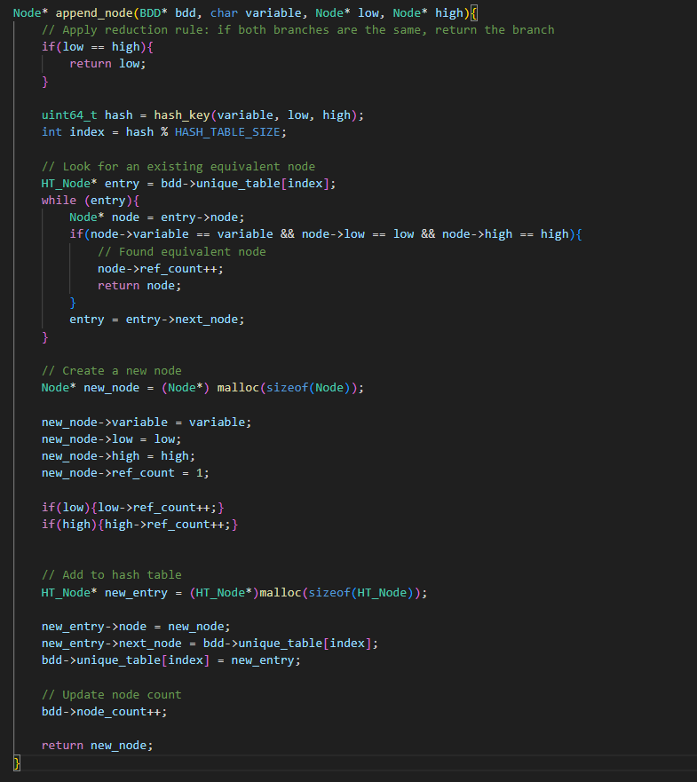
On the preceding code excerpt illustrating append_node function adds a new node to the Binary Decision Diagram (BDD) or finds and returns an already present equivalent node based on a reduction rule. The basic concept is to determine whether low and high are equal, upon which one of them is returned. If the branches are different, it computes a hash of the current node based on the variable and its child nodes and searches the hash table to see if there is a similar node. If there is a similar node, its reference count is incremented and the node is returned. If no such equivalent node exists, a new node is created, its reference count is initialized to 1, and it is added to the hash table. The count of BDD nodes is also incremented accordingly.

Descriptions of individually defined structures
On the following image we can see Node, HT_Node, and BDD structure definitions
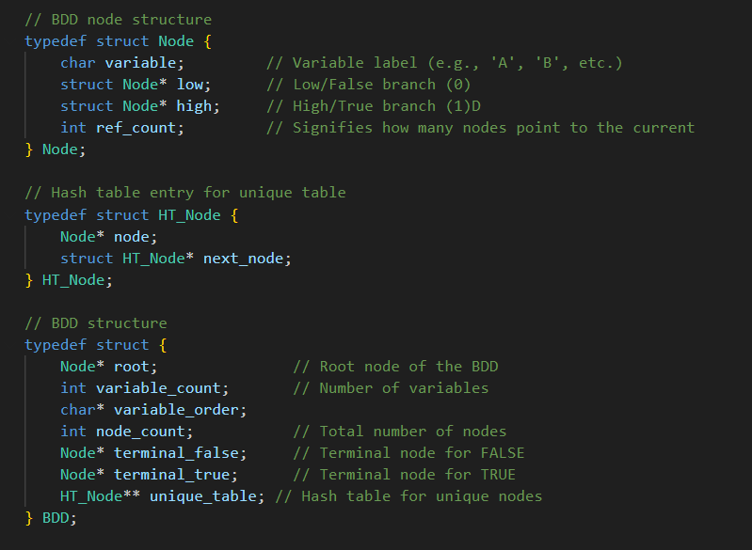
Node
The Node structure represents a single node in a Binary Decision Diagram (BDD). It contains the variable associated with the current node, a pointer to the "low" branch (false branch), a pointer to the "high" branch (true branch), and a reference count indicating how many other nodes point to this node.

HT_Node
The HT_Node structure is used for the hash table in the unique table of the BDD. Each entry in the hash table holds a pointer to a node and a pointer to the next node in the list, which helps resolve hash collisions when multiple nodes map to the same index.
BDD
The BDD structure represents the whole Binary Decision Diagram. It includes a pointer to the root node, the count of variables, a string indicating the order of variables, the total number of nodes, pointers to the terminal false and true nodes, and a hash table for unique nodes.

Descriptions of functions from the code
- Function - free_bdd_nodes
void free_bdd_nodes(Node* root, Node* terminal_true, Node* terminal_false)
Frees BDD nodes starting from root unless they are terminal_true or terminal_false. Decrements ref_count and frees the node only if ref_count reaches zero, then recurses on low and high children.
- Function - free_hash_table
void free_hash_table(HT_Node** table, int size)
Frees all entries in a hash table by traversing each bucket's linked list and deallocating each node, then frees the table itself.

- Function - free_bdd
void free_bdd(BDD* bdd)
Frees all memory used by a BDD structure. Deallocates the unique table, BDD nodes, terminal nodes, and finally the BDD itself if the pointer is not NULL.

- Function - glean_vars
char* glean_vars(char* expression)
Extracts and returns a dynamically allocated string of all unique alphabetic characters found in the input expression. Uses a lookup array to track seen characters. Returns NULL if input is NULL or memory allocation fails.

- Function - disintegrate_term
char* disintegrate_term(char* expression, short term_length, int position)
Allocates and returns a new string containing a substring of specified length copied from the given position in the input expression.

- Function - clean_spaces
char* clean_spaces(char* expression)
Creates and returns a new string with all whitespace characters removed from the input expression. Returns NULL if memory allocation fails.

- Function - dissect_expression
char** dissect_expression(char* expression, size_t* terms_number)
Parses the input expression by first removing all spaces, then splitting it into individual terms separated by '+' symbols. Allocates memory for each term and stores them in a list. Updates terms_number with the total number of terms and returns the list. Frees the intermediate cleaned expression after use.

- Function - hash_key
uint64_t hash_key(char variable, Node* low, Node* high)
Generates a hash value using the input variable and pointers to low and high BDD nodes. Combines the inputs with bitwise shifts and XOR, then reduces the result modulo the hash table size.

- Function - remap_assignments
char* remap_assignments(char* original_assignments, char* original_order, char* new_order)
Takes binary variable assignments and reorders them to match a new variable order. Creates a mapping from original variables to their assigned values, validates the inputs, and builds a new assignment string in the target order. Unknown or missing variables default to '0', with warnings printed for any irregularities.

- Function - evaluate_term
int evaluate_term(const char* term, const char* vars, const char* assignment, int var_count)
Evaluates a single DNF product term using a provided binary assignment for variables. First constructs a lookup table mapping each variable to its assigned '0' or '1' value. Then iterates through the characters of the term, identifying each variable and whether it is negated (indicated by a preceding '!'). For each literal, retrieves its value from the lookup table, applies negation if necessary, and checks its truth value. Since the term represents a logical AND of literals, the function returns 0 immediately if any literal evaluates to false. If all literals evaluate to true, the function returns 1. Handles missing or invalid assignments with warnings.

- Function - append_node
Node* append_node(BDD* bdd, char variable, Node* low, Node* high)
Adds a new node to the BDD or reuses an existing one if an equivalent already exists. If both low and high branches are identical, it returns the branch directly, applying a BDD reduction rule. Otherwise, it computes a hash using the variable and its child nodes, then searches the corresponding index in the unique table for a match. If a matching node is found, its reference count is incremented and it's returned. If not, a new node is allocated, initialized, and added to the unique table. Reference counts for its children are incremented, and the BDD’s node count is updated. Finally, the new node is returned.

- Function - build_recursive_bdd
Node* build_bdd_recursive(BDD* bdd, char** terms, int term_count, const char* vars, int var_count, int var_idx)
This function recursively builds a Binary Decision Diagram (BDD) from a set of terms in Disjunctive Normal Form (DNF). The process starts by iterating through the variables in the DNF expression, one at a time, and considering the current variable (vars[var_idx]) for division. For each variable, the terms are partitioned into two groups: the low branch (where the variable is assigned '0') and the high branch (where the variable is assigned '1'). If a term doesn't contain the current variable, it is included in both branches, effectively representing a "don't care" scenario.
The function also handles the negation of variables within the terms by checking for the presence of a negation symbol ('!'). If a variable is negated in a term, it will be assigned to the low branch, while non-negated variables go to the high branch.
After dividing the terms based on the current variable, the function recursively calls itself for both the low and high branches, further dividing the terms based on the next variable, until all variables are processed. Once all variables have been processed, the function applies BDD reduction rules, which include merging equivalent nodes and removing redundant branches. Finally, the function returns the root node of the constructed BDD, which represents the entire DNF expression. The process ensures that the resulting BDD is efficient and minimal, with duplicate terms and unnecessary nodes eliminated.

- Function - BDD_use
BDD_use(BDD* bdd, const char* assignment)
Evaluates a Binary Decision Diagram (BDD) based on a provided variable assignment. The function initializes a lookup table to map each variable to its corresponding value ('0' or '1') from the assignment string. It traverses the BDD starting from the root node, following the appropriate branch (low or high) based on the variable assignments, until it reaches a terminal node. If the assignment for any variable is invalid or missing, or if a NULL branch is encountered during traversal, an error is reported. The function returns 1 if the evaluation reaches the terminal true node, or 0 if it reaches the terminal false node.
- Function - create_BDD
create_BDD(BDD* bdd, char* Bfunction, char* vars)
This function creates a Binary Decision Diagram (BDD) based on a Boolean function (Bfunction) expressed in Disjunctive Normal Form (DNF). It first dissects the Boolean function into individual terms using the dissect_expression function and then initializes the necessary components of the BDD.
A new BDD structure is allocated, with memory allocated for the unique table and terminal nodes (false and true). The terminal false and true nodes are initialized with appropriate values, including reference counts set to INT_MAX to signify their immutability. Reference counts are later used to free all nodes from the BDD structure.
The function sets up the variable count, the number of nodes (initially just the two terminal nodes). The BDD’s root is then set by recursively building the BDD from the dissected terms and variable order using the build_bdd_recursive function.
Finally, the function returns the created BDD.

- Function - BDD_create_with_best_order
BDD* BDD_create_with_best_order(char* Bfunction)
This function creates a Binary Decision Diagram (BDD) with the most optimal variable order for a given Boolean function (Bfunction) expressed in Disjunctive Normal Form (DNF). It begins by extracting the variables from the Boolean function using the glean_vars function.
The function starts with the original variable order, creates the BDD, and initializes the best variable order and node count. It then performs systematic permutations of the variable order by swapping two variables at a time, creating new BDDs for each permutation and checking whether the new order results in fewer nodes. If a better order (with fewer nodes) is found, the function updates the best BDD, variable order, and node count accordingly.
Finally, the function ensures that the BDD's variable order is updated to the best order and cleans up any allocated memory before returning the optimized BDD.

Solution Justification

Correctness
My solution is correct because:
- The BDD construction uses the standard top-down approach. I.e. calling recursively a function until terminating node is encountered, while returning back optimizing the graph.
2. Reduction rules are applied during construction to avoid redundancy. Additionally calling function to reduce graph even further.
3. Each test case is validated by comparing the BDD result with direct evaluation of the Boolean expression.

Testing Method
The code was tested in the following manner:
- Creating BDDs for random Boolean functions with varying numbers of variables
2. Comparing results from both BDD implementations with direct term evaluation
3. Testing with different variable orderings to verify impact on BDD size

Testing Results

In most cases there is a reduction approximately 95 - 98% for the node quantity parameter.

Performance Analysis

Time Complexity
- Function - BDD_use

The time complexity of the function BDD_use is O(n), where n is the size of the variable order (alternatively, the number of variables in the Boolean function). In each iteration of the while loop, the function descends one level in the BDD based on the provided assignment. Since the height of a reduced BDD is at most n, the loop iterates at most n times. The work inside the loop (checking assignment map, comparing the current node with terminal nodes, and moving to the next node) takes constant time. Initializing the assignment map takes O(n) time since the loop needs to go through the variable order. Therefore, the overall time complexity is dominated by the BDD traversal and is O(n).

- Function - create_BDD

The create_BDD function has the worst-case exponential time complexity and can be formulated as O(2^n), where 'n' signifies the number of variables in the given Boolean function. The time complexity is basically caused by the recursive calls from the build_bdd_recursive function. Essentially, build_bdd_recursive is backtracking a decision tree structure, one level for each variable, resulting in potentially traversing all the 2^n paths before any gains from optimizing the BDD representation take effect.

- Function - BDD_create_with_best_order

The BDD_create_with_best_order function's time complexity is O(n + n + n*n*(n + 2^n)), reflecting the sequential nature of its operations. Initially, glean_vars, which extracts variables, contributes O(n), where 'n' is the length of the Boolean function. Then, strlen determines the number of variables ('n') in O(n) time. The core of the function involves nested loops that iterate up to n*n times to explore different variable order permutations. Within these loops, strdup duplicates strings in O(n) time, and crucially, create_BDD constructs a BDD in O(2^n) time. Because create_BDD is called within the nested loops, its exponential cost is multiplied by the loop's quadratic cost (n*n). Therefore, the O(n^2 * 2^n) term dominates the overall complexity, especially as 'n' increases.

Space Complexity

Worst-case scenario is O(2 ^n). Due to the fact that each level has twice as many nodes as previous, while creating a BDD structure memory is allocated for each of the nodes, therefore for 'n' nodes there must be allocated utmost 2^n memory compartments.

In practice, using an appropriate ordering of variables, the majority of Boolean functions can be represented and handled with polynomial complexity O(n^k) by BDDs, as presented in Randal E. Bryant's classical paper 'Graph-Based Algorithms for Boolean Function Manipulation.'

Efficiency Results
The BDD implementation shows significant reduction compared to a full binary tree.
Here are comparisons of functions BDD_create_with_best_order and create_BDD
BDD Statistics:
Number of variables: 12
Regular BDD order: ICGJEFHBADKL
Best BDD order: JABDGCEHILKF
Number of nodes (regular_bdd): 87
Number of nodes (best_bdd): 69
Maximum theoretical nodes: 4096
Reduction efficiency (regular): 97.88%
Reduction efficiency (best): 98.32%

All functions execute in under a second for functions with up to 15 variables.

