Documentation for Assignment #2

Assignment objective:
Implement an agglomerative algorithm for clusterization of points, that are generated in the amount of 20020 at the very beginning. The algorithm has 2 ways of determining center of a cluster: utilizing medoid and centroid points.

Since both methods have the same algorithm of merging points/clusters the core part of merging will be explained here, afterward methodology of computing centroid and medoid points will be elucidated.

Clusterization methodology
The main concept of the agglomerative approach is to have N points at the very beginning each representing a cluster. With every next iteration a pair of points with the smallest distance between them is merged together into a new cluster, concurrently number of clusters decrease as well to N - 1. The clusters are merged under the condition that average distance between points in cluster is less than 500.

The primary steps of the working algorithm

The first phase includes generation of points. First 20 points are generated using generate_anchors function, the residuum of points is generated by generate_residuum function. After that matrix of distances , i.e. distance_matrix, is calculated using calculate_distances function. (In test mode it's calculated using pre-compiled C-function to reduce time of waiting).
After all points are generated they're saved into pr_points array where on each index there's a vector pair of indices.

The second phase incorporates finding the smallest distance in the matrix and merging a pair of cluster/point elements. Basically, the smallest distance is found in the matrix at the interception of a pair of point/cluster and then types for each of those elements is determined. Using crap_cluster(CReate & APpend) function we are merging those 2 elements into one, creating new cluster with updated centroid/medoid, points that belong to it, and other essential parameters, mentioned later in this documentation. Function later returns a cluster. Any cluster in the program has the following structure:

[[ [x, y], average_incluster_distance, cns_f, color], [p1, p2, p3, p4…]]

x and y represent coordinates of a cluster center, i.e. that is medoid or centroid

average_incluster_distance - average distance between all points of the cluster and its center point

cns_f - clusterization set flag, flag that tells the algorithm to stop trying to merge a particular cluster with any of the remaining

color - color of points for inside of that cluster.

p1, p2, p3, p4… - are values that represent points, they're just index positions of those points inside of pr_points.

Third phase. After those 2 elements were merged they are either both deleted from matrix of distances, i.e for each of them their corresponding pair of row and column, or one of them is deleted and other is used later. They are both deleted from the distance matrix, if average_incluster_distance of the output cluster is 500, since the output cluster can't be merged anymore and they are parts of that cluster, they can't be merged anymore either, so they're both removed from the matrix of distances.
But if average_incluster_distance parameter for a merged cluster has a value of more than 500 inside the crap_cluster function then crap_cluster function returns one of the initially passed clusters, and specifically the one that has bigger average_incluster_distance, since that point was attempted to be merged with another. For that specific cluster cns_f is set to False, so the cluster is deemed to be not merge-able anymore. Later on in code that flag is always checked and if it's true than cluster returned will be removed from the distance matrix.
In case of distance being less that 500, one of the clusters is deleted and other's row/column is used for the new cluster as placeholder. Afterward name for the new cluster is generated. Onto a corresponding name, cluster structure is mapped inside the cr_info dictionary. The clusters from which the new cluster was made are deleted from cr_info dictionary subsequently. Of course, they're deleted only when they are deleted from the distance_matrix.

Fourth phase. While points are deleted from the distance_matrix, they're also deleted from cluster_mask. Mask of clusters is used to denote on which positions in the distance_matrix there are located points, and on which there are located clusters. At the beginning cluster_mask is filled with generated numbers from 0 to number of points in the matrix. And during each iteration in the main loop if a point/cluster gets deleted, the mask mirrors deletion of a particular point/cluster by deleting element on the corresponding position in the cluster_mask. And if a new cluster is created in matrix its name is added onto the corresponding position in cluster_mask instead of the old value.

Fifth and final phase. At the end for the newly created cluster distances are computed using recalculate_dists function, and the matrix gets updated with those recomputed values. Then everything repeats again and again until the distance_matrix has only 1 record left. And that record is always contained in the cr_info since it's a cluster.

Computing centroid

Centroid is the point that has the smallest distance to all points in a cluster, it's often not a real point. Centroid is computed by adding vectors of each point in a cluster and dividing by number of those points. It’s done pretty straightforward in code, just by adding all x coordinates of every point and dividing by their number, the same works for every other coordinate left in each point.

Computing medoid

Medoid is the point that has the smallest distance to all points in a cluster. That point is a real point and is one of the points of the cluster. Medoid is computed by computing distance from a particular point to every other point in the cluster and dividing that sum of distances by their number, the process is done for every point in the cluster, and then out of computed distances point with the smallest average is taken as the medoid. That's the brute force method. Another method might be like the following. First of all a centroid is found for the cluster, and then for every point in cluster distance is calculated between it and centroid. The point with the smallest distance is taken as medoid.

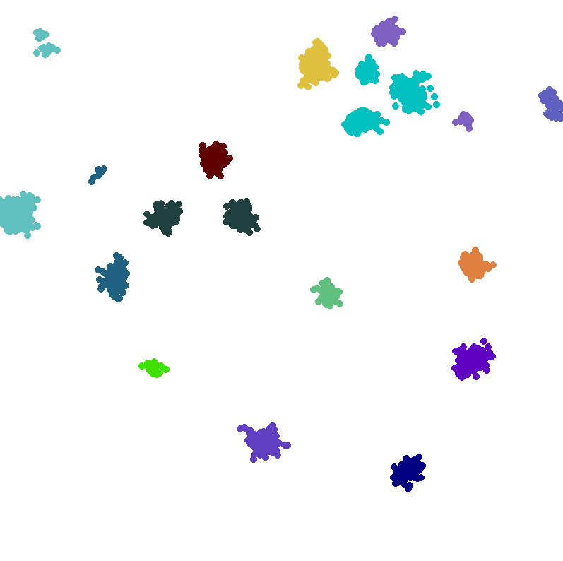
Fig. 1(Maximum incluster distance 500)

During first attempt with 5000 points and average distance in the cluster of less that 500 most of the clusters are bigger than they should be. It’s presumed to be like that because we don't have many points and the average distance allowed in the cluster is 500, therefore adjacent clusters are merged and they appear to be bigger then they should be
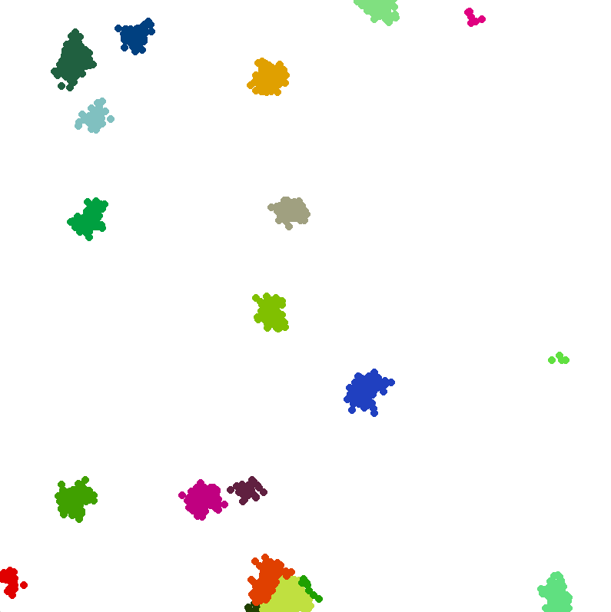

Fig. 2(Maximum incluster distance 200)
In this case the average incluster distance is less than 200, and as can be seen clusters are smaller and well resemble the result needed, they're clustered more precisely. Of course, some of the colors on the map are pretty similar, but upon checking their RGB values most of them appear to be different.

Fig. 3(Maximum incluster distance 250)
This is the case for 10000 points and incluster distance parameter set to 250. And as can be observed the clusters are having pretty much accurate borders. So the inference can be taken out of it.

Thus for every subsequent number of points it's own incluster distance must be calculated to clusterize clusters properly so no clusters with its fit size are merging with other fitted clusters. A fit cluster is a cluster which shouldn't merge with other clusters/points anymore, but still is doing so due to incorrectly set incluster distance parameter.

