Documentation for Algorithms
Written by Mykhailo Chepara. Student of Slovak Technical university of Bratislava studying at Faculty of Informatics and Information Technologies.

Algorithms Documentation

Hash Table

void test_hash_table(double* array_of_values, int num_values, int num_attempts)
Purpose: Benchmarks performance of insert, search, and delete operations on the hash table.
How it works: Runs num_attempts rounds of benchmarking. Each round tests insertions, searches, and deletions using values from array_of_values. Iteration numbers increase in steps (1000, 10000, 100000). Uses clock() to measure execution time. Writes results to three output files. Reinitializes the hash table after each round.

void init_HT()
Purpose: Initializes the hash table and status table.
How it works: Allocates memory for hash_table to store double values. Allocates and zeroes status_table to mark each slot as EMPTY.

void free_HT()
Purpose: Frees memory used by the hash table.
How it works: Calls free() on both hash_table and status_table.

unsigned long hash_dtk(double value)
Purpose: Converts a double value into a numeric key.
How it works: Uses a union to safely reinterpret the double as a 64-bit unsigned integer. Returns the result modulo LONG_MAX.

long hash_dp(double value)
Purpose: Computes a second hash for double hashing.
How it works: Initializes random coefficients once. Uses a polynomial-like hash function to combine key and coefficients. Returns result modulo LONG_MAX.

void resize_HT()
Purpose: Resizes the hash table when it's too full.
How it works: Multiplies TABLE_SIZE by 4, then finds the next prime number. Creates new tables of the new size. Rehashes and reinserts all OCCUPIED elements into the new table using double hashing. Frees the old tables and updates the global pointers.

void insert_HT(double value)
Purpose: Inserts a value into the hash table.
How it works: Uses double hashing to probe for an empty or DELETED slot. Inserts the value and updates status_table. If load factor exceeds 0.8, triggers resize_HT().

double search_HT(double value)
Purpose: Searches for a value in the hash table.
How it works: Uses double hashing to probe. If value is found at an OCCUPIED slot, returns it. If not found after all probes, returns -1.00.

void delete_HT(double value)
Purpose: Deletes a value from the hash table.
How it works: Uses double hashing to probe. If value is found in an OCCUPIED slot, marks the slot as DELETED.
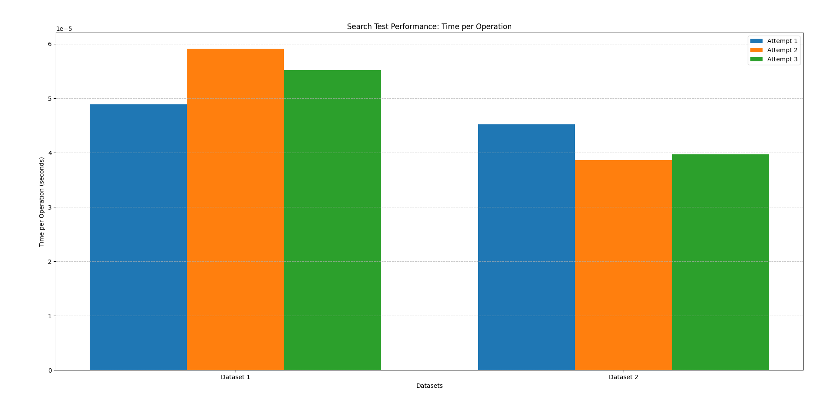
This are the data sets used for search operation and the measurements taken, as you can see it’s fast.
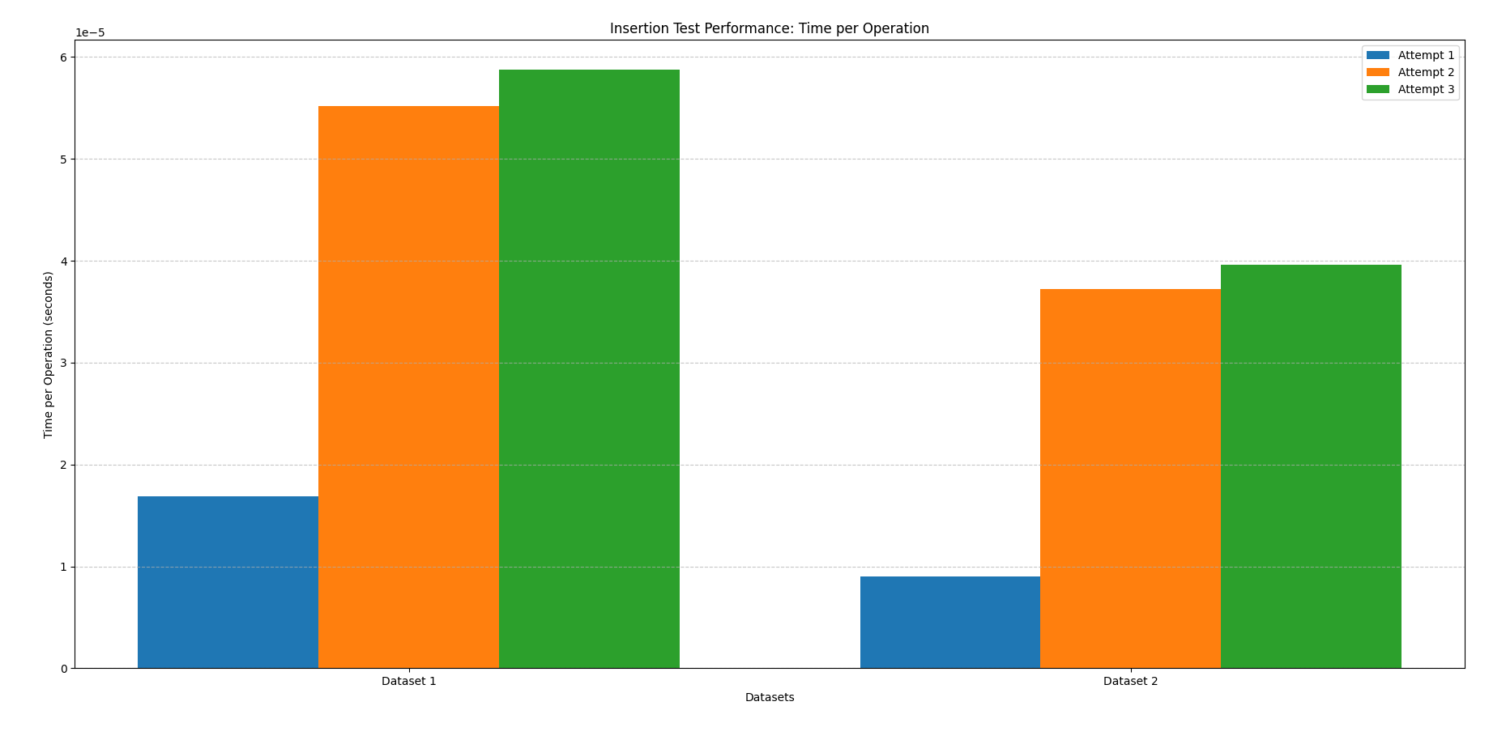 This are the data sets used for insert operation and the measurements taken, as you can see it’s fast too
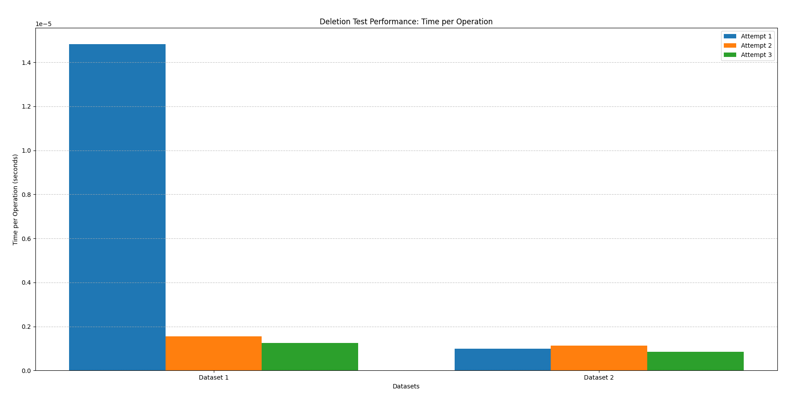.
This is the deletion test perfromance, sometimes it’s slow due to data being scattered.
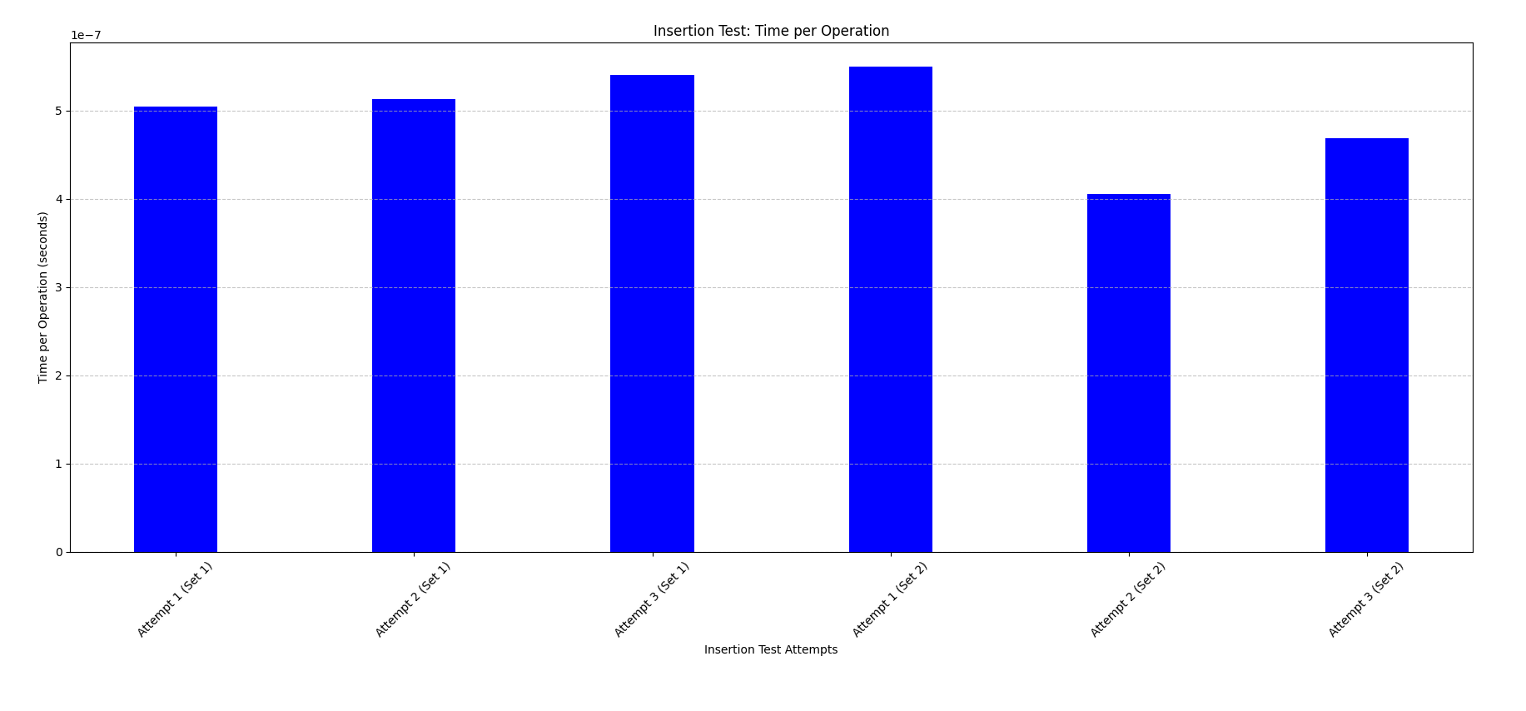This is the graph describing insertion time for Red Black Tree
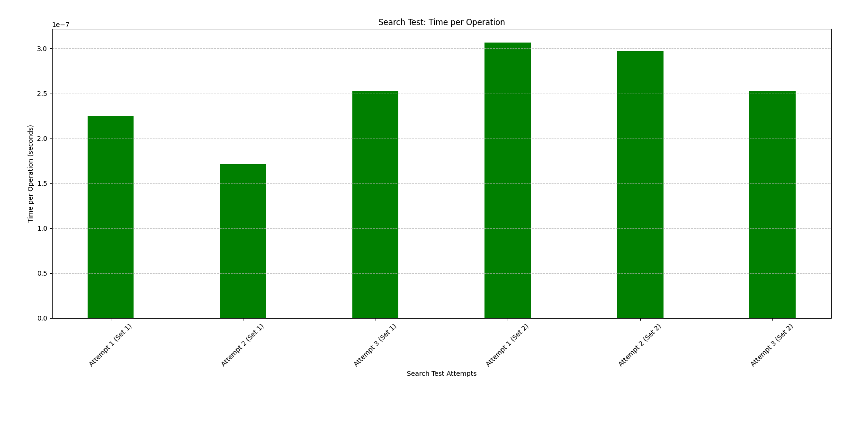 This is the graph describing search time for Red Black Tree
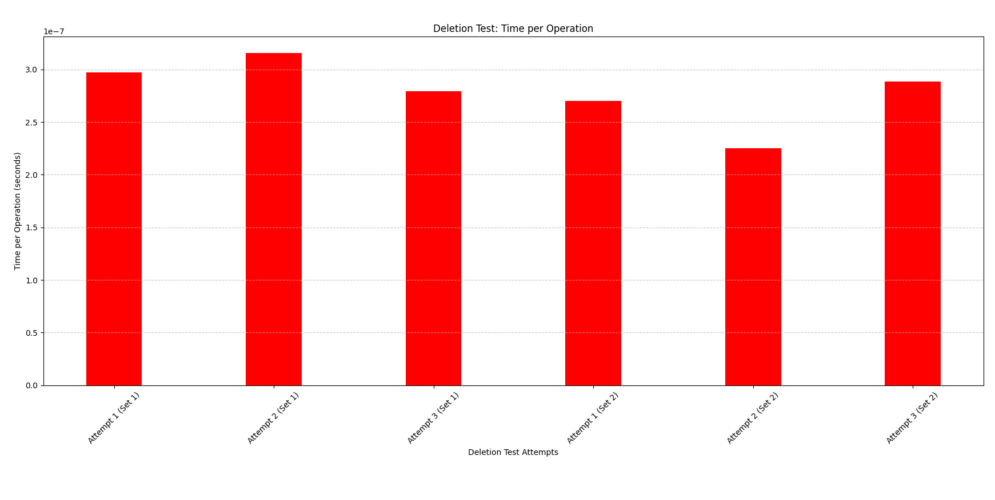
This is the graph describing deletion time for Red Black Tree

