Documentation for Assignment #1

Assignment objective:
Build a machine learning algorithm employing 2 solutions, both of which are designed to find the shortest path for NP-class problem named "Travelling Salesman Problem". First solution must utilize method of Genetic Algorithms, while second is supposed to use method of Simulated Annealing.

Genetic Algorithm
The method revolves around generating better population at every generational step.

The first phase of the aforementioned method, Population Generation, is generating a random population of individuals by calling the gen_popul function. There are 20-40 cities, i.e., genes per one program call. Each city, embodied by a set of coordinates (x, y) that creates the physical representation of it, is saved into pr_permutations_list. Physical representation is used to calculate the total length of a permutation. Inside the array with cities, while each is positioned at a certain index, their ordination forms their logical representation.

The second phase, Size Gauge, involves measurement of every permutation in the current generation and saving the data. It happens with the help of perm_plength_list, containing the path length of every permutation, and the perm_plength function, which computes each permutation's path size with the help of global logical embodiment, that is, lr_permutations_list, of every permutation and physical individual embodiment of every permutation. Moreover, general_fitness of a generation is calculated for Stochastic Universal Sampling parent selection method.

Moving to the third phase, Parent Selection. The presented solution is embedded with 2 parent selection methods: Rank Parent Selection and Stochastic Universal Sampling.
After usage of one of the provided methods, a set of parents is gleaned out of the current population using a fitness function. The fitness function computes fitness by getting the reciprocal of the length of the path of a permutation. All parents are saved into the parents array.

The fourth phase, Condition Check and Data Preservation, appends the best individual of a generation to the data_list_GA for later comparison of generations. Additionally, previous generations are checked for incidence of stagnation, using data_list_GA, in which case the program halts.

Concluding with the fifth phase, Offspring Generation, includes generating offspring and saving it. For every parent in the parents array, 10 successors are crossbred. For a parents' pair, the likelihood of them merging is 60%, using the recombine_permutations function. If they weren't fused, the parent with better fitness will be chosen as the descendant of the current pair. Then for their heir, a possibility of 0.1 - 10% is applied to it in order to deduce whether to mutate it or not, using the mutate_permutation function. Eventually, the successor is saved into the offspring array.

Permutation recombination
In the aforementioned algorithm, crossover is happening using the Edge Recombination Operator. Although there's an "operator" word inside of it, it's an algorithm that basically makes a path with no loops. It works in the following way. From each parent, a list of its immediate neighbors for each gene is created. By that I mean that for every gene in the permutation, a list of adjacent neighbors is created. Afterward it's done to both parents.
For every same gene pair in both parents, their lists are combined into sets with no repeated neighbors.
As the first step, later we choose randomly one of the parent's first genes. Then we select the neighbor of the current gene with the least amount of its neighbors. But before we move to the next iteration with it, we remove the current gene from every remaining list. We repeat the process until we encounter an empty list and choose the next gene that is not in the list of already selected genes. Eventually, when all genes are added into the crossbred permutation, the process halts.

Permutation mutation
In total, 7 methods were implemented into the code for mutation of permutations. Displacement, scramble, inversion, insertion, adjacent swap, random swap, and swap of 2 sub-arrays.
The displacement method involves extracting a sub-array out of the initial array and inserting it into a random position in the initial array. It works by randomly generating segment length, calculating segment position, and saving the segment itself using formerly mentioned variables.
Later on, it's inserted into a random constant position in the initial array in the decreasing position order of the sub-array, i.e., genes are inserted in order from the end of the list to the beginning.

Rank Parent Selection method
The main concept lies in computing fitness values of each permutation. After they're sorted inside of the array in ascending order, a rank is supplied to everyone in the list. Rank denoted fitness of an individual permutation and is given based on the fitness. The better the fitness is, the smaller rank number is. The ranks are stated from 1 to N, where N characterizes number of permutations, and lowest rank concurrently. Following that probability for each permutation is computed using formula:
$$p_{i} = \frac{2 ∙ (N − rank_{i} + 1)}{N ∙(N + 1)}$$
An array of probabilities is calculated, and later based on that array a parent is selected using generated pseudo-random value.

The graph below presents change of fitness rate for Rank Selection method used in Genetic Algorithm.
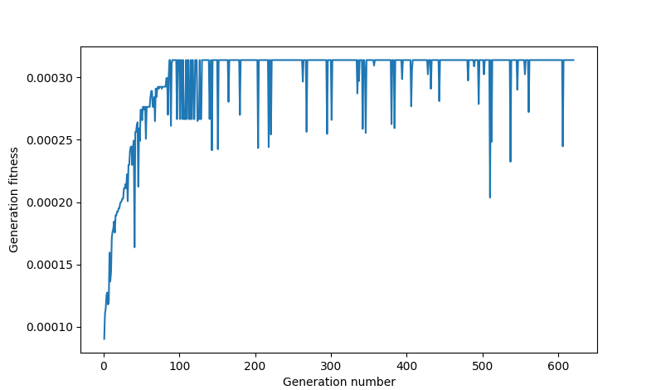
Due to the fact that Rank Selection chooses parents based on their rank, the ones situated higher in the hierarchy get a bigger probability of being selected as the next parent than ones located lower. Hence, rapid growth of fitness despite a small number of generations.
Nimble drops in fitness are just the algorithm's attempts to get better results. It's confirmed by the fact that after drops in fitness, ordinarily the next fitness is even better than previously detected ones, before the drop. And at later generations, the algorithm hits the ceiling and cannot get better despite occasional falls in fitness.

Stochastc Universal Sampling method
The main idea of the method is to assign each permutation an estimate of fitness with a certain probability.
Fundamentally, for every permutation a fitness is calculated. Later on an aggregate of them is tallied also. Following that, an array of likelihoods is refined using formula:
$$p_{i}= \frac{f_{i}}{\sum_{i = 1}^{N}{f_{i}}}$$
An array of probabilities is calculated, and later based on that array a parent is selected using generated pseudo-random value.

The graph below shows how does fitness rate change for Stochastic Universal Sampling method utilized in Genetic Algorithm.
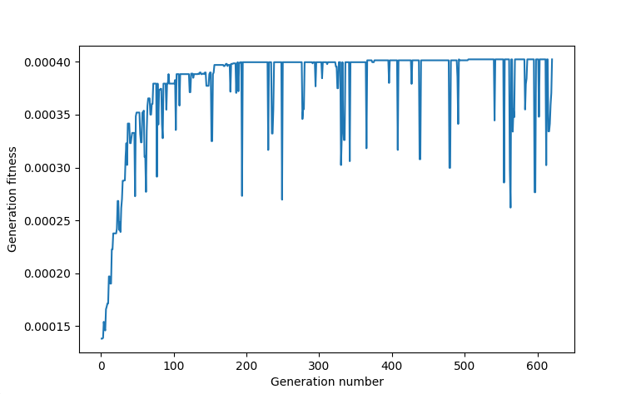
Since Stochastic Universal Sampling selection chooses parents sparingly, i.e., the best ones don't dominate the field of parents, the slope of growth isn't very steep. And the agile collapses of fitness values are stipulated by the algorithm's attempts to find better solutions, therefore not to stop in local stasis, local maximum.
On this particular graph there are 91 outlier values, and on the graph that represents Rank Selection method there are 143. It happens so because of the current method's sparing nature for parents. Since bad parents also have a chance to be chosen, it has a sloppier incline and smaller amount of abrupt changes, i.e., outliers. On the other hand, Rank Selection is less sparing; thus, only the best ones are left, and therefore it needs to have more rapid spikes, videlicet bad parents, to get out of its local maximum.

Simulated Annealing
This method, unlike the previously mentioned one, uses one individual, a permutation of genes that mutates in each generation.

The first phase, Initial Generation, comprises generating a singular random combination of genes and saving it under the best_perm name. Besides initial permutation, best_plength that embodies the size of the current permutation is calculated.

The second phase, Condition Check and Data Preservation, consists of checking whether the current generation should still run or cease to exist. Also during this phase, data is saved into data_list_SA for further research.

The third phase, Mutation and Offspring Selection, has 2 sub-parts. A mutation is performed using the mutate_permutation function, and offspring is selected using a probability saved under the sel_prob variable. The formula:

$$P = e^{\frac{−∆E}{T}}$$

$∆E$ denotes difference between $E_{new}$ and $E_{current}$, so $∆E$ = $E_{new}$ - $E_{current}$. In other words, the difference between the fitness of the current selected permutation, best_perm, and the new possible one. T denotes temperature. Temperature allows probability to decrease gradually, so worse solutions are going to be selected with smaller probability than better ones in future generations. Selected descendant is added to the data_list_SA, so it's not lost.

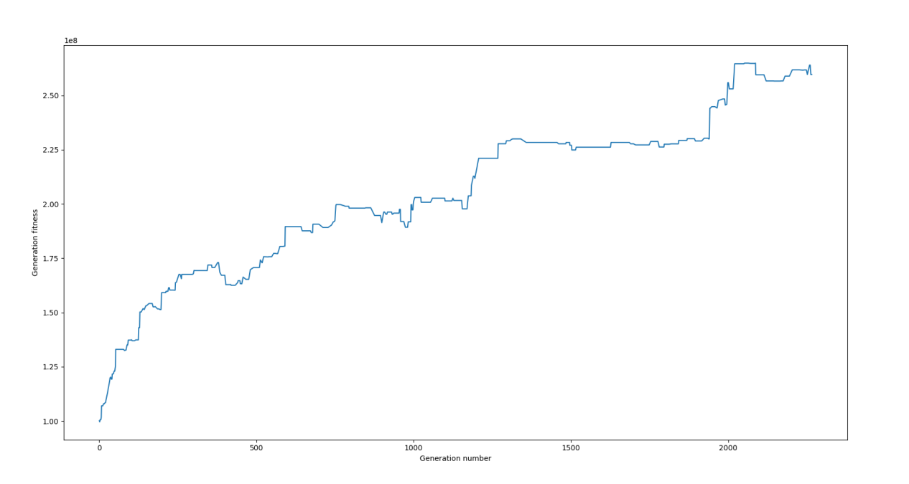
This graph represents change rate of the Simulated Annealing method. On the graph above change rate isn't rapid, because of the fact that temperature variable decreases slowly as each generation passes. Since temperature is moderately high it accepts even worse solutions, hence occasional drops in fitness. Overtime positive change, eventually, dominates the chronology.

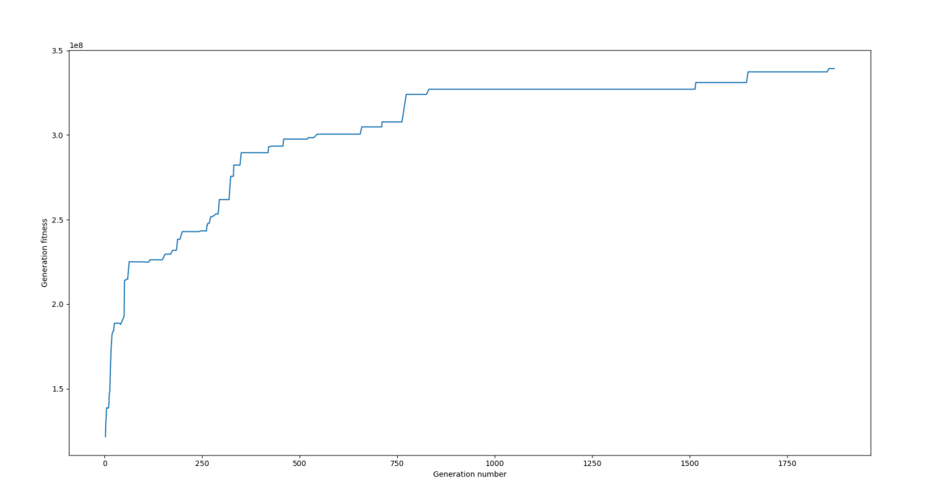
On the next image we can see a significant improvement. As a result of increasing temperature decline intensity, not only the fitness has increased but speed with which the algorithm reaches maximum increases.
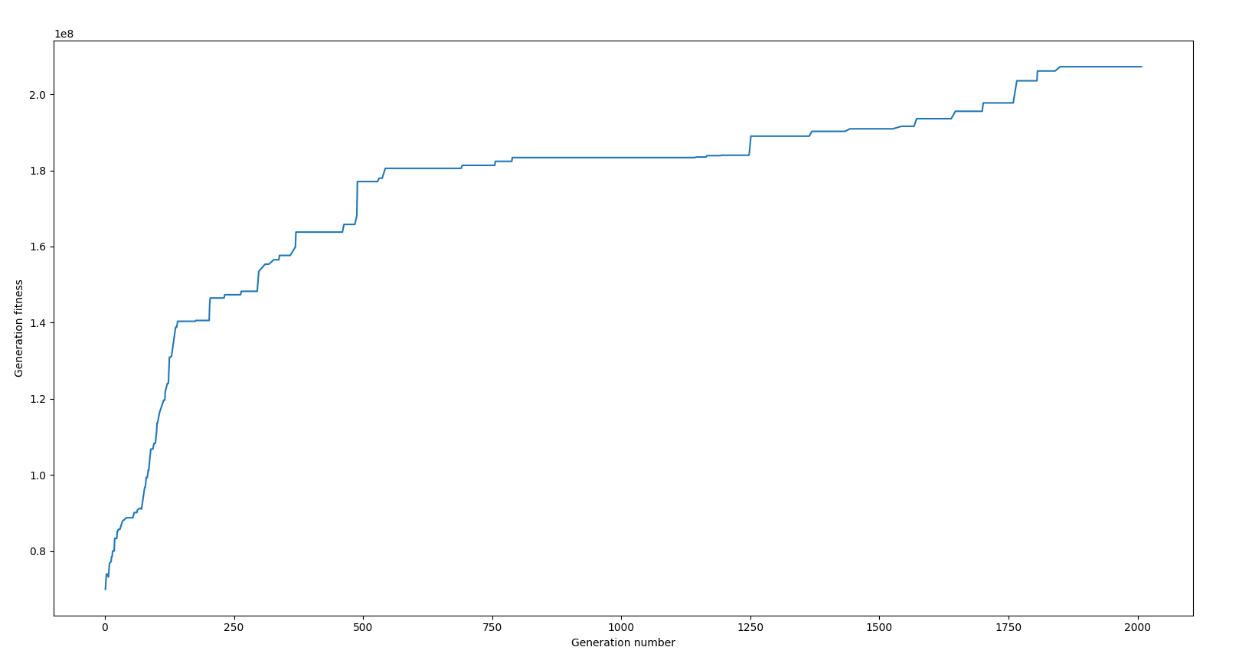
After increasing initial temperature the speed of growth has increased for a bit, and moderately growing portions of graph are still present. Albeit the temperature has increased it doesn't guarantee that algorithm will reach its global maximum.

