

Athens University of Economics and Business Department of Informatics

COURSE: PARALLEL PROGRAMMING

Spring Semester 2025‐26

ASSIGNMENT TITLE

Experimenting Different Methods for Workload Distribution with CUDA/OpenCL in C++

Name: MARAKIS MICHAIL
Semester: 6th
Email: p3230267@aueb.gr
Prof: Dr. VASILAKIS ANDREAS-ALEXANDROS

CUDA
The function I will be using for this assignment is $f\left(x\right)=x^{2}$. The GPU that these experiments are being operated is NVIDIA GeForce GTX 1650. The PC crashes when the algorithm is running for N > ${10}^{8}$. It is worth mentioning that for N = ${10}^{2}$ the integral result was 333.35 which is very close to the actual result of 333.333. Also, for ${10}^{3}$ the result is 333.334 which is even closer to the actual result, but the execution times are very low for both cases (e.g. 6.31e-05 seconds) and hard to make observations out of. As a result, the experiments are taking place with N = ${10}^{8}$ and N = ${10}^{5}$ where execution times are easier to deal with and can make clear observations.

Workload Distribution experiment

N = ${10}^{8}$
Result = 333.333

Distribution | Avg Time of Execution
1 element per thread | 0.665325
Multiple elements per thread | 0.541353

According to the results, the distribution that allows each thread to process multiple elements is more efficient than assigning one element per thread, achieving a speedup of approximately 1.23x. This improvement occurs because each thread performs more useful computation, reducing thread management overhead and improving overall GPU utilization. As a result, computational resources are used more effectively, leading to better overall performance.

N = ${10}^{5}$
Result = 333.333

Distribution | Avg Time of Execution
1 element per thread | 0.0011542
Multiple elements per thread | 0.0006744

For the same reason as when N = ${10}^{8}$, the Multiple elements per thread case is 1.7x faster than the 1 element per thread case.

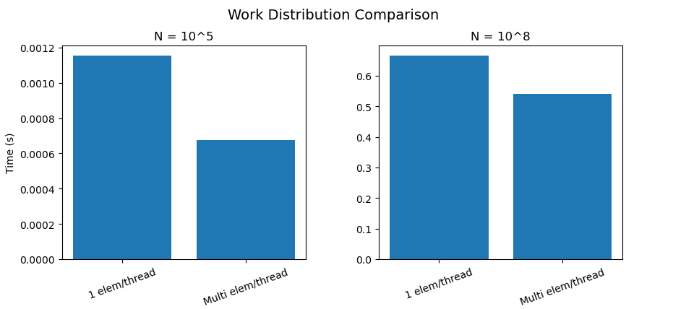
(Comparison between times for different N)

According to the graphs above, it is observable that multiple elements per thread strategy consistently outperforms the one element per thread approach. This behavior is observed for both problem sizes. However, the speedup varies with N, increasing from approximately 1.23x for N=${10}^{8}$ to 1.7x for N=${10}^{5}$.

This difference indicates that workload distribution affects performance differently depending on the problem size. For smaller N, thread management overhead becomes more significant, making the multi-element case more efficient, as it reduces the number of active threads and improves resource utilization. For larger N, both approaches achieve better GPU utilization, reducing the relative performance gap.

Different Threads per Block Experiment

N = ${10}^{8}$
Result = 333.333

Block Size | Avg Time of Execution
32 | 0.504229
64 | 0.469479
128 | 0.465583
256 | 0.484181
512 | 0.470296

From the results for N = ${10}^{8}$, it is observed that the execution time varies slightly across different block sizes. The best performance is achieved when block size=128, with the lowest average execution time. When block size = 32 or block size = 64 it is shown to have higher execution time due to increased scheduling overhead, while larger block sizes (e.g. 256 and 512) do not improve performance, due to lack of resources.

N = ${10}^{5}$
Result = 333.333

Block Size | Avg Time of Execution
32 | 0.0011016
64 | 0.0005773
128 | 0.0005694
256 | 0.0005715
512 | 0.0005722

For N = ${10}^{5}$, the execution times are generally lower, as expected due to the smaller N. The best performance is again observed when block size = 128, where the GPU achieves a good balance between resources and scheduling overhead. Apart from the worst case of block size = 32, differences between the other block sizes are smaller compared to the larger N case, indicating that for small workloads the impact of execution is less significant.

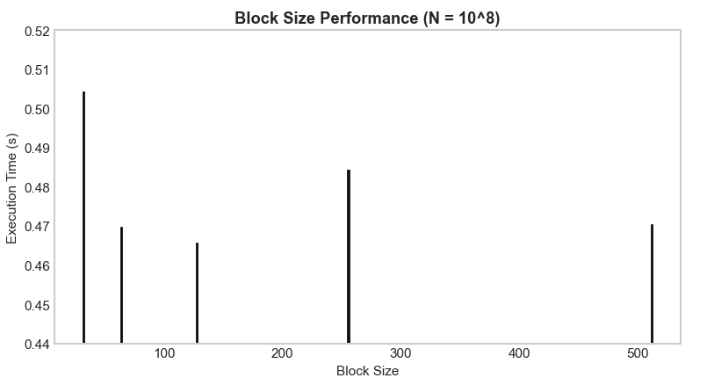
(Comparison between block sizes for N = ${10}^{8}$)

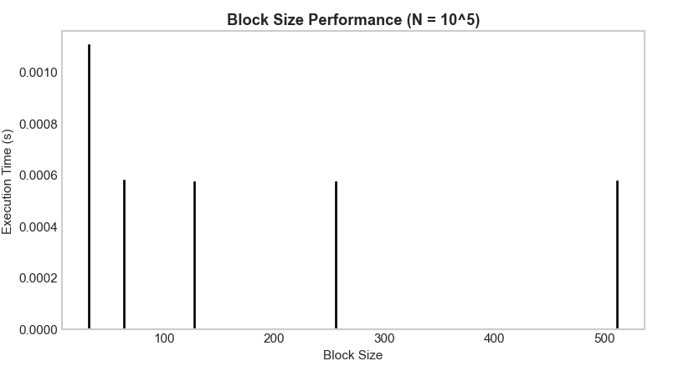
(Comparison between block sizes for N = ${10}^{5}$)

From the comparison of both graphs, it is observable that block size has a stronger impact on performance for larger values of N. For N = ${10}^{8}$, execution times vary more noticeably, while for N = ${10}^{5}$the results are more stable, except for the worst-performing case of block size = 32.

Barrier Experiment
N = ${10}^{8}$
Result = 333.333

Barrier status | Avg Time of Execution
Inactive | 0.585209
Active | 0.526852

According to the results, the case with the barrier active shows slightly faster execution time for N = 10^8, with a speedup of approximately 1.11x compared to the inactive barrier case. The difference is relatively small but still noticeable. This happens because the barrier makes all threads in a block wait until they finish their work before continuing. In this way, the work inside each block is better synchronized before writing results to global memory, in this case at the partial_sum dynamic array

N = ${10}^{5}$
Result = 333.333
Barrier status | Avg Time of Execution
Inactive | 0.0013327
Active | 0.0006022

For the same reason as the case of N = ${10}^{8}$, having an active barrier makes the algorithm more efficient. The difference here is the speedup where the active barrier case is 2.21x faster.

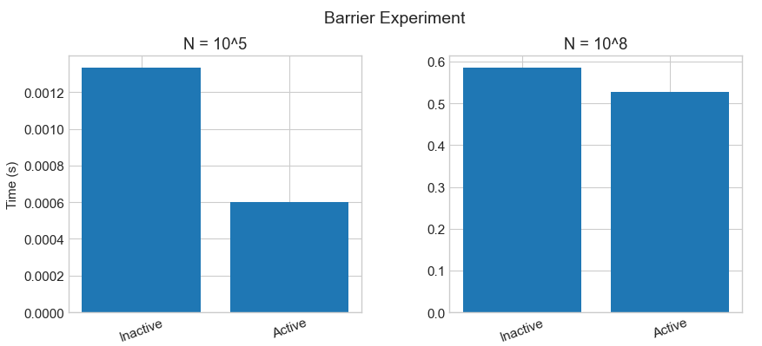
(Comparison between barrier status for different N)

From the graphs we can clearly observe the difference in execution time between the two cases. For the smaller value of N, the impact of the barrier is more noticeable, since synchronization overhead becomes more significant compared to the actual computation. For the larger N, this effect is reduced because the computation dominates the execution time, making the difference between the two cases less visible.

Different Memory Models
N = ${10}^{8}$
Result = 333.333

Memory Model | Avg Time of Execution
Registers | 0.579726
Global | 0.563278
Shared | 0.552382

N = ${10}^{5}$
Result = 333.333

Memory Model | Avg Time of Execution
Registers | 0.0010704
Global | 0.0010199
Shared | 0.0010658

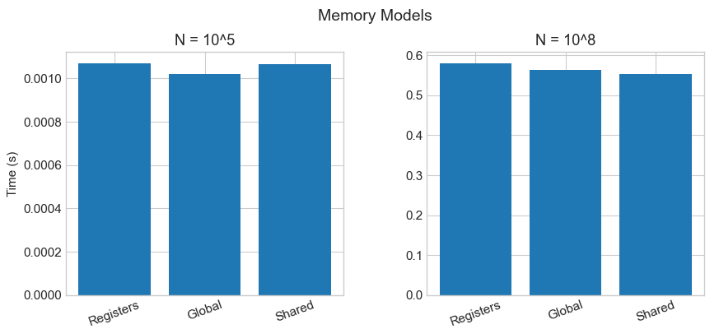
(Comparison between memory models for different N)

