

Athens University of Economics and Business Department of Informatics

COURSE: PARALLEL PROGRAMMING

Spring Semester 2025‐26

ASSIGNMENT TITLE

Experimenting Different Methods for Workload Distribution with OpenMP in C++

Name: MARAKIS MICHAIL
Semester: 6th
Email: p3230267@aueb.gr
Prof: Dr. VASILAKIS ANDREAS-ALEXANDROS

TABLE OF CONTENTS
Περιεχόμενα
1 Introduction 3
1.1 Setup 3
1.2 Compile and run 3
1.3 The Problem 3
1.4 Integrals to compute 4
2 Parallelism with Loop 6
2.1 With Reduction 6
2.1.1 Experiment Results 6
2.1.2 Experiment Observations 7
2.2 Without Reduction 7
2.2.1 Experiment Results 8
2.2.1 Experiment Observations 9
2.3 Reduction Vs No Reduction 9
3 Alternative Routing 10
3.1 Static Routing 10
3.1.1 Experiment Results 10
3.1.2 Experiment Observations 13
3.2 Dynamic Routing 13
3.2.1 Experiment Results 13
3.2.2 Experiment Observations 16
3.3 Guided Routing 16
3.3.1 Experiment Results 16
3.3.2 Experiment Observations 19
3.4 Static Vs Dynamic Vs Guided 19
4 Task-Based Parallelism 19
4.1 With Recursion 19
4.1.1 Experiment Results 19
4.1.2 Experiment Observations 19
4.2 Without Recursion 19
4.2.1 Experiment Results 19
4.2.2 Experiment Observations 19
4.3 Recursion Vs No Recursion 19
5 General Observations 19
6 Threads Vs OpenMP 19

1 Introduction
The second assignment in this Parallel Programming course focuses on the use of OpenMP in C++ for the parallelization of numerical integration. More specifically, it involves the implementation and evaluation of different workload distribution strategies in an integral computation application. These approaches include parallelization using loops (with and without reduction), different scheduling policies (static, dynamic, and guided), and task-based parallelism using OpenMP tasks.
The goal is to analyze their performance and determine the most efficient approach under different workload conditions. The integral method on which these methods are tested is the Trapezoidal Rule for numerical integration:

𝑏
∫ 𝑓(𝑥)𝑑𝑥 ≈ ^{ℎ} [𝑓(𝑎) + 𝑓(𝑏) + 2
2
𝑎
𝑛−1
∑ 𝑓(𝑎 + 𝑖ℎ)], ℎ = (𝑏 − 𝑎)/𝑛
𝑖 = 1

Setup

Metrics were conducted on the following system:

Computer | Processor | Cores | Compiler | O.S.
DESKTOP-M U9QIDD | Intel i5 vPro 8th Gen | 4 | gcc v15.2.0 | Windows 11

Compile and run

First find the name of the file(file_name) where the code is and run this command to compile:
g++ -std=c++17 -fopenmp <file_name>.cpp -o <file_name>

After a successful compilation an .exe file has been created. To run it use the command:
.\<file_name>.exe

The Problem

The problem is based on approximating an integral using the Riemann sum approach, specifically through the Trapezoidal Rule. According to the definition of the Riemann integral, the continuous space [a,b] is divided into many small
subspaces of width ^{𝑏−𝑎} , and the integral is approximated as the sum of the
ℎ =
𝑁
function values over these subspaces. As the number of subspaces increases(
𝑁 → ∞) the approximation becomes more accurate and converges to the exact

value of the integral. In the Trapezoidal Rule, the area is approximated using trapezoids instead of rectangles, providing better accuracy. This formulation makes the problem very suitable for parallelization, since each part of the sum is independent and can be computed by different threads, theoretically allowing faster execution compared to the sequential approach.
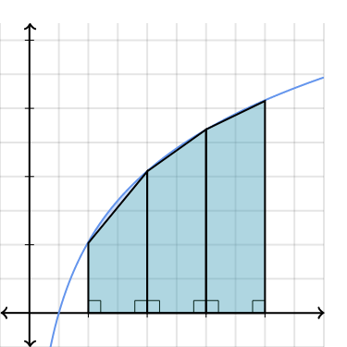
(Application of the Trapezoid Riemann Integral)

Integrals to compute

The functions i chose for this assignment are
2
−𝑥 2
² To begin

𝑒 , 𝑐𝑜𝑠(𝑥 ) 𝑎𝑛𝑑 𝑥 .
with, the function 𝑥 at [0.0, 10.0] is simple and computationally lightweight. As we
2
can see from the graph, it is very easy to understand how the Trapezoid Rieman integral works and how the threads will be used in order to compute it. The
2
−𝑥
Gaussian Function, 𝑒 , introduces computational cost due to the exponential
operation while also providing a well-defined and symmetric shape over the interval [-10.0, 10.0] due to it being symmetrical around the y-axis. This makes it useful for

analyzing numerical integration in general. Lastly
2
𝑐𝑜𝑠(𝑥 )
at [-50.0, 50.0] is more

computationally demanding because of the trigonometric calculation while also exhibiting more complex behavior, making it a good test case for evaluating performance under more challenging conditions. Because of its complex behaviour, an extra experiment will be demonstrated on this function. This extra experiment will be on changing the N(number of subspaces) and we will see how the time of

execution changes, the accuracy of the integral and how the threads are behaving with different N. Taking all the above into consideration, these functions differ in terms of computational complexity, smoothness, and graphical behavior making the evaluation of performance of workload distribution methods using threads more comprehensive and interesting. Below, the graphs of the functions that will be used can be seen visually.

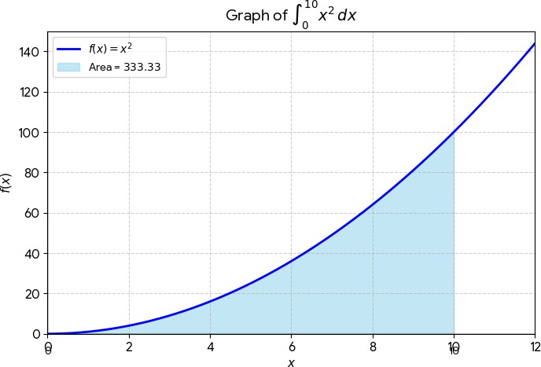

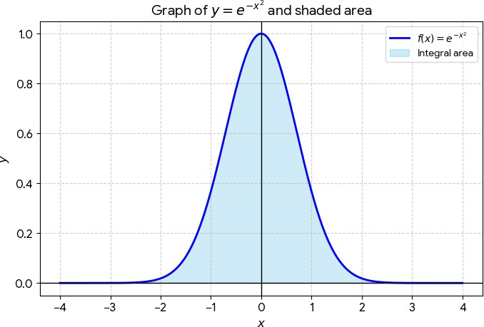

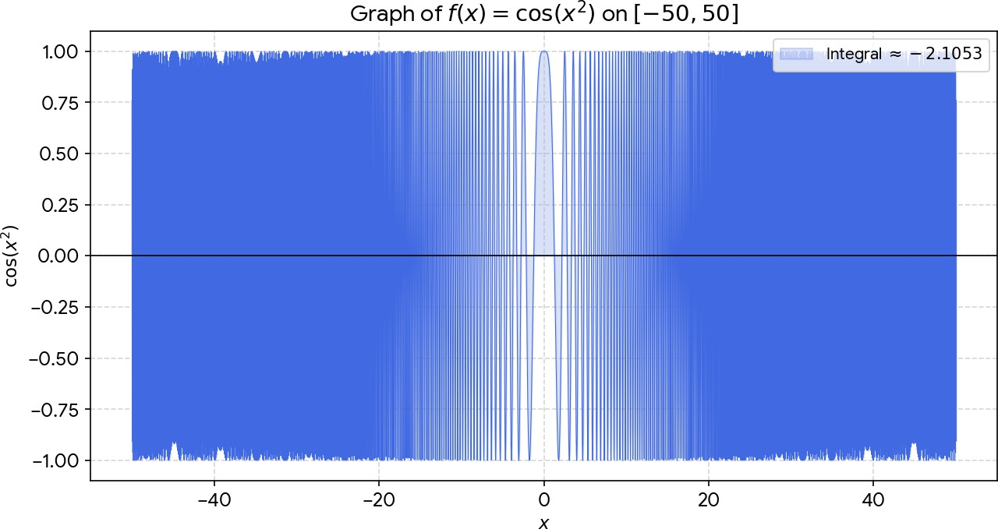

2 Parallelism with Loop

The main idea when we try to implement Parallelism with Loop is that we take a hard to compute loop and distribute its iterations among multiple threads, so that they execute the loop concurrently and not sequentially. This is achieved using the #pragma omp for command, which automatically divides the iterations of a loop across the available threads in a parallel region. Each thread is assigned to a subset of iterations and executes them independently. It must be mentioned that all threads must complete their assigned work before the program continues, as there is an implicit synchronization barrier at the end of the loop.
OpenMP follows a fork-join model, where a master thread creates a team of threads when entering a parallel region, and these threads collaborate to execute the loop in parallel. After completing their work, the threads synchronize and the program continues sequentially.

2.1 With Reduction
With reduction, OpenMP provides a built-in mechanism to safely combine results from all threads. Each thread works with a private copy of the variable, which is automatically initialized and updated independently. At the end of the parallel loop, all partial results are combined into the final value using the specified operation (e.g., sum). In this implementation, this is achieved using the reduction(+:sum) command in the #pragma omp parallel for. Also, the number of threads is declared in the same line of command. Each thread computes its own partial contribution to the integral and stores it in a private copy of sum. After the loop finishes, OpenMP automatically combines all partial sums into the result, eliminating the need for explicit synchronization such as critical sections that must be used when we don’t use reduction.
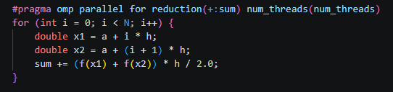

2.1.1 Experiment Results

Results are calculated in seconds

2
Computing the integral of
𝑓(𝑥) = 𝑥 𝑎𝑡 [𝑎 : 0. 0, 𝑏 : 10. 0]
N = 100000000
Result= 333.333

Threads | first run | second run | third run | fourth run | fifth run | average
1 | 0.535975 | 0.543268 | 0.541957 | 0..563139 | 0.541037 | 0.545075
2 | 0.319855 | 0.283923 | 0.327597 | 0.270113 | 0.314848 | 0.303267
4 | 0.1877 | 0.180355 | 0.201397 | 0.187932 | 0.180318 | 0.18754
6 | 0.153006 | 0.141563 | 0.146986 | 0.139907 | 0.148152 | 0.145923
8 | 0.131853 | 0.116673 | 0.122732 | 0.122827 | 0.121278 | 0.123073

Total average: 0.260976
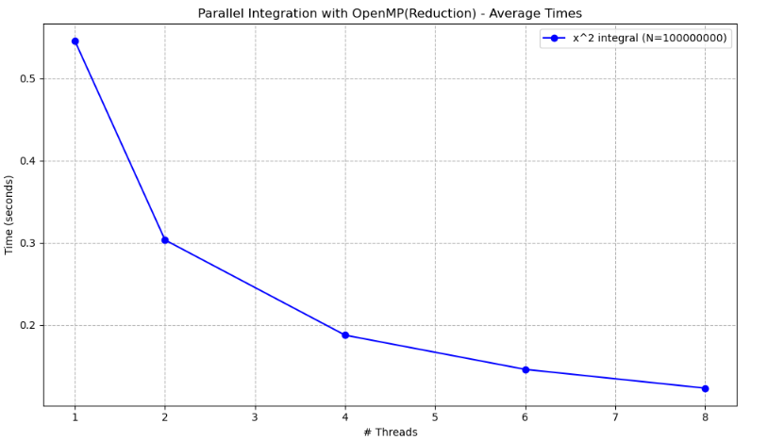

2.1.2 Experiment Observations
The results show that as the number of threads increases, the execution time decreases. The program becomes significantly faster when moving from 1 to 2 and then to 4 threads. However, after 4–6 threads, the improvement becomes smaller. The difference between 6 and 8 threads is quite small. This happens because the computer used for these experiments has 4 cores. As a result, when using more than 4 threads, a form of “pseudo-parallelism” is created rather than true parallel execution. The best result is achieved with 8 threads, but the gain is limited due to the hardware constraint that is mentioned.

2.2 Without Reduction

In loop parallelization without using the reduction clause, each thread computes a part of the loop independently, but shared variables must be handled carefully. If multiple threads update the same variable, this can lead to race conditions. To avoid this, synchronization mechanisms are used. In this implementation, this is achieved using a private variable (local_sum) inside the parallel region, where each thread stores its own partial result. The workload is distributed using #pragma omp for, while the parallel region is created with #pragma omp parallel firstprivate(h, a) num_threads(num_threads).
On the one hand, the firstprivate(h, a) command ensures that each thread receives its own private copy of the variables h and a, initialized with the same values as in the main thread. On the other hand, the num_threads(num_threads) command explicitly sets the number of threads that will be used in the parallel region. This allows the programmer to use and experiment with as many threads as he wants. After the loop execution, the partial sums are combined into the global variable sum using a #pragma omp critical command, ensuring correct synchronization between threads.

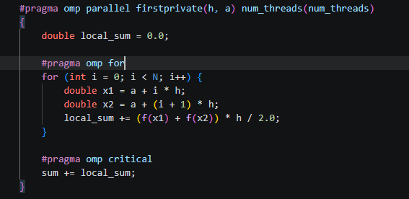

2.2.1 Experiment Results

Results are calculated in seconds

2
Computing the integral of
𝑓(𝑥) = 𝑥 𝑎𝑡 [𝑎 : 0. 0, 𝑏 : 10. 0]
N = 100000000
Result= 333.333

Threads | first run | second run | third run | fourth run | fifth run | average
1 | 0.534718 | 0.537042 | 0.541987 | 0.540844 | 0.539062 | 0.538731
2 | 0.303505 | 0.274507 | 0.288936 | 0.282304 | 0.287401 | 0.287331
4 | 0.176549 | 0.178923 | 0.181634 | 0.186726 | 0. 162804 | 0.177327
6 | 0.140042 | 0.141892 | 0.151363 | 0.154398 | 0.148143 | 0.147168
8 | 0.118858 | 0.127222 | 0.122707 | 0.12144 | 0.118666 | 0.121779

Total average: 0.254467
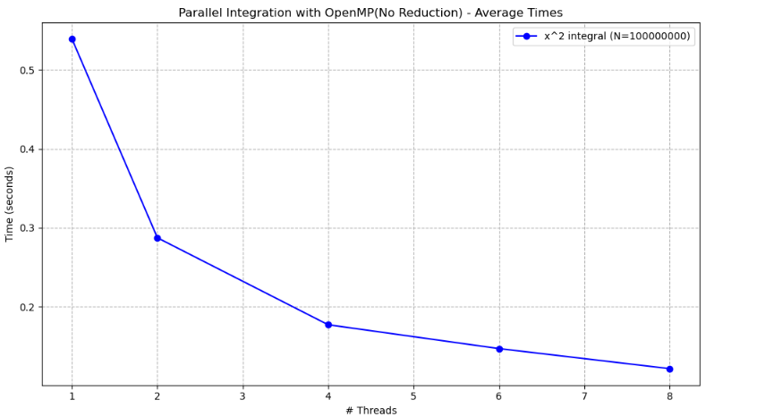

2.2.1 Experiment Observations

The results show that as the number of threads increases, the execution time decreases. The program becomes significantly faster when moving from 1 to 2 and then to 4 threads. However, after 4–6 threads, the improvement becomes smaller. The difference between 6 and 8 threads is relatively small. This behavior is like the previous case, even though a different form of parallelism is used. The reason is that the computer used for these experiments has 4 cores, so using more than 4 threads does not provide true parallelism. Instead, threads must share the available cores. The best performance is achieved with 8 threads, but the improvement is limited due to the hardware constraint.

2.3 Reduction Vs No Reduction

# Threads | Reduction | No Reduction
1 | 0.545075 | 0.538731
2 | 0.303267 | 0.287331
4 | 0.18754 | 0.177327
6 | 0.145923 | 0.147168
8 | 0.123073 | 0.121779

As we can observe from the results, parallelization without using reduction is slightly faster in most cases for different numbers of threads, except when 6 threads are used, where the version using reduction is a little bit faster. Overall, the performance differences between the two methods are very small, and in practice there is almost no noticeable difference when computing this simple integral.

3 Alternative Routing

Alternative routing in OpenMP refers to the different ways loop iterations can be distributed among threads to improve load balancing and performance. Instead of using a fixed distribution, OpenMP allows control over how the work is assigned during execution. The scheduling methods are static, dynamic, and guided, where each method determines differently how iterations are divided and given to threads.
An important parameter in those methods is the chunk size, which defines how many iterations are assigned to a single thread each time. By adjusting the chunk size, it is possible to control how frequently work is distributed among threads,

3.1 Static Routing

In OpenMP, static scheduling divides the loop iterations into fixed-size chunks and assigns them to threads in a predefined way. In schedule(static, chunk_size), each thread receives blocks of chunk_size iterations until all iterations are distributed. If no chunk size is given, the iterations are split approximately equally between the threads, so each thread gets about $\frac{N }{P}$ iterations. In the code that is shown below, static scheduling is used in #pragma omp parallel for reduction(+:sum) schedule(static, 1000), where each thread processes chunks of 1000 iterations of the integration loop. Since all threads contribute to the shared variable sum, synchronization is required to avoid race conditions. In this case, this is done using the reduction(+:sum) command instead of using a local_sum variable and a critical section (no reduction), because it is simpler in terms of syntax and automatically handles the correct combination of partial results.

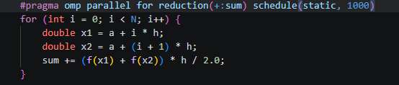

3.1.1 Experiment Results

Results are calculated in seconds

2
Computing the integral of
𝑓(𝑥) = 𝑥 𝑎𝑡 [𝑎 : 0. 0, 𝑏 : 10. 0]
N = 100000000
Result= 333.333
Chunk size = 1

Threads | first run | second run | third run | fourth run | fifth run | average
1 | 0.785 | 0.654323 | 0.708377 | 0.683581 | 0.743215 | 0.714899
2 | 0.418368 | 0.425268 | 0.411131 | 0.423902 | 0.38301 | 0.412336
4 | 0.289918 | 0.304908 | 0.265493 | 0.327692 | 0.299944 | 0.297591
6 | 0.254818 | 0.275013 | 0.269772 | 0.28465 | 0.298532 | 0.276557
8 | 0.232346 | 0.213953 | 0.374451 | 0.213261 | 0.241066 | 0.255015

Total average: 0.39128

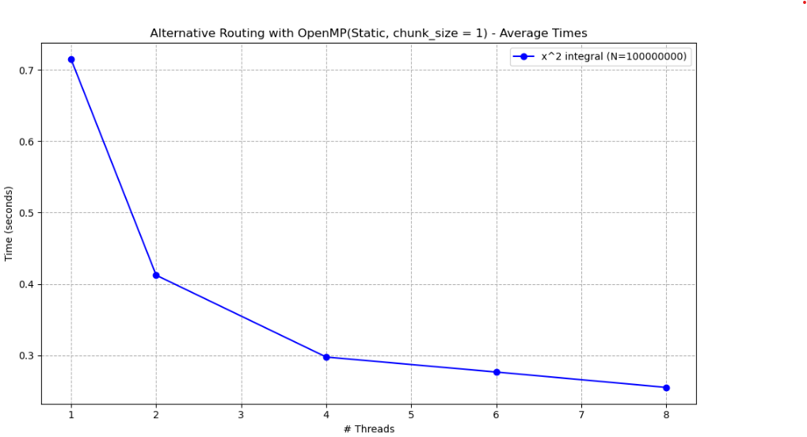

2
Computing the integral of
𝑓(𝑥) = 𝑥 𝑎𝑡 [𝑎 : 0. 0, 𝑏 : 10. 0]
N = 100000000
Result= 333.333
Chunk size = 100

Threads | first run | second run | third run | fourth run | fifth run | average
1 | 0.54968 | 0.546788 | 0.545181 | 0.549388 | 0.545972 | 0.547402
2 | 0.273938 | 0.275855 | 0.273639 | 0.281674 | 0.289894 | 0.279
4 | 0.176818 | 0.163923 | 0.161599 | 0.215454 | 0.181894 | 0.179938
6 | 0.146435 | 0.138716 | 0.151401 | 0.150566 | 0.136785 | 0.144781
8 | 0.137201 | 0.121929 | 0.124733 | 0.133827 | 0.128536 | 0.129245

Total average: 0.256073
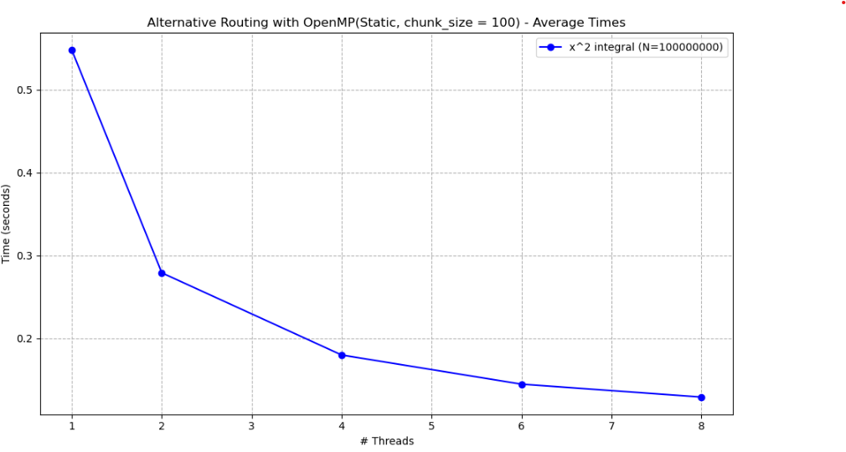

2
Computing the integral of
𝑓(𝑥) = 𝑥 𝑎𝑡 [𝑎 : 0. 0, 𝑏 : 10. 0]
N = 100000000
Result= 333.333
Chunk size = 1000

Threads | first run | second run | third run | fourth run | fifth run | average
1 | 0.538596 | 0.539211 | 0.539082 | 0.539604 | 0.541547 | 0.539608
2 | 0.279941 | 0.279149 | 0.273886 | 0.2786 | 0.277884 | 0.277892
4 | 0.18753 | 0.164446 | 0.175933 | 0.17797 | 0.166316 | 0.174439
6 | 0.147556 | 0.144587 | 0.142535 | 0.139284 | 0.142535 | 0.143299
8 | 0.121948 | 0.119946 | 0.11992 | 0.121915 | 0.123303 | 0.121406

Total average: 0.251329

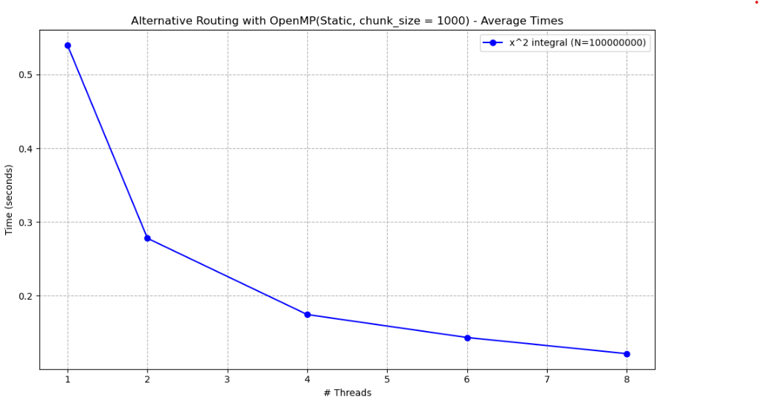

3.1.2 Experiment Observations

3.2 Dynamic Routing

Dynamic scheduling divides the loop iterations into chunks of a given size and assigns them to threads during execution. With schedule(dynamic, chunk_size), each thread receives chunk_size iterations, and as soon as it finishes its work, it dynamically takes the next available chunk until all iterations are completed. Unlike static scheduling, the distribution is not fixed at the beginning, which helps balance the load when iterations do not have the same computational cost. It is important to note that this has nothing to do with the “dynamic mode” of the number of threads. In the code that is shown in the photo below, dynamic scheduling would appear as #pragma omp parallel for reduction(+:sum) schedule(dynamic, 1000), where each thread processes chunks of 1000 iterations of the integration loop. It is important to mention that synchronization is still needed for the shared variable sum using reduction(+:sum) to avoid race conditions.

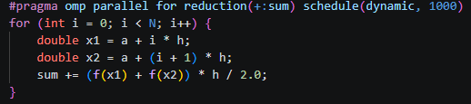

3.2.1 Experiment Results

Results are calculated in seconds

Computing the integral of 𝑓(𝑥) = 𝑥2 𝑎𝑡 [𝑎 : 0. 0, 𝑏 : 10. 0]
N = 100000000
Result= 333.333
Chunk size = 1

Threads | first run | second run | third run | fourth run | fifth run | average
1 | 8.06953 | 10.5563 | 6.60443 | 5.97784 | 6.35724 | 7.51307
2 | 5.17995 | 5.39077 | 5.55554 | 5.59469 | 5.46938 | 5.43807
4 | 3.87967 | 4.24927 | 4.01909 | 3.96071 | 4.22978 | 4.0677
6 | 3.91885 | 3.95963 | 4.31582 | 3.98656 | 3.97378 | 4.03093
8 | 3.75392 | 4.15736 | 3.84549 | 4.20095 | 3.83267 | 3.95808

2
Total average: 5.00157

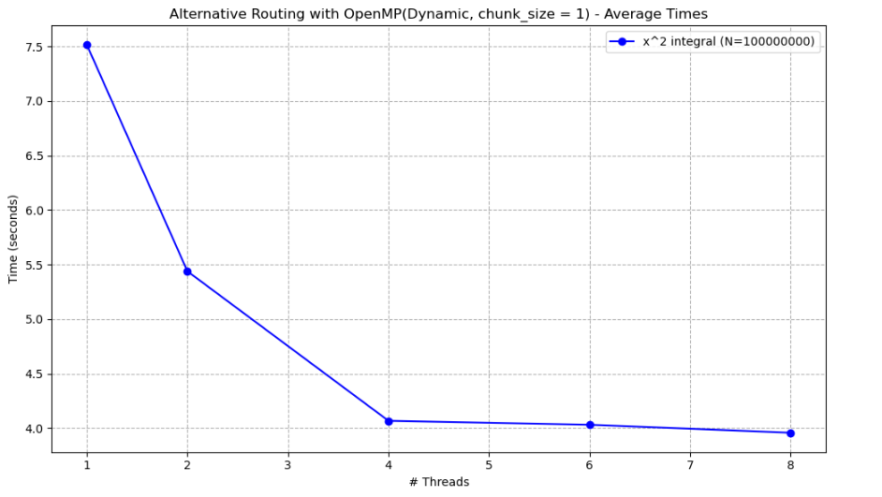

Computing the integral of 𝑓(𝑥) = 𝑥2 𝑎𝑡 [𝑎 : 0. 0, 𝑏 : 10. 0]
N = 100000000
Result= 333.333
Chunk size = 100

Threads | first run | second run | third run | fourth run | fifth run | average
1 | 0.573667 | 0.576336 | 0.581015 | 0.635688 | 0.579288 | 0.589199
2 | 0.310537 | 0.307244 | 0.308659 | 0.322865 | 0.318479 | 0.313557
4 | 0.178383 | 0.176179 | 0.161395 | 0.172578 | 0.17515 | 0.172737
6 | 0.151743 | 0.144352 | 0.150329 | 0.152488 | 0.150152 | 0.149813
8 | 0.136154 | 0.14439 | 0.130489 | 0.135459 | 0.131022 | 0.135503

Total average: 0.272162

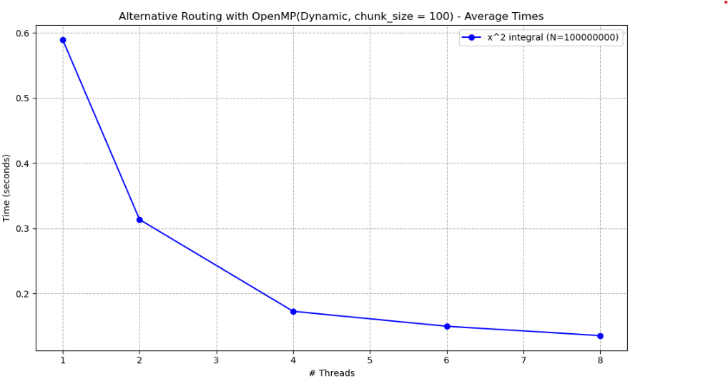

Computing the integral of 𝑓(𝑥) = 𝑥2 𝑎𝑡 [𝑎 : 0. 0, 𝑏 : 10. 0]
N = 100000000
Result= 333.333
Chunk size = 1000

Threads | first run | second run | third run | fourth run | fifth run | average
1 | 0.541176 | 0.541415 | 0.582365 | 0.564643 | 0.541209 | 0.554162
2 | 0.273723 | 0.278401 | 0.274127 | 0.279618 | 0.279394 | 0.277053
4 | 0.160518 | 0.150994 | 0.159085 | 0.161814 | 0.153581 | 0.157198
6 | 0.134024 | 0.15027 | 0.13275 | 0.132215 | 0.156617 | 0.141175
8 | 0.151375 | 0.147285 | 0.121537 | 0.124544 | 0.123238 | 0.133596

Total average: 0.252637

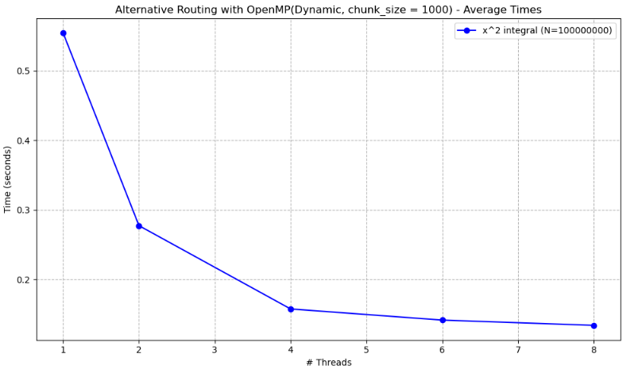

3.2.2 Experiment Observations

3.3 Guided Routing

Guided scheduling is like dynamic scheduling, but the size of the chunks changes during execution. With schedule(guided, chunk_size), each thread receives a chunk of iterations, and after finishing it, it takes another one whose size is calculated based on the remaining work. At the beginning, the chunks are large, and as the loop progresses, they become exponentially smaller to better balance the workload. The chunk size is always at least equal to the specified minimum value but never goes below the specified minimum chunk_size. In the code, this would appear #pragma omp parallel for reduction(+:sum) schedule(guided, 1000), where threads process chunks of the integration loop that gradually decrease in size until all iterations are completed. As in the other cases, synchronization is still required for the shared variable sum, which is handled using reduction(+:sum) to ensure correct results without race conditions.

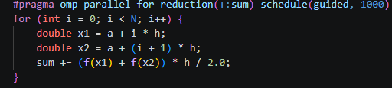

3.3.1 Experiment Results

Results are calculated in seconds

Computing the integral of 𝑓(𝑥) = 𝑥2 𝑎𝑡 [𝑎 : 0. 0, 𝑏 : 10. 0]
N = 100000000
Result= 333.333
Chunk size = 1

Threads | first run | second run | third run | fourth run | fifth run | average
1 | 0.729637 | 0.795279 | 0.822679 | 0.85782 | 0.836284 | 0.80834
2 | 0.403537 | 0.394573 | 0.411157 | 0.433361 | 0.414469 | 0.411419
4 | 0.281956 | 0.273901 | 0.302483 | 0.262564 | 0.256225 | 0.275426
6 | 0.243043 | 0.230116 | 0.222632 | 0.223101 | 0.21654 | 0.227086
8 | 0.207453 | 0.204238 | 0.205822 | 0.203021 | 0.198261 | 0.203759

Total average: 0.385206

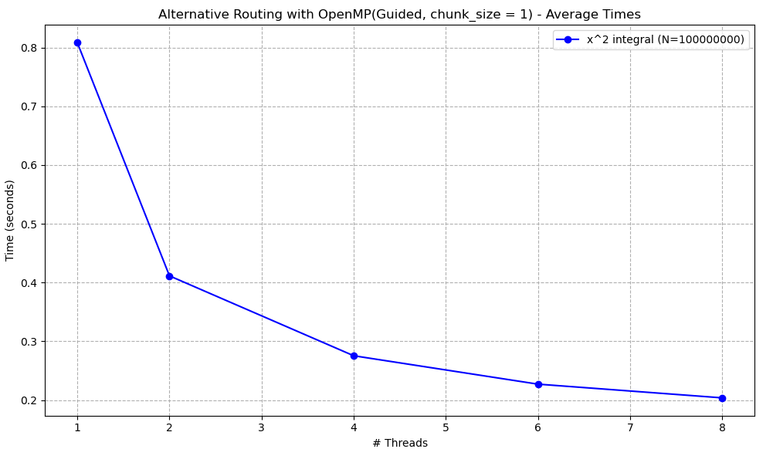

Computing the integral of 𝑓(𝑥) = 𝑥2 𝑎𝑡 [𝑎 : 0. 0, 𝑏 : 10. 0]
N = 100000000
Result= 333.333
Chunk size = 100

Threads | first run | second run | third run | fourth run | fifth run | average
1 | 0.539167 | 0.53575 | 0.544397 | 0.538611 | 0.541998 | 0.539985
2 | 0.284938 | 0.27936 | 0.283523 | 0.27942 | 0.293169 | 0.284082
4 | 0.154112 | 0.165075 | 0.179073 | 0.163578 | 0.155947 | 0.163557
6 | 0.141815 | 0.134182 | 0.140199 | 0.142746 | 0.140131 | 0.139815
8 | 0.12565 | 0.119367 | 0.125451 | 0.119364 | 0.124157 | 0.122798

Total average: 0.250047

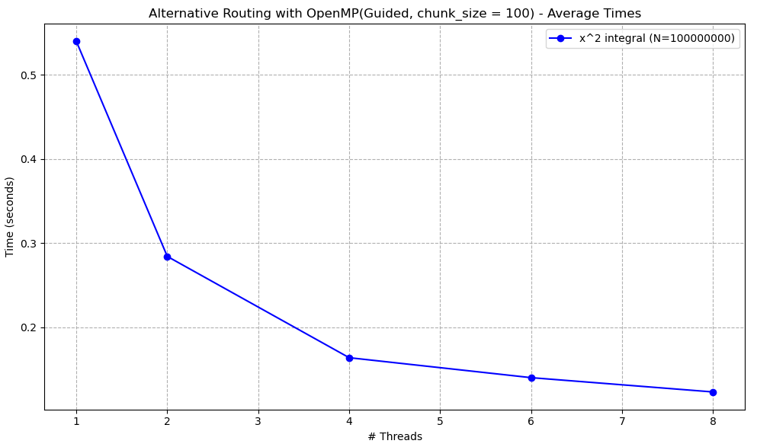

Computing the integral of 𝑓(𝑥) = 𝑥2 𝑎𝑡 [𝑎 : 0. 0, 𝑏 : 10. 0]
N = 100000000
Result= 333.333
Chunk size = 1000

Threads | first run | second run | third run | fourth run | fifth run | average
1 | 0.539532 | 0.539392 | 0.535797 | 0.538039 | 0.536994 | 0.537951
2 | 0.278088 | 0.289477 | 0.272096 | 0.276073 | 0.291029 | 0.281353
4 | 0.155457 | 0.159415 | 0.159449 | 0.17047 | 0.160283 | 0.161015
6 | 0.135887 | 0.129998 | 0.13231 | 0.128907 | 0.132743 | 0.131969
8 | 0.118712 | 0.118581 | 0.1202 | 0.118815 | 0.12131 | 0.119524

Total average: 0.246362
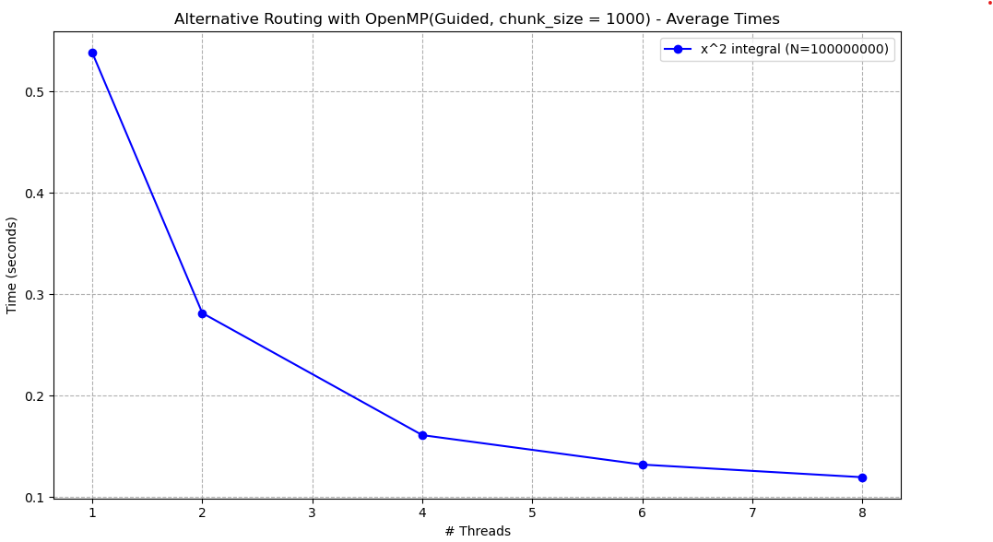

3.3.2 Experiment Observations

3.4 Static Vs Dynamic Vs Guided

4 Task-Based Parallelism

Task-based parallelism in OpenMP refers to the definition of independent units of work (tasks) that are executed by threads. Instead of distributing loop iterations, this method allows the programmer to define tasks that represent work to be done at some point during execution, not necessarily immediately or by the thread that created them. This provides more flexibility and is useful in applications where the workload is irregular or not known in advance.
An important aspect of this OpenMP method is that each task includes both the code to be executed and the data it operates on. As a result, it carries the values of its variables at the time of its creation. Task execution is separated into two phases: creation (packaging of code and data) and execution by a thread. Tasks are scheduled dynamically among threads, and synchronization between them can be controlled using mechanisms such as #pragma omp taskwait, ensuring correct program execution.

With Recursion

4.1.1 Experiment Results

4.1.2 Experiment Observations

Without Recursion

4.2.1 Experiment Results

4.2.2 Experiment Observations

Recursion Vs No Recursion

5 General Observations

6 Threads Vs OpenMP

