Assignment 2: Dashboard (Evaluation of Amazon Prime Video Content Distribution)
Name: Ebrahim Haque Bhatti

Table of Contents
Business Requirements 3
Understanding and preparing data 5
1. Characteristics of Data and Summary Statistics about Variables 5
2. Initial Data Cleaning and Transformations 6
Dashboard Screen 10
Publicly accessible link to the Dashboard 10
Alarm Metrics 10
Review 1 12
Review 2 13

Business Requirements
1. Business Problems Based on the Data: Content Library Composition and Strategy Challenges in a Streaming Platform
The dataset reflects a streaming-content catalog, where each row represents a movie or TV show and includes attributes such as type, release year, rating, country, duration, and genre classification. In the streaming industry, one of the main business challenges is understanding whether the content library is balanced, diverse, and aligned with audience demand.
Based on this data, the main business problem is that the platform needs to understand the composition of its content library across several dimensions: content type, genres, ratings, geography, and release timeline. Without this visibility, it becomes difficult to assess whether the library is overly concentrated in a few genres, skewed toward one audience segment, limited in regional diversity, or reliant on older content.
A second business problem concerns content strategy. Streaming platforms compete by curating libraries that attract and retain subscribers. The platform, therefore, needs to know whether it has the right mix of movies versus TV shows and whether its ratings profile fits its target audience to keep the catalog relevant.
2. Content Strategy Objectives: Composition and Diversity
The main business goals are:
- Understand the composition of the content library by measuring total titles and the split between movies and TV shows.
- Assess genre concentration and content diversity to identify which genres dominate the catalog and where there may be underrepresentation.
- Evaluate audience targeting through content ratings to understand whether the platform is more focused on family-friendly, teen, or mature audiences.
3. Identify the key questions that the dashboard should answer
The dashboard should answer the following key business questions:
- What is the overall composition of the Amazon Prime Video library, including total titles and the split between movies and TV shows?
- Which genres dominate the platform, and what does this reveal about the platform’s content focus?
- How is content distributed across ratings and countries, and what does this indicate about target audiences and geographic diversity?
- How has the volume of content changed over time, and are there visible trends in recent release years?
4. Target Audience of the Dashboard
The dashboard is primarily for:
- Content Strategy Managers
- Streaming Platform Executives
Their needs include:
- A quick view of how the catalog is structured
- Clear visibility into genre and rating distribution
- A simple way to identify imbalances or opportunities in the content portfolio

Understanding and preparing data

1. Characteristics of Data and Summary Statistics about Variables
This is a categorical and descriptive dataset containing content metadata. The main variables can be grouped as follows:
Identifier
- show_id: unique identifier for each title
Categorical variables
- type: Movie or TV Show
- director
- cast
- country
- rating
- listed_in: genre/category tags
Time-related variables
- date_added
- release_year
Text variable
- title
Summary observations from the dashboard
- The catalog contains 9,655 total titles
- Movies dominate the library at about 7.81K (80.82%)
- TV Shows represent about 1.85K (19.18%)
- There are 25 rating categories
- The most frequent rating appears to be 13+
- The top genre shown is Drama
- The release-year trend suggests strong growth in titles in more recent years

2. Initial Data Cleaning and Transformations
The initial cleaning and transformation included the following:
Missing values
Checked for missing or blank values in:
- country
- director
- cast
- rating
- date_added
The director column had 2082 missing values, and the cast had 1233 missing values. Blank values were excluded at the visualization level using filters. Moreover, these columns were not used for any graphs.
Data Type Corrections
- Converted date_added to a proper date format
- Ensured release_year is numeric
- Standardized text columns as strings
- inconsistent genre labels
Dashboard design
1. Dashboard Title
Amazon Prime Video Content Dashboard
The Prime Video logo is used appropriately for the dashboard context.
2. Key performance indicators (KPIs) that match business goals
- Total Titles
Count of unique show_id
- Movies
Count of titles where type = Movie
- TV Shows
Count of titles where type = TV Show
- Rating Categories
Count of distinct values in rating
- Genre Entries / Genre Tags
Count of genre tags derived from listed_in
3. Visualization types and Filters
Recommended visualizations
- Horizontal bar chart: Ratings by Title Count
Useful for comparing categorical counts across ratings
- Horizontal bar chart: Top Genres by Title Count
Appropriate because genres are numerous, and comparison is important
- Map: Titles by Country
Useful for geographic spread and country-based distribution
- Donut chart: Movies vs TV Shows
Suitable for showing a simple part-to-whole split
- Line/area chart: Titles by Release Year and Type
Effective for trend analysis over time
Filters
- Type
Movie / TV Show
- Rating
- Country
- Release Year
- Genre
4. Layout of the dashboard
The color #00A8E1and its tint #A0D1FF match the logo colors.
Header
- Dashboard title (Amazon Prime Video Content Dashboard)
- Prime Video logo
- 4 cards displaying genres, directors, rating categories, and total genre entries
Middle section
- Ratings by Title Count
- Top Genres by Title Count
Bottom section
- Titles by Country
- Movies vs TV Shows
- Titles by Release Year
5. BI tool Used
Power BI is used for this dashboard because the dataset is tabular, the metrics are mostly descriptive, and interactivity is important. Moreover, the UI is quite intuitive.
- Dashboard and its Interactivity and Update frequency
The dashboard supports interactivity through cross-filtering, where selecting elements within visuals (such as countries, ratings, or genres) dynamically updates other charts.
Interactivity to test
- Filtering by type updates genre, rating, and trend visuals correctly
- Filtering by country updates map and content composition views
- Filtering by rating narrows the catalog consistently
- Filtering by release year adjusts the trend and counts properly
- Cross-highlighting between charts behaves as expected
Update frequency
Since this is a catalog-style dataset and not live operational data, a reasonable update frequency is:
Quarterly, or whenever the source catalog is refreshed.

Dashboard Screen
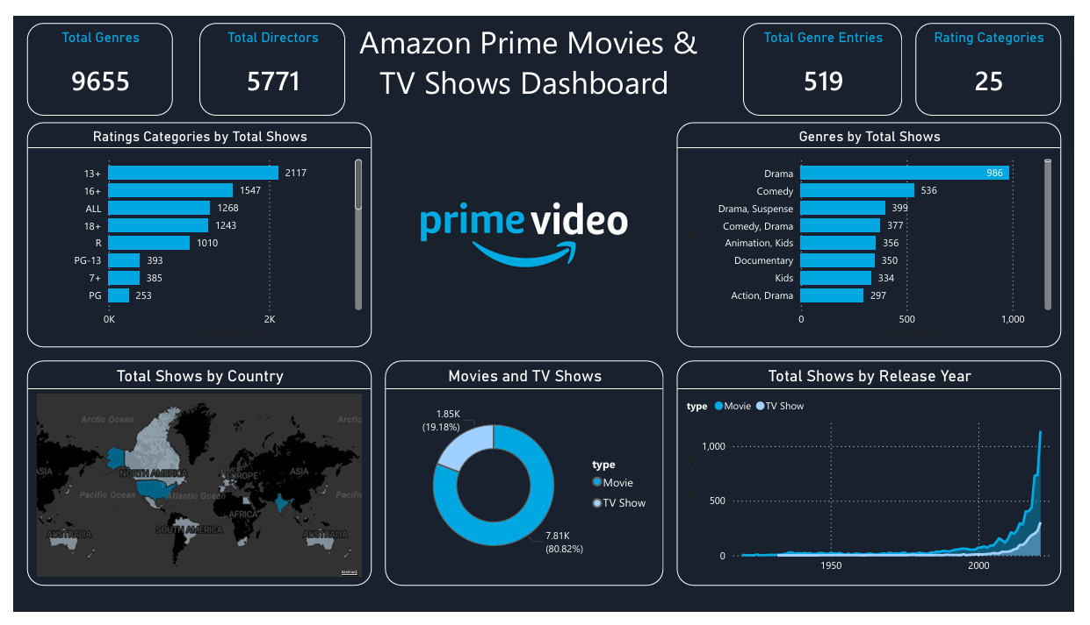

Publicly accessible link to the Dashboard
The Link to the dashboard is here

Alarm Metrics
Although no alerts need to be implemented, the following dashboard metrics can serve as triggers:
1. Low share of recent content
Trigger: Sharp decline in titles released in recent years
Action: Review acquisition strategy for newer content
2. Overconcentration in a few genres
Trigger: One or two genres become disproportionately dominant
Action: Diversify content portfolio to broaden audience appeal
3. Weak TV Show representation
Trigger: TV show share falls below a defined threshold
Action: Assess whether the platform needs more episodic content

Review 1
Reviewer: Ebrahim Haque Bhatti
Dashboard being reviewed: Retail Sales Performance
Dashboard Being Reviewed Created By: Noor Muhammad, Hafsa Id Said, Almas
1: Summary & First Impressions (The "What")
Description
The dashboard presents a descriptive analysis of monthly sales performance for a retail business. It is categorized by product categories and regions. It uses the following metrics that can assist a manager in decision-making:
- sales
- profit
- discount
- quantity
The primary user appears to be a Sales Manager or Business Analyst who needs a quick operational view of sales performance across products and regions.
First Impression
At first glance, the dashboard appears somewhat cluttered. The “Monthly Sales by Product Sub-Category” chart includes 17 categories, which overlap and reduce readability.
Part 2: Analysis of Strengths ("What Works")
KPI Cards: The top KPI cards (Total Sales, Profit, Discount, and Quantity) are clearly separated and prominently placed. This allows users to quickly grasp the performance without needing to interpret detailed charts.
Chart Diversity: The combination of visuals such as the category distribution donut chart, regional profit bar chart, and month-over-month trend line, effectively covers multiple analytical dimensions. They enable users to understand performance by product, geography, and time within a single view.
Color Scheme: The color scheme is immaculate. Tints of the same color have been used consistently across all the charts.
Part 3: Constructive Critique & Recommendations
1) Only Show the Top N Categories in the Product Sub-Category Graph: Only Show the Top N Categories in the Product Sub-Category Graph: Currently, there are 17 categories, which makes the chart difficult to interpret. According to George A. Miller, who is a cognitive psychologist, human working memory is limited to about seven (±2) items at a time. There are some categories, like Fasteners and Envelopes, with small volumes, we can remove them from the chart.
2) Add Meaningful Titles: The dashboard title, “Monthly Sales Performance,” does not indicate that it relates to a retail store. Similarly, the chart “Total Profit by Region” does not specify which country or regions are being represented. Lastly, the same problem with the “Discount” card is that it is the discount offered by the retail store, specifically, what does it mean? A bit descriptive or specific titles would add clarity for the target audience.
3) Reduce Clutter in Line Chart: The main issue with this chart is overplotting and visual clutter. With 12 months displayed as separate lines across 30 days, the chart becomes difficult to interpret. Reduce visual clutter by limiting the number of lines. Either show one month at a time using a filter/slicer, or compare only 2–3 key months (e.g., current vs. previous).

Review 2
Reviewer: Ebrahim Haque Bhatti
Dashboard Being Reviewed: Data Horizon
Dashboard Being Reviewed Created By: Sofiya Karpova, Egor Konstantinov, Andrei Velicorodnov
Part 1: Summary & First Impressions (The "What")
Description
This dashboard measures the effectiveness of an AI support agent by comparing customer service KPIs before and after its implementation. The main parameters include response time, resolution time, CSAT, and workload distribution. It is designed to help management assess whether the AI system improves operational efficiency and service quality while reducing reliance on human support.
First Impression
The sleek design, with each graph separated by borders, immediately gets the attention. However, the layout feels slightly dense, and the heavy use of text may slow down quick interpretation for decision-makers.
Part 2: Analysis of Strengths ("What Works")
Specific strengths of the dashboard:
Subtitles Help Understand the Chart Better: For example, the donut chart “AI Performance” has a subtitle, “The percentage of chats resolved by an AI support agent”, which provides added information to the reader. Similarly, for the cards titled “Efficiency”, the subtitle “Daily chat volume for human support agents” adds further clarity
Percentage Change Info is Helpful: Including percentage change indicators next to each KPI (e.g., -73.7%, +7.5%) provides clear context for the results. This makes it easy for decision-makers to understand the magnitude and direction of change at a glance.
Before-and-After Comparison is Helpful: The side-by-side before-and-after KPI comparison is highly effective. It allows users to immediately assess the impact of the AI agent without needing to interpret separate charts or time series.
Part 3: Constructive Critique & Recommendations
Remove the Gridlines and the Legend: There are gridlines in the bar chart titled “Top topics by volume”. Gridlines reduce the readability of the graph and should therefore be removed. Secondly, a legend is required only when there are two or more categories; a single category does not require one.
Reduce the Text on the Dashboard: Although text adds context to the dashboard, too much text makes quick interpretation difficult. A chart and title should be self-sufficient to tell the complete story.
Use Bar Chart Instead of Cards: In the “Top KPI” graph, a clustered column chart could have been a better choice as it enhances the visual appeal of the dashboard. Plus, one chart is easier to interpret than multiple cards.

https://pmc.ncbi.nlm.nih.gov/articles/PMC4486516/

