1. Business Requirements & Data Preparation

1.1 Business Requirements
The airline industry operates in a highly complex and time sensitive environment where flight delays can lead to significant operational disruptions, increased costs, and reduced customer satisfaction. One of the key challenges faced by airlines is the ability to anticipate and manage delays effectively in order to maintain punctuality and optimize resource allocation.
The main business problem in this project is the high frequency of flight delays and their negative impact on operational efficiency and financial performance. Delays often result in cascading effects across flight schedules, increased compensation costs, and inefficient use of aircraft and crew.
The primary objective of this project is to design a management dashboard that enables real time monitoring of flight performance and supports proactive decision making. Specifically, the dashboard aims to improve On Time Performance (OTP), reduce average delay minutes, and minimize delay related costs through the integration of predictive analytics.
To achieve these objectives, the dashboard is designed to answer the following key business questions:
- What are the main factors contributing to flight delays (e.g., weather, congestion)?
- How do delays evolve over time?
- Does the use of AI based predictions help reduce delays?
- Which airports or operational conditions are associated with higher delay risk?
- What proportion of flights are currently at high risk of delay?
The target audience for this dashboard includes airline operations managers, control center teams, and decision makers responsible for flight scheduling and operational efficiency. The dashboard is intended to serve as a real-time decision-support tool, enabling users to quickly identify issues and take corrective actions.

1.2 Data Preparation
The dataset used in this project consists of simulated flight operations data designed to reflect realistic airline conditions. The data includes information on flight schedules, delay durations, weather conditions, airport congestion levels, and AI based delay prediction scores.
Key variables in the dataset include:
- Flight ID: Unique identifier for each flight
- Date: Flight date
- Origin: Departure airport
- Airport_Type: Classification of airport (Hub or Regional)
- Delay_Minutes: Total delay duration in minutes
- Weather: Weather severity level (Low, Medium, High)
- Congestion: Airport traffic density (Low, Medium, High)
- AI_Score: Predicted probability of delay (0 to 1)
- Delay_Occurred: Binary indicator of whether a delay occurred
- Cost_EUR: Estimated cost associated with delays
Initial data preparation steps were performed to ensure data quality and usability. These steps included checking for missing values, verifying data consistency, and standardizing categorical variables such as weather and congestion levels. Outliers in delay values were reviewed to ensure they reflected realistic operational scenarios.
In addition, several calculated metrics were created to support analysis within the dashboard. These include On Time Performance (OTP), defined as the percentage of flights without delay, average delay per flight, total delay-related costs, and the proportion of high risk flights based on AI predictions.
The prepared dataset provides a structured foundation for building a management dashboard that transforms raw operational data into actionable insights, enabling more efficient and proactive decision making.

2. Dashboard screenshot,

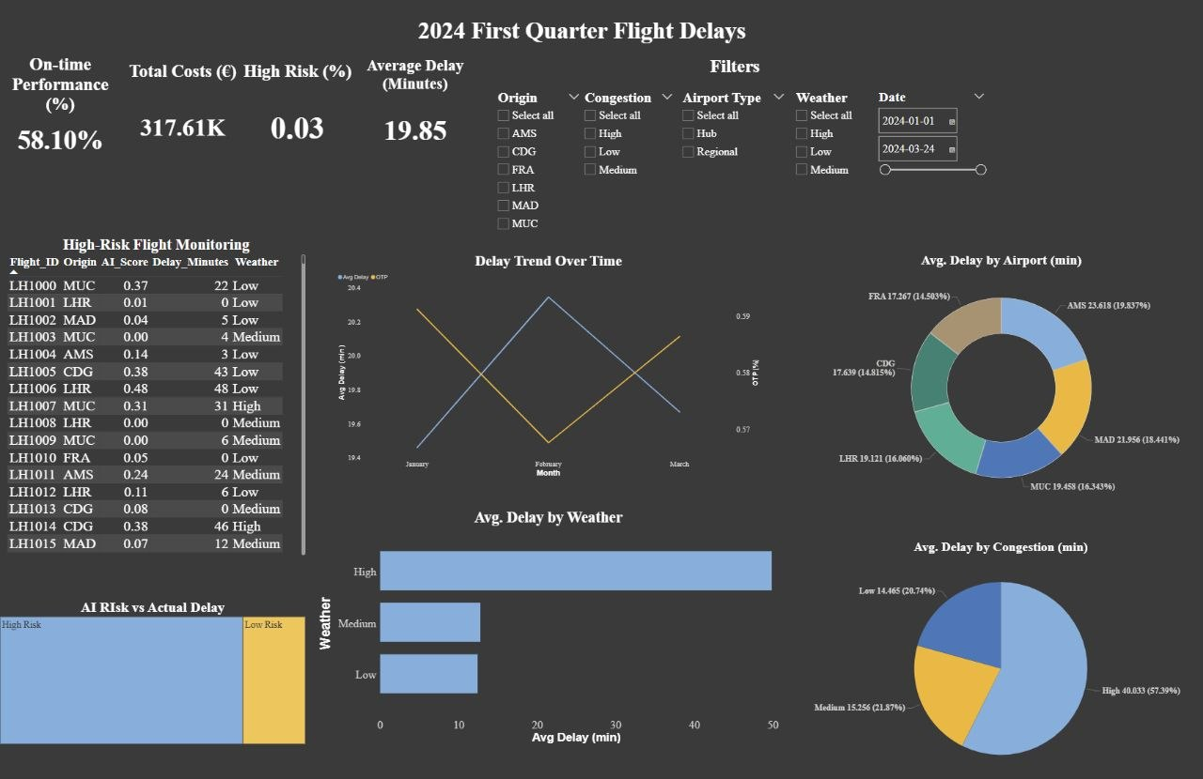

3. Public link for the dashboard

https://disk.360.yandex.ru/d/UempFgY8iXmB3w

4. Dashboard & Alarm Description

4.1 Dashboard Description
The AI Based Flight Delay Management Dashboard is designed to provide a comprehensive and real time overview of airline operational performance. The dashboard integrates historical data and predictive analytics to support data driven decision-making and improve operational efficiency.
At the top of the dashboard, key performance indicators (KPIs) are displayed to provide a quick summary of overall performance. These include On Time Performance (OTP), Average Delay (minutes), Total Delay Cost (€), and the percentage of High-Risk Flights. These KPIs allow decision-makers to quickly assess whether operations are performing within acceptable thresholds.
The dashboard includes a time-series visualization that shows the evolution of delays over time. This allows users to identify trends, detect patterns, and evaluate whether performance is improving or deteriorating.
To better understand the root causes of delays, the dashboard incorporates analytical visualizations that examine key operational drivers such as weather conditions and airport congestion. These visuals enable users to identify which factors contribute most significantly to delays and under which conditions performance is most affected.
A dedicated section of the dashboard focuses on airport performance, allowing users to compare delay levels across different airports. This helps identify high-risk locations and supports more effective resource allocation and operational planning.
The dashboard also integrates predictive analytics through the inclusion of AI based risk segmentation. Flights are categorized based on their predicted probability of delay, enabling users to distinguish between low-risk and high risk operations. This feature supports proactive decision making by allowing managers to focus attention on flights that are more likely to experience disruptions.
Finally, a detailed table of flights provides granular visibility into individual operations, including delay duration, risk level, and contributing factors. This enables deeper analysis and supports operational follow up actions.
Overall, the dashboard transforms complex operational data into clear and actionable insights, enabling airline managers to monitor performance, identify issues, and take timely corrective actions.

4.2 Alarm Description
To enhance decision-making, the dashboard includes a set of predefined alert conditions (alarms) that act as triggers for managerial action. These alarms are based on key performance thresholds and are designed to highlight critical situations requiring immediate attention.
The following alarm conditions are defined:
- If On Time Performance (OTP) falls below 80%, this indicates a significant decline in punctuality and requires investigation into operational inefficiencies.
- If the Average Delay exceeds 30 minutes, corrective actions should be taken to identify and address the root causes of delays.
- If the percentage of High Risk Flights exceeds 25%, operational adjustments such as rescheduling or resource reallocation should be considered to mitigate potential disruptions.
- If Total Delay Cost increases by more than 10% compared to the baseline, a cost analysis should be conducted to identify inefficiencies and implement cost control measures.
These alarms are not implemented as automated triggers within the system but are conceptually defined to support proactive management. By monitoring these thresholds, decision makers can respond quickly to emerging issues and minimize the impact of delays on both operations and financial performance.

5. Review of another dashboard
Reviewer:
Dashboard being reviewed: Jiyun Yu, Pedro Daniel, Steve James
Dashboard being reviewed created by: Ghaidaa

1: Summary & First Impressions (The "What")
This dashboard monitors AI chatbot growth vs. inventory stockouts, targeting an Operations Lead.
Impression: Clear narrative, but layout feels crowded with multiple charts.

Part 2: Analysis of Strengths ("What Works")
- Dual narrative – Shows both strong growth with inventory issues and to drive action.
- Action labels – “Action needed” highlights specific medications to fix.
- Relevant filters – enable analysis by session status and time period.

Part 3: Constructive Critique & Recommandations ("What Could Be Improved")
A. Clarity & Usability – Truncated labels (“Albuterol Inha…”) need full names; filters belong at the top, not bottom.
B. Strategic Relevance – Add financial impact of stockouts and a combined view linking inventory dips to growth.
C. Data Storytelling – Provide benchmark for “exceeded industry average”; connect peak hours to staffing needs.
D. Visual Design – Reduce chart density by grouping; use consistent alert colors for out-of-stocks; soften gridlines.

Overall: Tight integration of growth and inventory data, plus clearer labeling and context, would make this a stronger strategic tool.

