PetConnect — Platform Conversion and Efficiency
Assignment 2: Business Intelligence Dashboard
Team: Serchenko Nikita, Gomon Mark, Denisova Daria
Tool: Yandex DataLens | March 2026
Public DataLens link: https://datalens.yandex/58r6ygh21cw6p

PART 1 — BUSINESS REQUIREMENTS
1.1 Business Problem
PetConnect is a pet marketplace operating in Moscow, Saint Petersburg, and Kazan. Despite growing registrations, the team lacks visibility into:
- How users convert from page view to purchase (and where they drop off)
- Whether breeder verification and rating actually influence buyer behaviour
- Which content formats drive engagement and lead to sales
- How much it costs to acquire a registered user per paid channel
- Which breed categories are in highest demand by city
- What share of buyers ever returns for a second purchase
- How often pets fail to meet buyer expectations, and why
1.2 Business Goals
- Monitor the full conversion funnel from Page View to Pet Purchase
- Evaluate breeder quality signals (verification, rating, response rate) as trust drivers
- Identify the most effective content format for driving purchases
- Measure CAC per paid channel and optimise budget allocation
- Map breed demand by city to guide breeder recruitment
- Track repeat purchase rate as a retention health metric
- Reduce returns by monitoring pet-match scores and return reasons
1.3 Key Dashboard Questions
- At which funnel step do most users drop off, and does it differ by city?
- Do Premium Verified breeders get meaningfully better ratings and response rates?
- Which content type (Video, Webinar, Blog, etc.) generates the longest engagement and most purchases?
- What is the CAC for Google Ads, Telegram Ads, and Yandex Direct?
- Which city shows the highest demand for Luxury/Designer and Working breed categories?
- What share of buyers made more than one purchase?
- What is the average pet-expectation match score, and what are the top return reasons?
1.4 Target Audience
Primary: CMO and Head of Product — weekly KPI review, channel budget decisions.
Secondary: City managers — city-level breed demand for breeder recruitment.
PART 2 — DATA PREPARATION
2.1 Datasets
File | Rows | Key content
pet_platform_transactions.csv | 8,543 | Event-level: 11 event types, traffic, breeder data, content, purchases
user_profiles.csv | 2,800 | User-level: demographics, purchase history, LTV, churn risk
Period: January 2023 – June 2024 (18 months).
2.2 Key Statistics
- Most frequent events: Registration (18%), Pet View (22%), Page View (31%)
- Paid channel share: ~28% of events (traffic_medium = cpc)
- pet_price: 2,500–180,000 RUB, median ~38,000 RUB
- platform_commission: ~9.5–10% of pet_price
- breeder_rating: mean 4.1 / 5
- pet_matched_expectations: mean 3.9 / 5 (purchase events only)
- is_repeat_buyer = TRUE: ~18% of registered users
- predicted_churn_risk > 0.7 (high risk): ~12% of users
2.3 Data Cleaning & Transformations
Structural NULLs — many columns are empty by design (breeder fields only fill on Pet View/Inquiry/Purchase events; content fields only on Content View). Handled via chart-level IS NOT NULL filters.
Calculated fields added in transactions_ds:
- is_purchase = IF(event_type = "Pet Purchase", 1, 0)
- is_registration = IF(event_type = "Registration", 1, 0)
- has_content = IF(ISNULL(content_id), 0, 1)
- funnel_order = IF chain assigning 1–5 to funnel stages for sorting
- event_date / event_month = DATETRUNC(event_timestamp, "day"/"month")
Calculated fields added in users_ds:
- is_buyer = IF(pets_purchased > 0, 1, 0)
- ltv_segment = High/Mid/Low LTV based on lifetime_value_12mo thresholds
- churn_risk_label = High/Medium/Low Risk based on predicted_churn_risk
No duplicate event_id values found. event_timestamp converted from String to Date & time in connection settings.
PART 3 — DASHBOARD DESCRIPTION
3.1 Overview
Title: PetConnect — Platform Conversion and Efficiency
Tool: Yandex DataLens (cloud)
Layout: Single-screen desktop grid. Filter selectors at the top, a row of 4 KPI cards, then charts arranged in a two-column layout below.
Public link: https://datalens.yandex/58r6ygh21cw6p
3.2 KPI Cards (Top Row)
Four indicator widgets provide an at-a-glance platform health summary. They are the first element a manager sees and answer the question "is the platform operating at expected volume?"
KPI | Field | Aggregation | Business meaning
Total Events | event_id | COUNT | Overall platform activity volume
Registered Users | is_registration | SUM | Top-of-funnel size
Completed Purchases | is_purchase | SUM | Primary revenue-generating action count
Platform Commission (RUB) | platform_commission | SUM | Direct platform revenue
3.3 Charts
Chart 1 — Conversion Funnel by City (Horizontal Bar)
Shows how many unique events occur at each stage of the purchase funnel: Page View → Registration → Breeder Search → Inquiry → Pet Purchase. Bars are coloured by city. The chart reveals where the biggest drop-off occurs and whether it differs across Moscow, Saint Petersburg, and Kazan. Dimension: event_type (sorted by funnel_order field); Measure: COUNTD(event_id); Color: city.
Chart 2 — Breeder Rating and Response Rate by Verification Level (Scatter)
Each point represents a verification tier (Basic, Verified, Premium Verified, Unverified). X-axis: average breeder rating; Y-axis: average response rate within 24h; point size: volume of interactions. Answers whether higher verification correlates with better quality signals. Filter: breeder_id IS NOT NULL.
Chart 3 — Content Engagement and Purchases by Content Type (Combined Chart)
Bars show average time on page (seconds) per content type; the overlaid line shows total linked purchases (SUM of is_purchase). Dual Y-axis separates the two scales. Identifies which format (Blog, Video, Webinar, Care Guide, etc.) both retains attention and converts to sales. Filter: content_type IS NOT NULL.
Chart 4 — CAC by Paid Channel (Bar Chart)
Calculates Customer Acquisition Cost as SUM(ad_cost) / COUNTD(registrations) for each paid traffic source. Shows the cost of acquiring one registered user via Google Ads, Telegram Ads, and Yandex Direct. Filter: traffic_medium = "cpc". Enables direct budget reallocation decisions.
Chart 5 — Breed Demand by City (Pivot Table / Heatmap)
A matrix of cities (rows) × breed categories (columns) with cell values = COUNTD(event_id). Cell colour intensity increases with demand volume, creating a heatmap effect. Filters: event_type IN (Pet View, Pet Purchase); breed_category IS NOT NULL. Guides breeder recruitment by showing which categories are undersupplied relative to demand.
Chart 6A — Repeat Customer Rate (Donut)
Shows the share of registered users who made more than one purchase (is_repeat_buyer = TRUE vs FALSE). Provides an immediate read on platform loyalty and the health of the retention funnel. Dataset: users_ds.
Chart 6B — Repeat Customers by City (Stacked Bar)
Breaks down repeat vs. first-time buyers by city. Reveals whether retention is a platform-wide issue or concentrated in specific geographies. Dataset: users_ds.
Chart 7A — Average Match with Expectations (KPI Indicator)
Displays the mean of pet_matched_expectations (1–5 scale, collected via post-purchase survey). Sourced from transactions_ds, filtered to Pet Purchase events only. A score below 3.5 is the alarm trigger for matching algorithm review.
Chart 7B — Pet Return Reasons by City (Bar Chart)
Shows the count of return events grouped by return_reason and coloured by city. Filter: return_reason IS NOT NULL. Diagnoses the root causes of returns (Breed Mismatch, Health Issue, Buyer Remorse, etc.) and their geographic distribution.
3.4 Filters (5 Selectors)
Filter | Field | Type | Applied to
Period | event_timestamp | Date range calendar | All charts on transactions_ds
City | city | Multi-select list | All charts
Device Type | device_type | Multi-select list | All charts on transactions_ds
Traffic Source | traffic_source | Multi-select list | All charts on transactions_ds
Breed Category | breed_category | Multi-select list | Chart 5 only
3.5 Update Frequency
The dashboard currently uses static CSV files. Data is refreshed manually when a new CSV export is uploaded to the DataLens connection. In a production environment this would be replaced by a live database connection with a nightly automated refresh (every 24 hours).

PART 4 — DASHBOARD SCREENSHOT
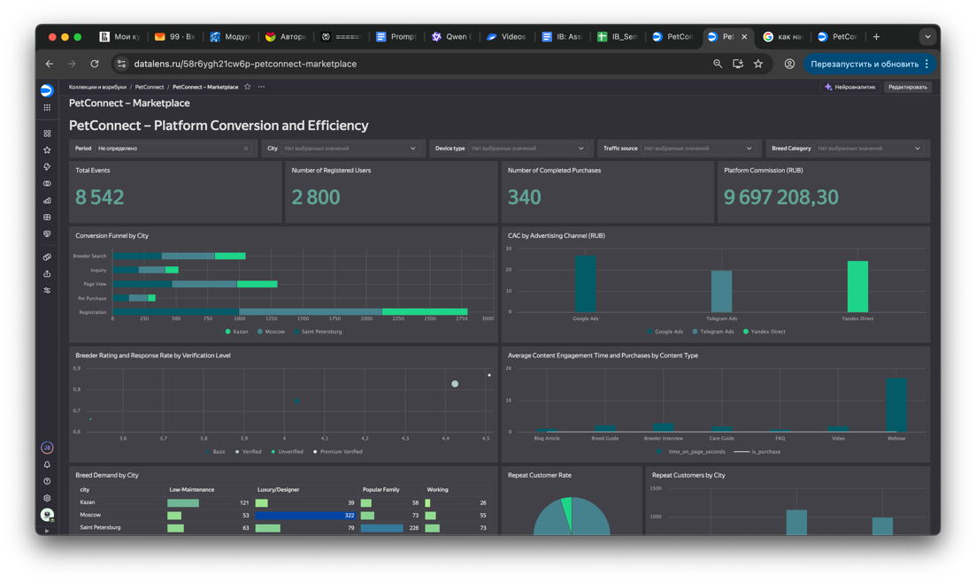
Fig. 1 — PetConnect Dashboard, Yandex DataLens
Public DataLens link: https://datalens.yandex/58r6ygh21cw6p

PART 5 — ALARM SYSTEM
Alarms are not technically implemented in DataLens (the free tier does not support native alerting), but the following thresholds are defined for operational monitoring. Each alarm is readable directly from the dashboard without additional calculations.
# | Metric | Visible on | Threshold | Why it matters | Recommended action
1 | Registration → Purchase conversion rate | Chart 1 | < 2% | Below 2% suggests a fundamental onboarding or trust barrier | Audit email nurture sequence; add in-app prompts after registration
2 | CAC on Telegram Ads | Chart 4 | > 3,000 RUB per registration | Telegram is a high-cost channel; above 3K makes it unprofitable vs. organic | Pause campaign; A/B test new creative and audience targeting
3 | CAC on Yandex Direct | Chart 4 | > 2,500 RUB per registration | Indicates keyword bidding is too aggressive or landing page conversion is low | Reduce max CPC bids; shift budget to retargeting campaigns
4 | CAC on Google Ads | Chart 4 | > 2,000 RUB per registration | Google typically has higher intent; above 2K suggests targeting drift | Review search term report; exclude irrelevant queries
5 | Average pet-match score | KPI 7A | < 3.5 / 5 | A score below 3.5 means the matching algorithm is producing mismatches at scale | Expand breed-matching questionnaire; review breeder listing quality
6 | Return rate | Chart 7B | > 5% of purchases | Above 5% indicates systemic quality issues, not random events | Trigger breeder quality audit; strengthen health certification checks
7 | Repeat buyer rate | Chart 6A | < 15% of all buyers | Signals that post-purchase engagement is failing | Launch post-purchase email flow; introduce loyalty discount on supplies

PART 6 — PEER REVIEW
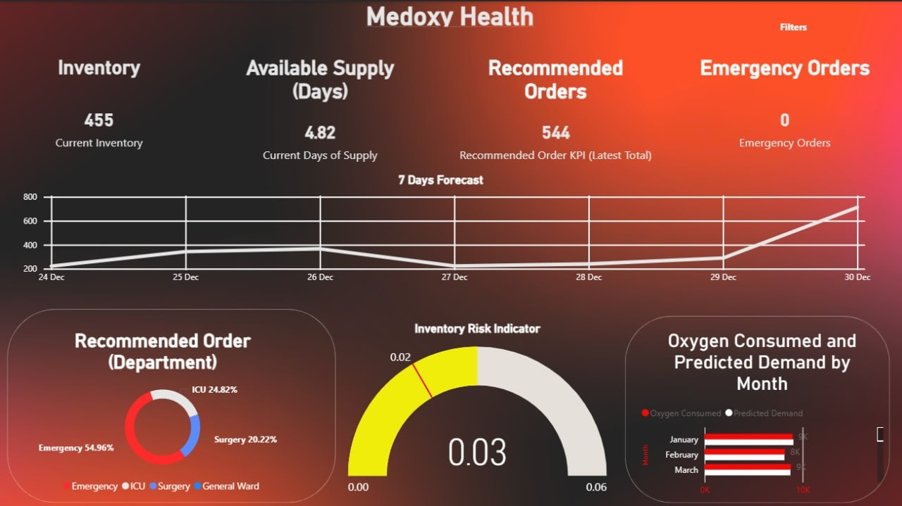
Fig. 2 — Medoxy Health Dashboard (Sameer's team)
Reviewer | Daria Denisova
Dashboard reviewed | Medoxy Health — Medical Oxygen Inventory & Demand Management (Sameer's team)
Tool | Power BI
Date | March 22, 2026

Overall rating: 4 / 5

The Medoxy Health dashboard addresses a genuinely critical operational problem — managing medical oxygen supply in a hospital — and communicates urgency effectively through its dark red-gradient design. The 7-day forecast line chart is the standout element: it immediately shows a supply dip near Dec 26–27 that would require emergency procurement, which is precisely the kind of actionable intelligence a supply manager needs. The Inventory Risk Indicator gauge translates a risk score into a colour-coded dial (yellow = caution) that requires no explanation — a strong alarm visualisation. The department breakdown in the donut chart (Emergency 54.96%, ICU 24.82%, Surgery 20.22%) correctly disaggregates demand by decision unit.
Main areas for improvement:
- Title names the company, not the problem. "Medoxy Health" tells the viewer nothing about what to monitor. A title like "Oxygen Inventory & Demand Forecast — Dec 2024" would communicate purpose immediately, as recommended in the course guidelines.
- KPI cards have no context. Inventory = 455, Available Supply = 4.82 days — a manager cannot judge whether these are safe or alarming without a baseline. Adding a delta vs. yesterday (e.g., "↓ 1.2 days") or a reference line (minimum safe = 7 days) would make each number actionable at a glance.
- "General Ward" appears in the legend but not in the chart. The donut chart legend lists four departments including General Ward, but only three are visible with percentages. This creates confusion and undermines trust in the data.
- No time filter visible. The forecast shows one fixed week (Dec 24–30) with no way to shift the window. A date range selector would make the dashboard reusable beyond its current snapshot.
Overall, the dashboard has strong visual design and a clear operational focus. Fixing the title, adding benchmark context to KPIs, and introducing a time filter would bring it to a high professional standard.

