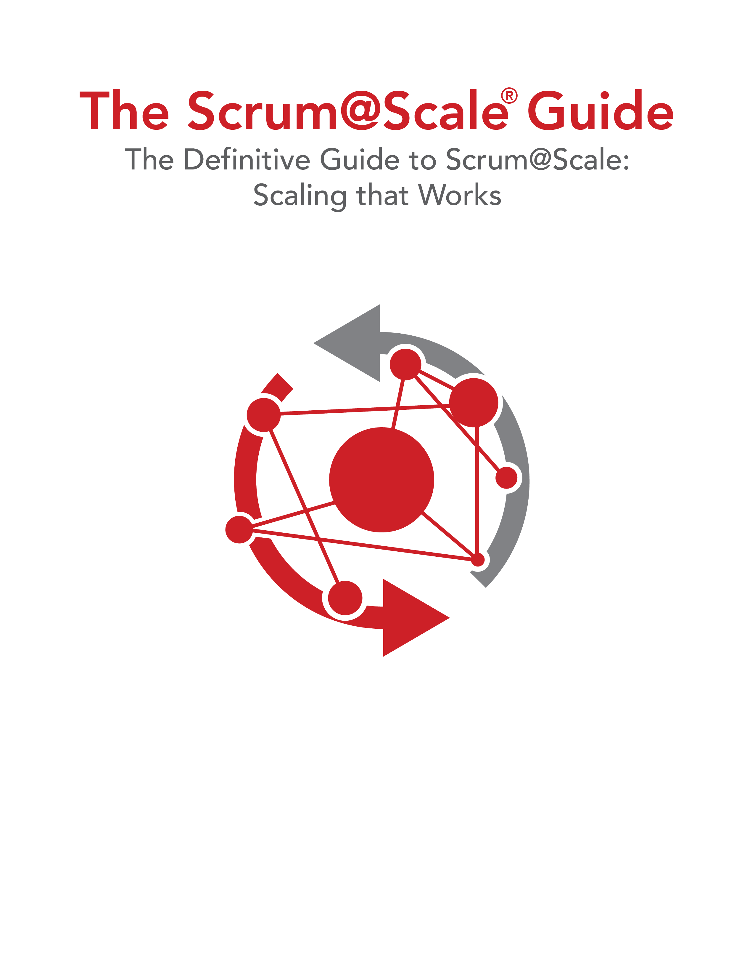

Version 2.1 — February 2022

©2006-2022 Jeff Sutherland and Scrum Inc., All Rights Reserved   
Scrum@Scale is a registered trademark of Scrum Inc.   
Released under Creative Commons 4.0 Attribution-Sharealike License