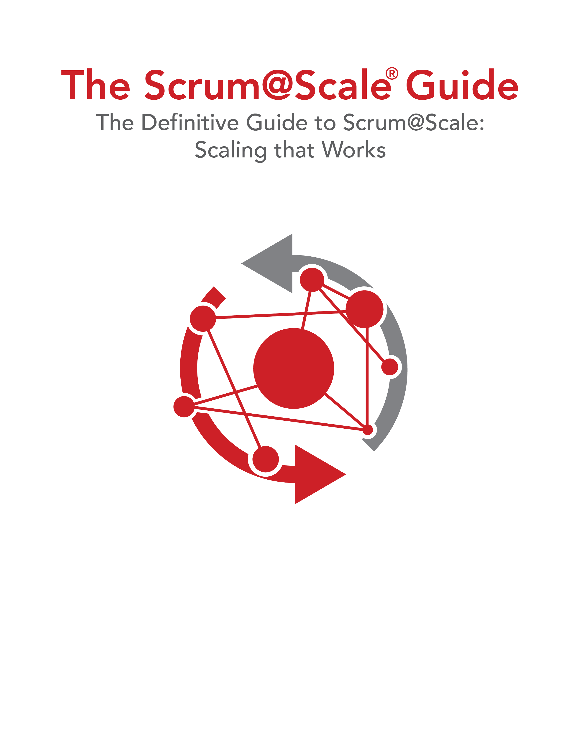

スクラムをスケールする

Scrum@Scaleの決定版ガイド

Scrum@Scale‎Ⓡ ガイド

Version 2.1 — January 2021

©2006-2021 Jeff Sutherland and Scrum Inc., All Rights Reserved   
Scrum@Scale is a registered trademark of Scrum Inc.   
Released under Creative Commons 4.0 Attribution-Sharealike License