**Hardware**

|  |  |
| --- | --- |
| **Hardware** | **Task** |
| Raspberry pi zero | Small sized computer.Project creation. |
| Male/Male Jumper wires  Female/Male Jumper wires  Female/Female Jumper wires | Making wire harnesses or jumpering between headers. |
| LED | Sensor movement identification. |
| PIR Sensor | Detect movement in the surrounding area. |
| Piezo Buzzer | Alerts when PIR Sensor detects movement. |
| Resistor Kit | Reduce current flow. |
| Power Bank | Power Raspberry Pi |

**Door Sensor with PIR Sensor & Buzzer**

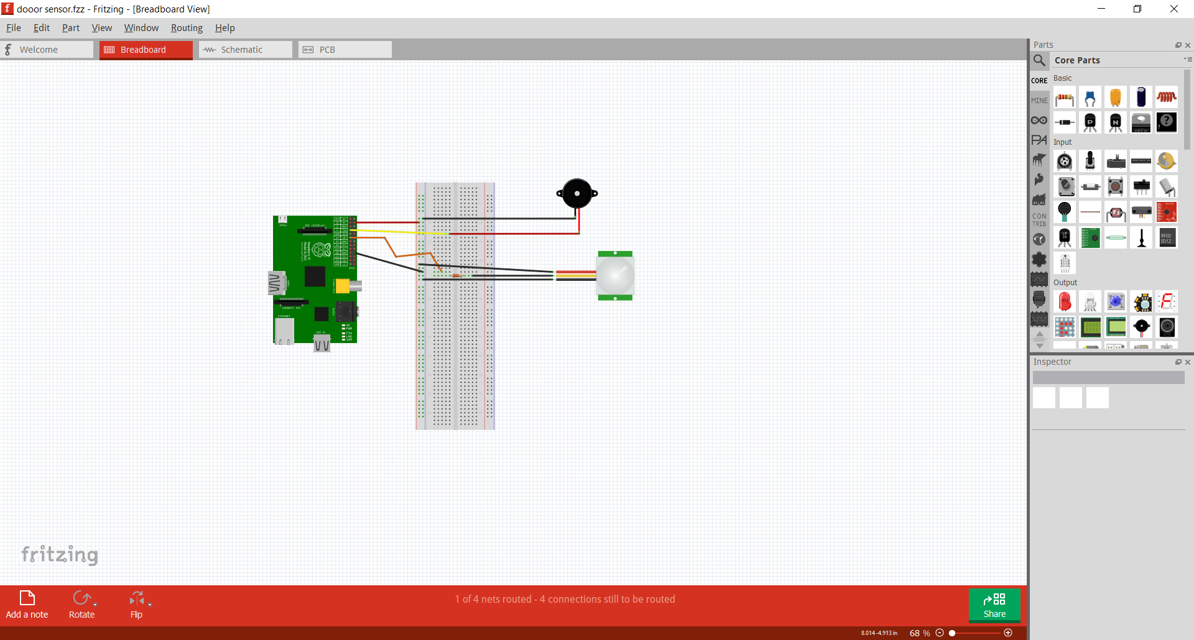

**Room Motion Sensor with PIR Sensor & LED**

