**Hardware**

|  |  |
| --- | --- |
| **Hardware** | **Task** |
| Raspberry pi zero | Small sized computer.Project creation. |
| 5 Female/Female Jumper wires | Making wire harnesses. |
| PIR Sensor | Detect movement in the surrounding area. |
| Piezo Buzzer | Alerts when PIR Sensor detects movement. |

**Bedroom & Hall-way Sensor**

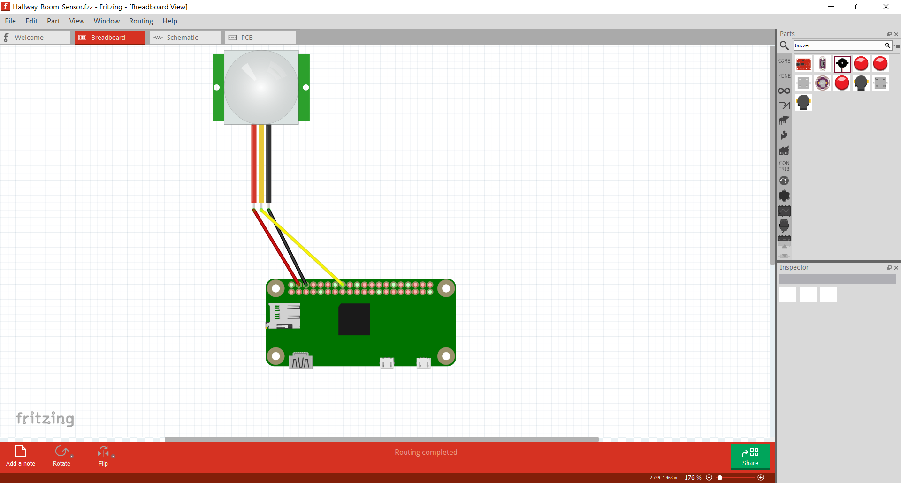

* Red wire is connected to Pin 4(5V power) & (3-5VDC Power)
* Yellow wire is connected to Pin 16(GPIO 23) & (Digital OUT)
* Black wire is connected to Pin 6(Ground) & (Ground)

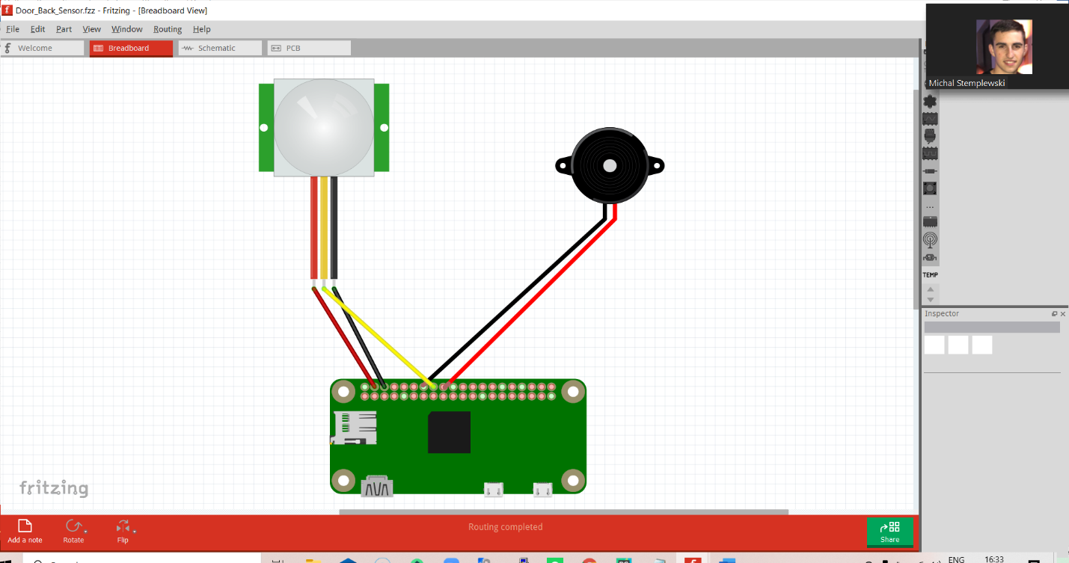**Front door & Back door Sensor**

**Sensor**

* Red wire is connected to Pin 4(5V power) & (3-5VDC Power)
* Yellow wire is connected to Pin 16(GPIO 23) & (Digital OUT)
* Black wire is connected to Pin 6(Ground) & (Ground)

**Piezo Buzzer**

* Black wire connected to Pin 7(Ground) to Ground
* 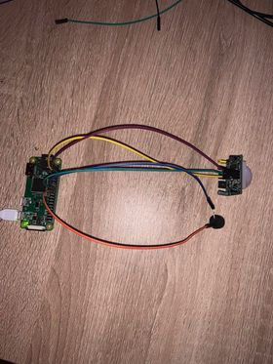Red wire connected to Pin 18 to GPIO 24