JavaScript Functions

Zawartość

Modular code with functions 2

Arrow Function 5

Default Params and Spread 8

# Modular code with functions

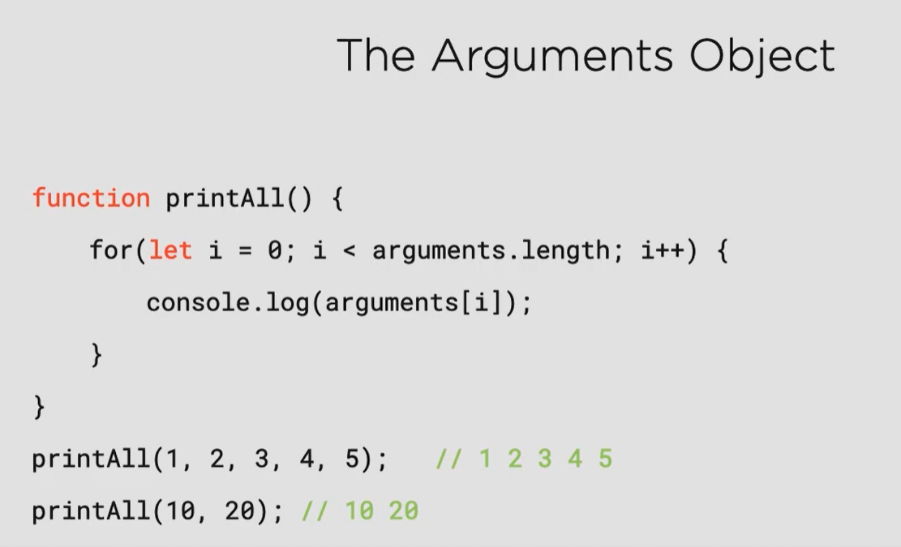

Argument.Length keep all args pass to the function as argument when this function is call.

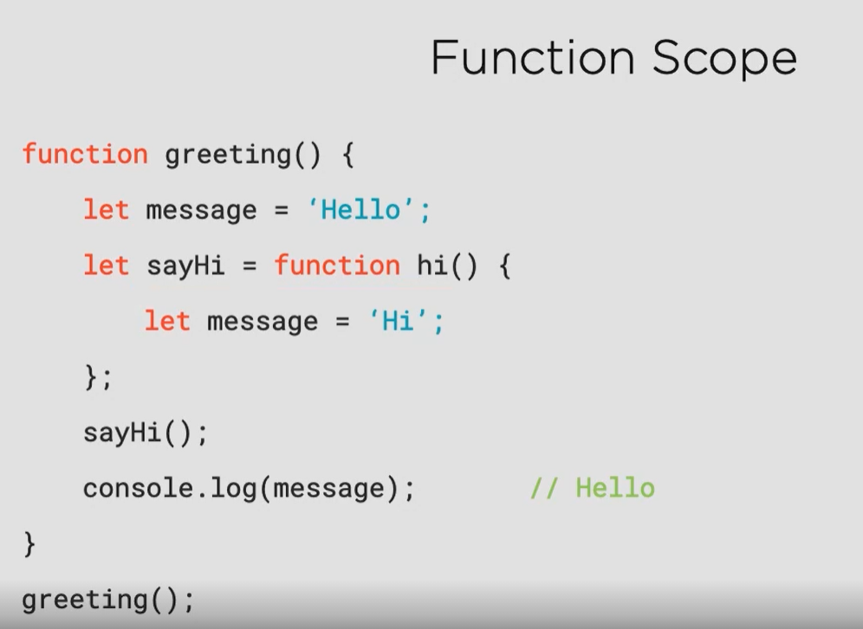

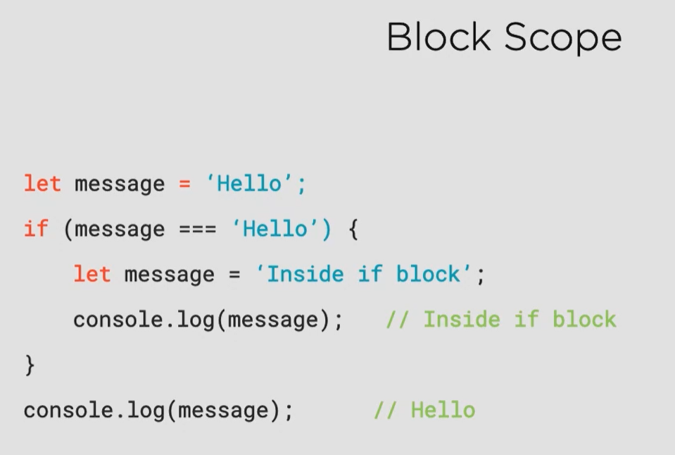

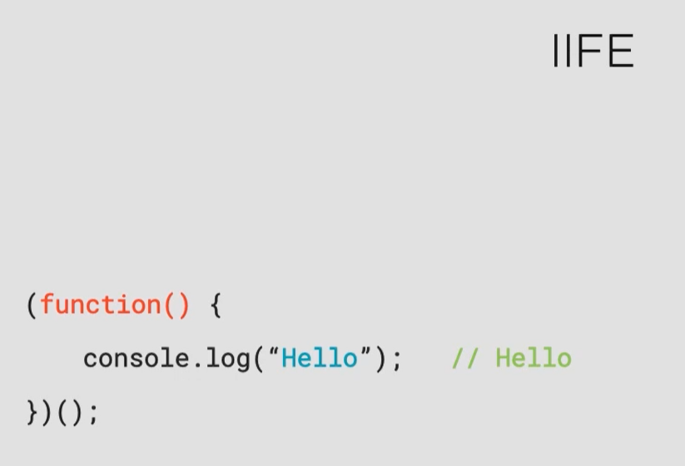

This feature is use to keep all scripts value in encapsulation. It is a hermetic environment which make you sure that your var from your code is not available in global scope and there is no collision between two or more scripts.

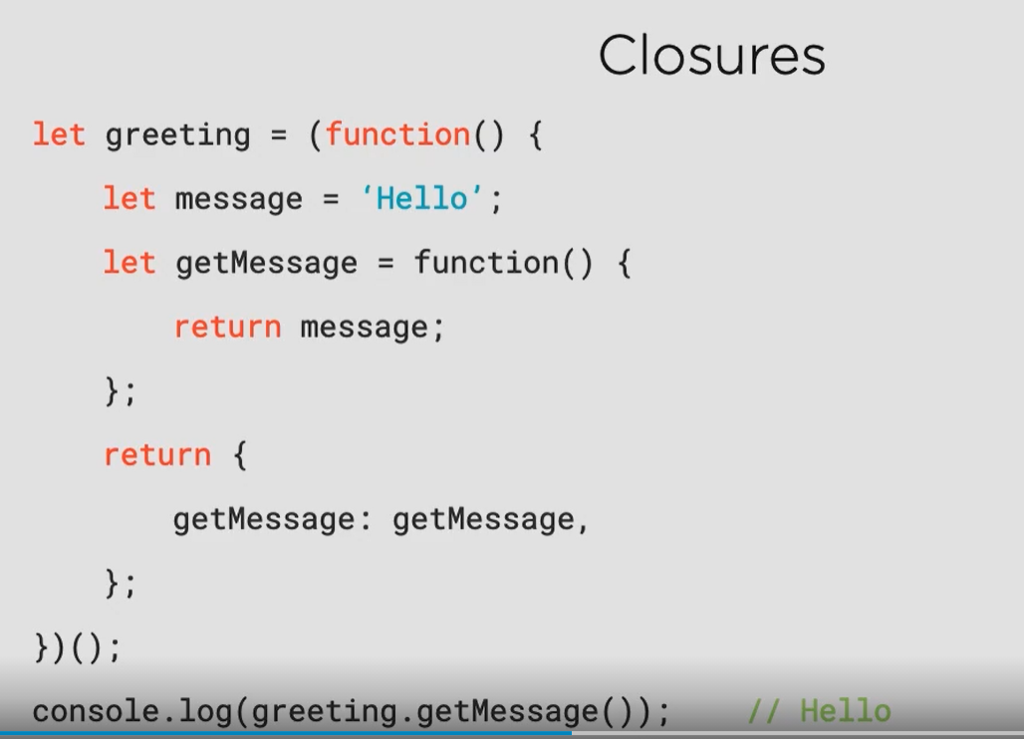

This works almost like getter but dev has possibility to retrieve a function from restricted code block.

# Arrow Function

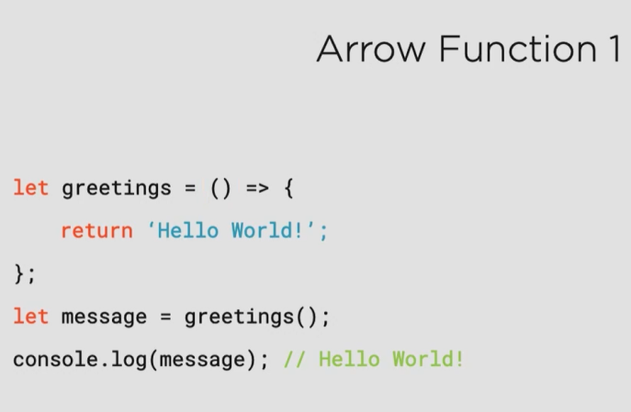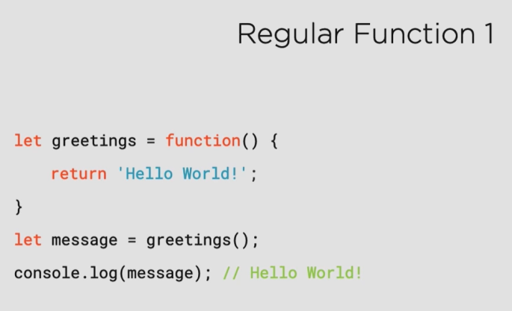

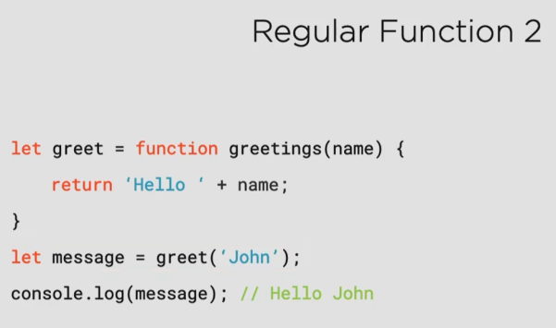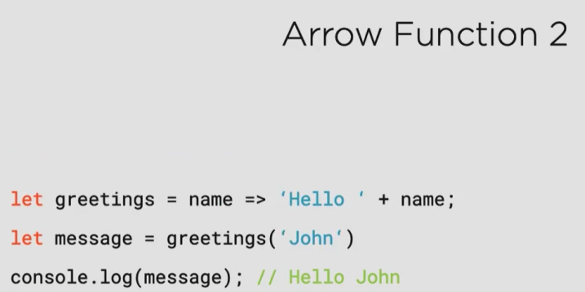





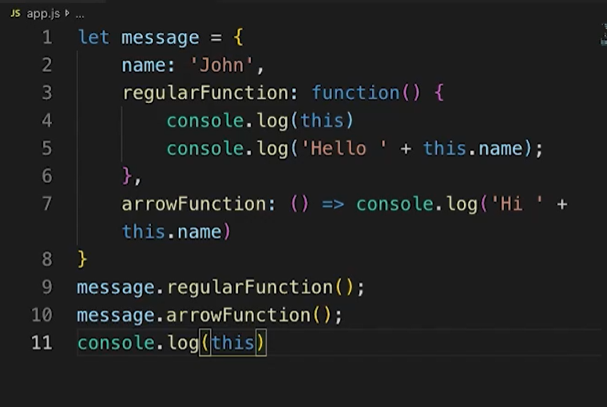

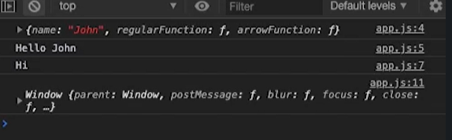

Arrow function is not associate with object where it is a declare. This function is related to Window object. However normal function belong to the object when declaration is place. When dev invokes this keyword it indicate a object which has this function in block scope.

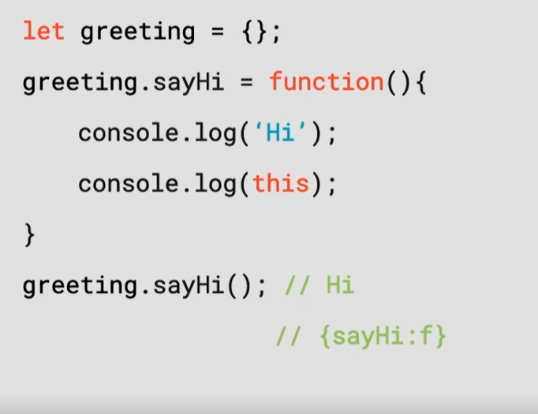

Function is only assigned to object. This operation require = mark

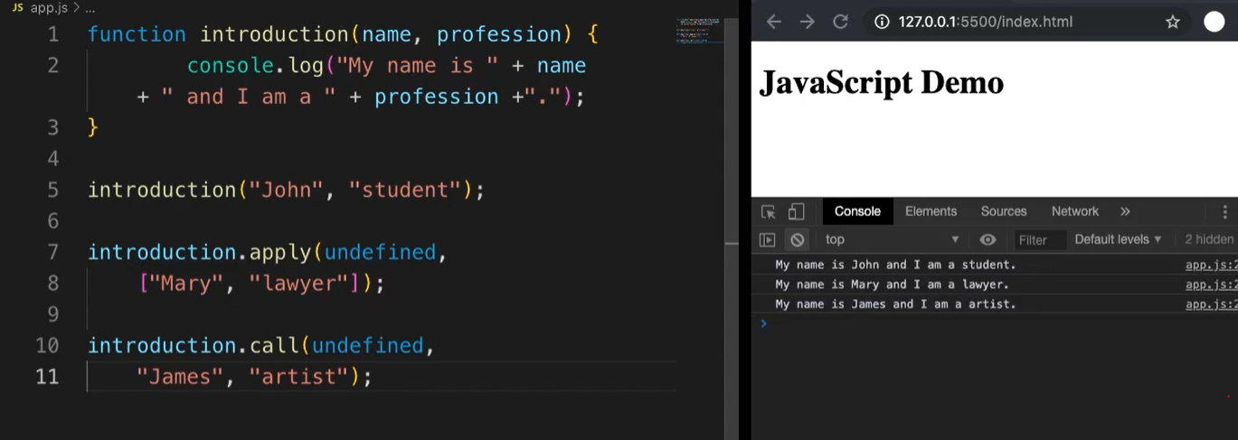

Yep it is JS.

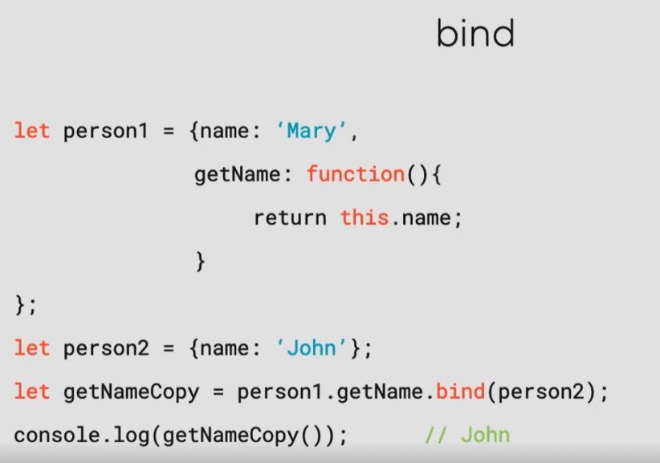

We can assign value to object with bind function.

# Default Params and Spread

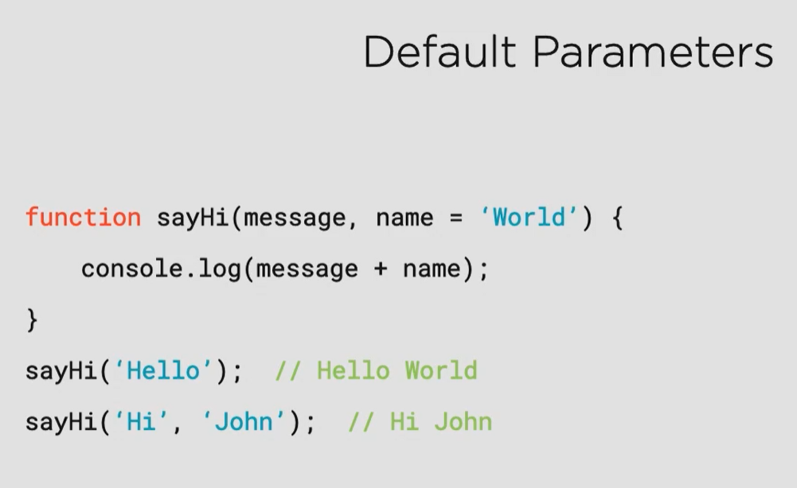

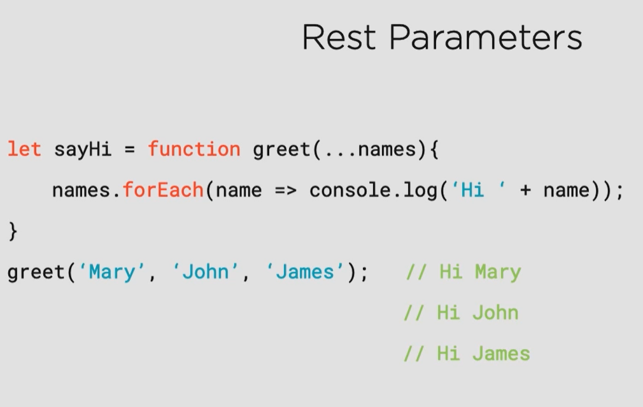

Used in declaration

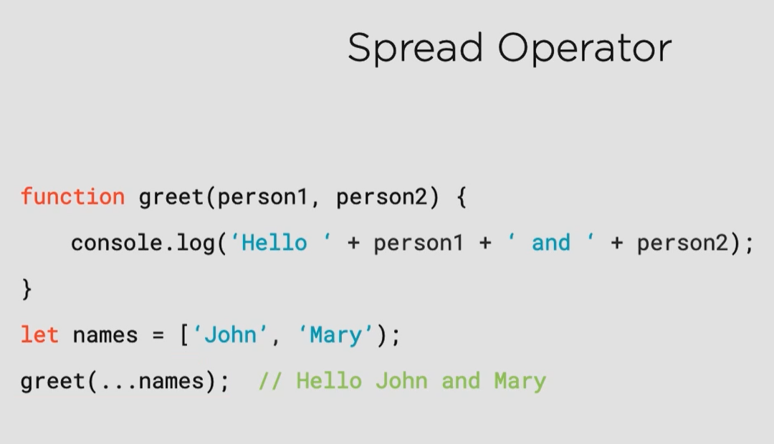

Use in implementation. This two paramas means the same give me more args as much as you want.

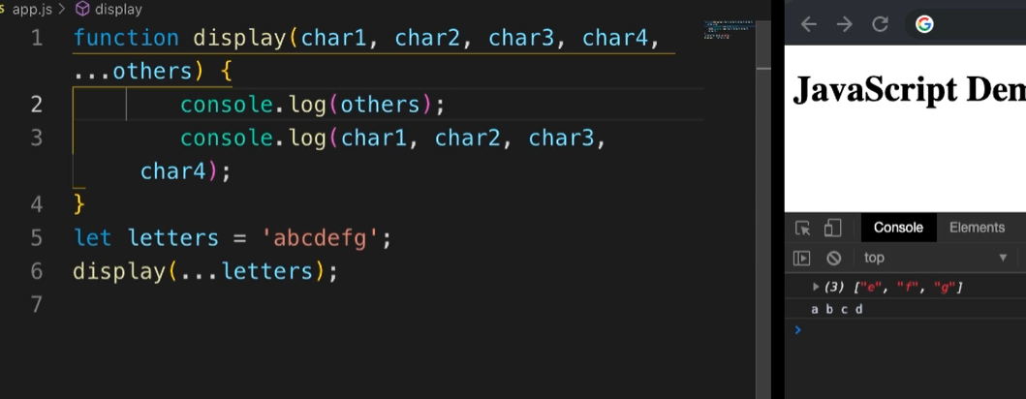

This two parameters can be use simultaneously.