JavaScript Variables and Types

Zawartość

Using Variable, assignments, literals 2

Strings 2

Scopes 2

Primitive Types 5

Symbol 5

# Using Variable, assignments, literals

## Strings



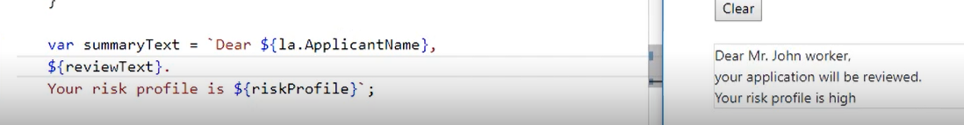

Interpolation string with variables . or second name is a template string.

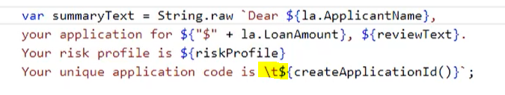

String.raw is used to use magic mark \t.

## Scopes

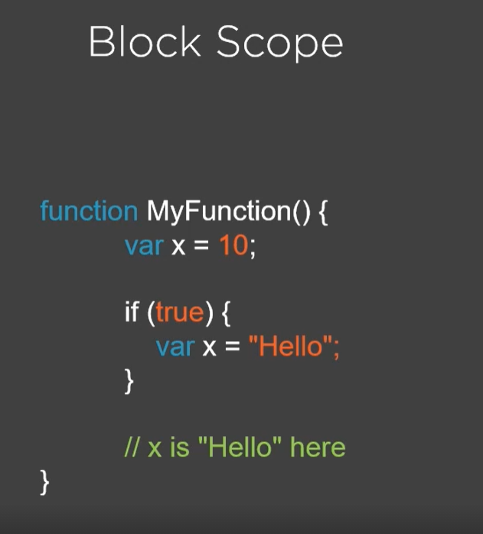

Yes you see in good way. X is assigned in block scope to hello and it is the same value after that ☺. Var doesn’t have a local scope.

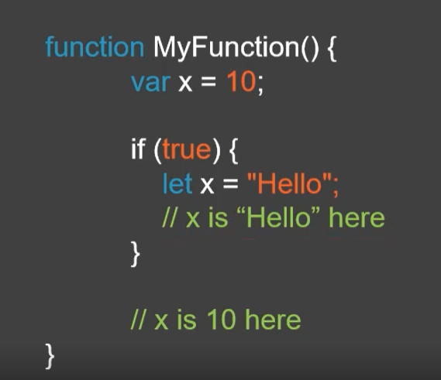

Let works propertly.

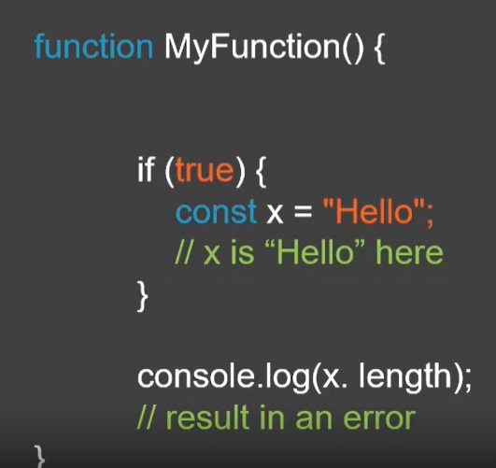

Look works great

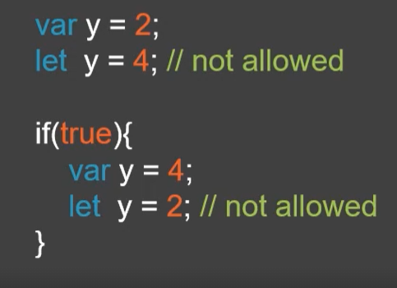

We can’t do this the same vars name.

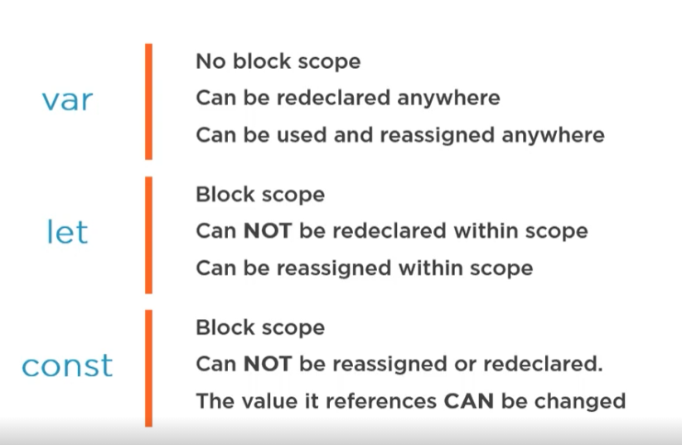

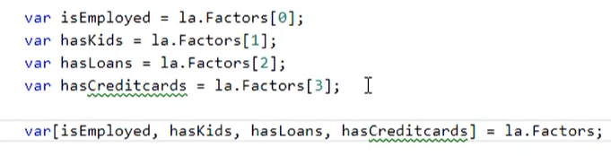

This two way to assign values is equal. Second one is destructing syntax.

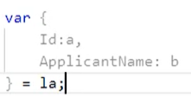

It can create a new var with name. Name is after : mark in this example there are a and b.

# Primitive Types

## Symbol

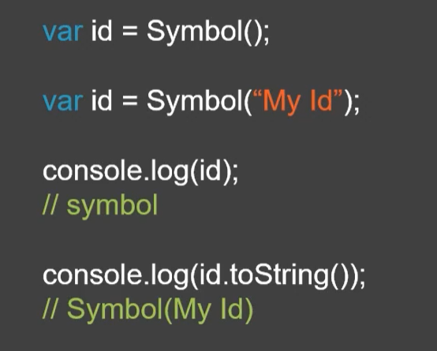

Rest types are the same like in rest programming languages.