Strategic Mind Wandering
Description of the experiments and of data processing

1. Shared material: the story
- A fairy-tale narrative about two siblings, Karolina and Janek, generated semi-automatically (GPT-4o following a four-act plot plan, then manually edited) and rendered to audio with text-to-speech (TTS).
- 40 fragments (20 per protagonist) alternating KAROLINA_n / JANEK_n, about 45 ± 5 s each, in a fixed order for all participants (trial n: KAROLINA_k → 2k−1, JANEK_k → 2k).
- The protagonists differ morally: one is altruistic and honourable (Janek), the other cunning and self-serving (Karolina).
- Fragments of the two protagonists do not differ in length, readability (Fog-Gunning), lexical diversity, word entropy or semantic dispersion (SBERT).
- Text source: story3.txt

2. On-screen procedure (both experiments)
- Welcome screen – the study examines "the effects of sustaining attention in an auditory task"; participation is voluntary, data anonymous and confidential.
- Instructions – a story of about 40 min (Exp1) / 50 min (Exp2); keep the gaze on the fixation cross; description of the probe and its scale ("the beginning of the scale means full attention to the story, the end means distraction from listening"; "do not be afraid to report distraction").
- Practice trials (3 fragments of different story to practice)
- Eye-tracker calibration.
- Main part – the protagonist to remember is shown (see §3 and §4), then the story starts.
- Each trial: (a) listening to the fragment with a fixation cross; (b) thought probe on a linear scale "No distraction" – "Full distraction", answered with a mouse click and a NEXT button; (c) oral thought report "Describe the course of your thoughts since the last interruption of the story", started with SPACE, with a timer (red near the limit), ENTER to finish plus a confirmation screen, then "Recording saved!".
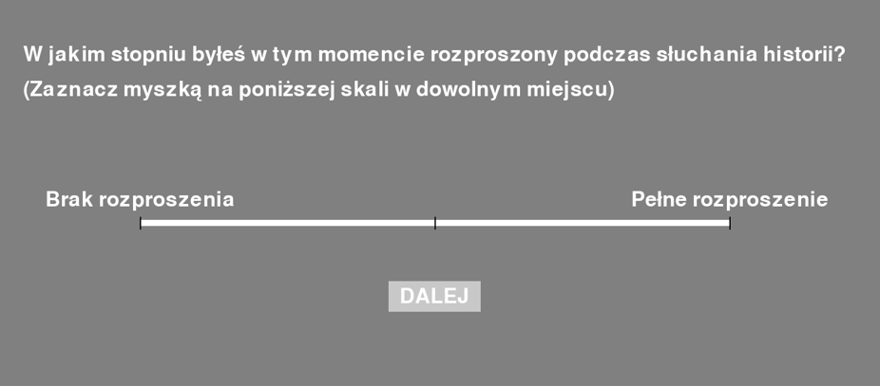
- Recalibration in the middle of the session (then the procedure continues automatically).
- Final recall – recorded after the experimenter sets up the equipment.
- End – thanks and a short questionnaire.

3. Exp1_Cued (SecondExp) – cued protagonist
Aim: whether mind wandering is strategically allocated to task-irrelevant fragments and whether thought content decouples from the narrative during it.
- Participants: 30 people (21 F, 9 M), aged 18–35, All 30 are in the merged tables
- Manipulation: the screen before the story says "Try to focus on and remember all fragments concerning the protagonist named: <NAME>"; the final recall concerns only that protagonist. Fragments are therefore TRACKED or UNTRACKED (column Tracking); the tracked protagonist is counterbalanced.
- Probe: "To what extent were you distracted at this moment while listening to the story?"; stored as 0–99 (MW).
- Thought report: limit 25 s (timer turns red at about 20 s); participants were told the recordings are anonymous and private thoughts need be mentioned only as far as they are comfortable.
- Thought-report processing: transcription (Whisper), syntax correction, review by judges; lemmatisation (Morfeusz) and sentence splitting; three judges coded attentional state (1 Focus, 2 Task-Related Thoughts, 3 Mind Wandering, 4 Mind Blanking; median; Fleiss' κ = 0.689).
- MIGO2607 has MW, tracking and eye data for all 40 trials but no thought reports (not in data_filtered.xlsx).

4. Exp2_Preference– interest instead of a cue
Aim: whether less interesting fragments are associated with more mind wandering,and what kinds of content mind wandering contains and how they relate to the narrative,
- Participants: 29 people (20 F, 9 M), aged 20–36, 25 of them gave at least one thought report (4 gave none).
- No attentional manipulation (according to the thesis): participants rate how interesting each fragment was; the instruction says the final recall concerns the whole story.
- Probe: "How much do you feel distracted from listening to the story at this moment?" – same scale and anchors as in Exp1.
- Interest scale: "completely uninteresting" – "completely interesting" (Preference).
- The position of the thought-report question relative to the scales varied (recall_first).

5. Eye tracking

5.1 Recording and extraction
- Equipment: EyeLink 1000, binocular, 500 Hz; viewing distance 93 cm; monitor 53 × 30 cm (1920 × 1080 px). Events (fixations, saccades, blinks) from the EyeLink online parser.
- Extraction (analysisFunctions.py): samples and events read from the .asc file (loadParticipant, getEvent); time re-referenced to the first sample of the recording (changeTiming); trials defined by the PART <name> … PART <name> END markers (parse_events, rename_parts, split_dataframes_by_events).
- Trial window: gaze samples with start ≤ TimePoint ≤ end; events only if they lie entirely inside the trial (Beg ≥ start and End ≤ end).
- Raw data = these samples without any further processing (missing pupil = 0, missing gaze = NaN, as in the .asc file).

5.2 Preprocessing – identical in both experiments
Both experiments were preprocessed with the same code and the same parameters
- Exp1_Cued: startegicMW_lite/Experiment/analysis/preprocessingPipeline.py → individuals/<ID>/<ID>_preprocessed.pickle, key Gaze.
- Exp2_Preference: Experiment_MW_Story/analysis/behavDataExtraction.py → Preprocessed/Preprocessed_Data_2/individual/<ID>/Preprocessed.pkl. Natalia's analysisFunctions.py allows a separate post-blink margin (blkboundry2); it was set equal to the pre-blink margin (75 ms), which makes the two code versions equivalent.

Parameter | Value | Meaning
downs / resRate | 1 / 100 Hz | downsampling 500 → 100 Hz
centering / dgvCent | 0 / (5°) | no rejection of gaze far from the fixation cross
binterp / blinkInt | 1 / 0 | blink interpolation, linear
maxblength | 500 ms | longest blink that is interpolated
blkboundry (= blkboundry2) | 75 ms | margin added before (and after) each blink
blinkbegbound | 1000 ms | no interpolation within 1 s of the trial edges
outrmv | 1 | outlier removal
nanrmv | 1 | zero pupil → NaN
smth / smoothwin | 1 / 10 samples | rolling mean (= 100 ms at 100 Hz)
maxcluslen | 2000 ms | shortest segment kept (and smoothed)
mingaplen | 50 ms | gap that splits continuous segments
verbose | 1 | required: downsampling only runs when verbose = 1 (see 5.3)

Steps actually performed by the code, per trial and per eye:
- Downsampling: keep samples whose TimePoint is divisible by 5 ms (i.e. every 10 ms); no anti-aliasing filter.
- Centering: off.
- Blinks: left- and right-eye blinks are merged, each widened by 75 ms on both sides; a merged interval is linearly interpolated if it lasts ≤ 650 ms (500 + 2 × 75) and lies more than 1 s from both trial edges; otherwise it is set to NaN.
- Outliers: 3σ rule on the differenced pupil signal, ±40 ms margin (hard-coded), cubic-spline interpolation; clusters > 500 ms → NaN.
- Zero pupil values → NaN (no margin).
- Smoothing: centred rolling mean over 10 samples (100 ms) inside continuous segments (split at gaps > 50 ms); segments shorter than 2 s → NaN.
The preprocessed signal covers the whole trial. The 5-s trial-onset cut and the 5–10 s baseline (begTrialOff = baseOffset = 5000) are part of the trial-level pupil measures in preprocessingPipeline.py and are not applied to the samples; no trial-level measures are included in the merged tables.

6. Merged dataset (mergeData.py)

6.1 files
One file per data type; both experiments stacked (column Experiment). Common key in every table: Experiment, Subject, TrialNum, Fragment, Hero.
File | Content | Rows Exp1 / Exp2
behavioral.csv | one row per Subject × trial (all 40 trials) | 1 200 / 1 160
gaze_raw.csv.gz | raw samples, 500 Hz: TimePoint, Left/Right X, Y, Pupil | 27 146 126 / 26 250 226
gaze_preproc.csv.gz | preprocessed samples, 100 Hz (same columns) | 5 429 219 / 5 250 017
saccades.csv.gz | Eye, Beg, End, Duration, StartX/Y, EndX/Y, Amplitude (°), Velocity (peak, °/s) | 155 276 / 135 340
blinks.csv.gz | Eye, Beg, End, Duration | 59 457 / 46 652
fixations.csv.gz | Eye, Beg, End, Length (= duration), X, Y, Disp (= mean pupil) | 153 471 / 133 698
Times are in ms from the first sample of the recording; event durations equal End − Beg + 2 ms (EyeLink counts the last sample). Raw and preprocessed gaze share timestamps (every 5th raw sample), so interpolated samples can be identified by comparing the two files (raw pupil = 0, preprocessed pupil present).

6.2 Columns of behavioral.csv
Column | Description | Exp
Experiment, Subject | experiment name; participant ID | both
TrialNum, Fragment, Hero | trial 1–40 (fixed story order); fragment name; protagonist | both
MW | raw probe response, 0–99 (higher = more distracted) | both
MW_Estimate | z-score of MW within participant (40 trials, ddof = 1); same formula in both experiments | both
Tracking | TRACKED / UNTRACKED | Exp1
Preference, Pref_relative | interest rating; its within-participant z-score (ddof = 0) | Exp2
Utterance, Sentences, Lemmas, Verbs, Nouns | thought report: full original text, sentences, lemmas, verb and noun phrases | both
StoryFrag, StorySentences, StoryLemmas | text of the story fragment, its sentences and lemmas (present in every row) | both
FragmentLength | duration of the fragment (ms) | Exp2
recall_first | order of the thought-report question relative to the scales (from the PRPREC marker) | Exp2
no_discernable_thoughts | report consists only of statements about attentional state (source: IS_Wholy_About_Attention) | both
has_attention_indicator | report contains an explicit attention statement (source: Has_explicit_attention) | both
bad_texts | flag of unusable reports | Exp1
has_thoughts | 1 if a thought report exists (Exp1: 1 125; Exp2: 795) | both

6.3 Data quality – left for the analysis stage
- Missing pupil data (left eye, preprocessed): highest for MAWA1105 (61%), MAPO1405 (44%), ZUWI1506 (28%) in Exp2 and KABE2308 (35%), JAJA2108 (33%) in Exp1. Trials with no pupil data at all: 5 (Exp1) and 36 (Exp2). No trial or participant exclusions are applied in the merged tables.
- Single-sample blinks (Beg = End, Duration = 2 ms): 48 (Exp1) and 115 (Exp2) – likely artefacts, easy to filter by Duration.
- Reading the files: the .csv.gz files are written participant by participant (multi-member gzip); some archivers (e.g. WinRAR) show a wrong unpacked size, pandas reads them correctly. For gaze_raw use dtype (category for text columns, float32 for measurements) or chunksize.

6.4 Reproducing the preprocessing
behavDataExtraction.py with Natalia's analysisFunctions.py contains all signal-processing steps (5.1–5.2) and can be used for both experiments. For Exp1 data: set dataPath to data_second, dataSaves = 0, a new analysisName, blkboundry2 = 75, verbose = 1, and add a fallback in parse_events for missing PRPREC markers (Exp1 .asc files contain none, which otherwise yields an empty trial table).

