Michał Gawor
228204
13.05.2018

Introduction to Artificial Intelligence

Lab 1
Genetic Algorithm

1. The task
This document covers required points mentioned in the task accessible via WUST W8 Board page:
https://eportal.ii.pwr.edu.pl/w08/BOARD/Introduction%20to%20Artificial%20Intelligence/Laboratory/1_EA-v2018.pdf

2. Build genetic algorithm
Individual is a polynomial in notation of vector [Theta3, Theta2, Theta1, Theta0], every element of the vector is a genome and a descending parameter for polynomial.
Fitness function is defined as percentage of properly separated points according to class it is belonging to.
Crossover operation is a roulette for choosing first parent with probability defined as FitnessValue / Sum(FitnessValue) and for pairing a second parent probability of reproduction is defined as FitnessValue * EuclideanDistanceFromFirstParent / Sum(EuclideanDistanceFromFirstParent) / Sum(FitnessValue * EuclideanDistanceFromFirstParent / Sum(EuclideanDistanceFromFirstParent))

3. Implementation of genetic algorithm
Source code for solution can be find at:
https://github.com/MichalGawor
Note that only latest version of algorithm is visible in the repository.

4. Provide visualization of solution
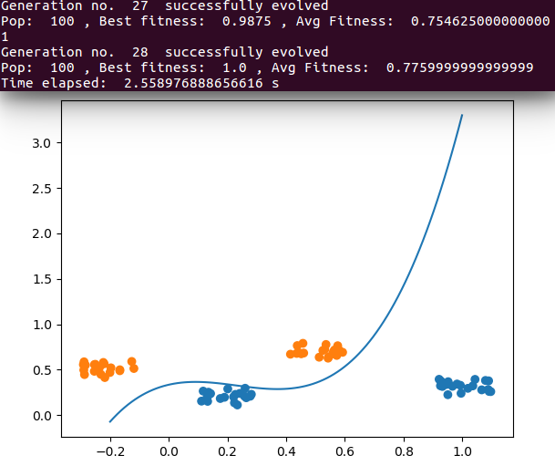
a) visualization of polynomial found in case of separable points

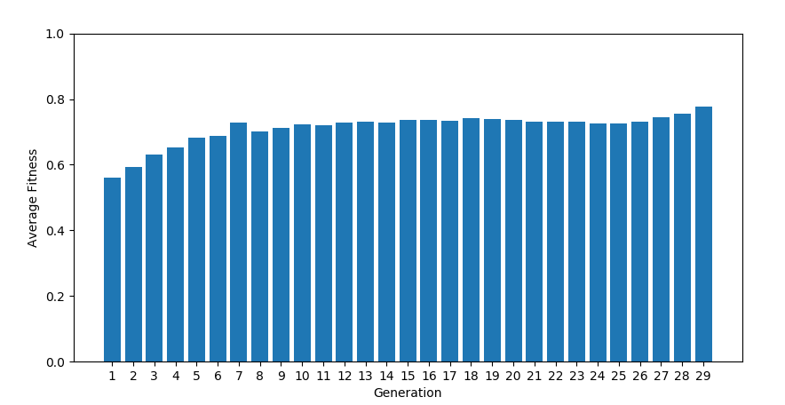
b) change of average fit over generations in case of separable points

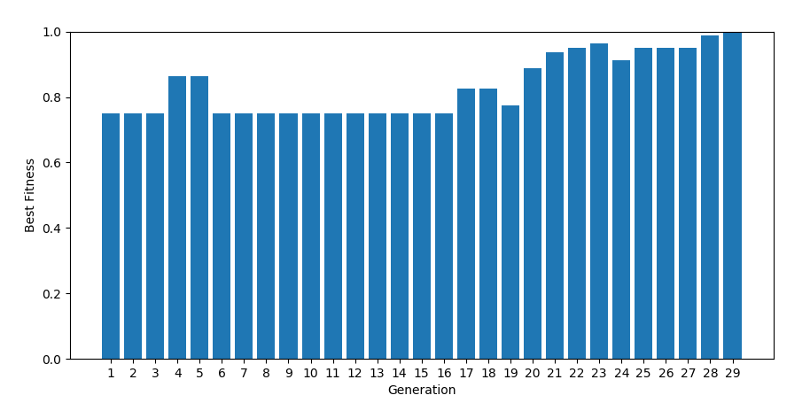
c) change of best fit over generations in case of separable points

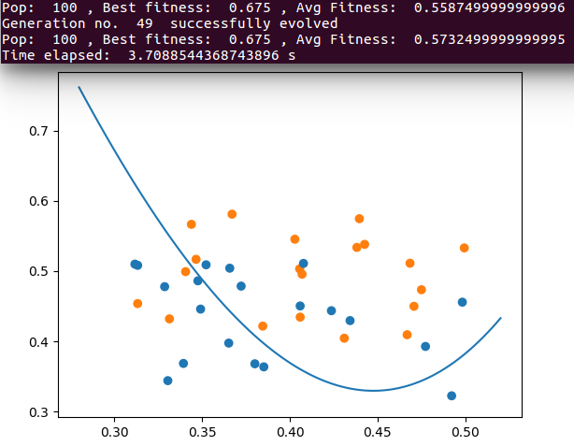
d) visualization of polynomial in cast of non-separable points

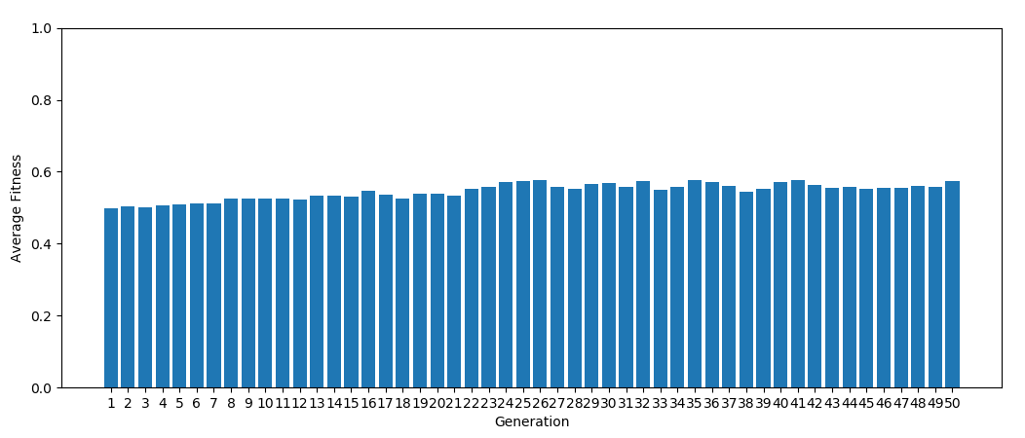
e) change of average fit over generations in case of non-separable points
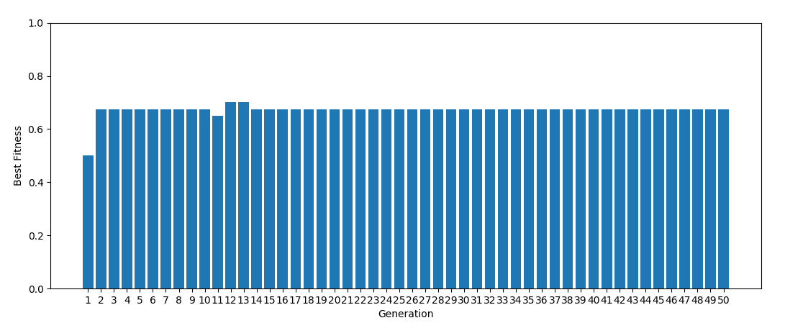
f) change of best fitness over generations in case of non-separable points

5. Test influence of parameters
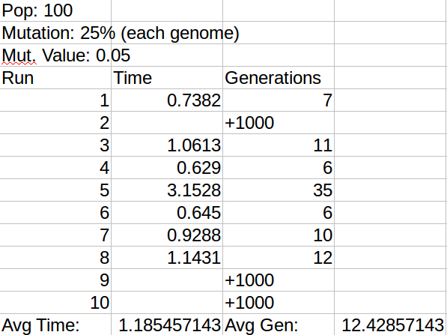
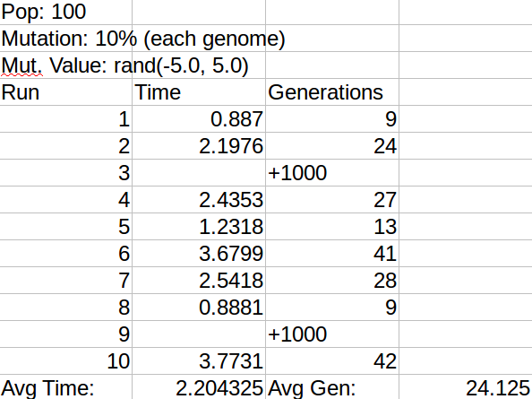

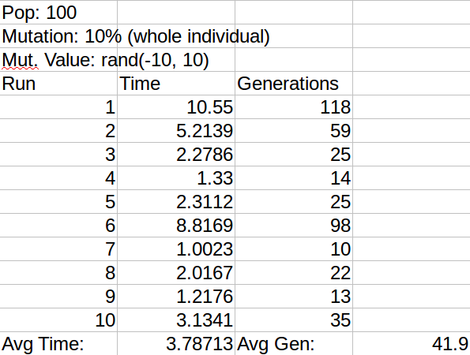
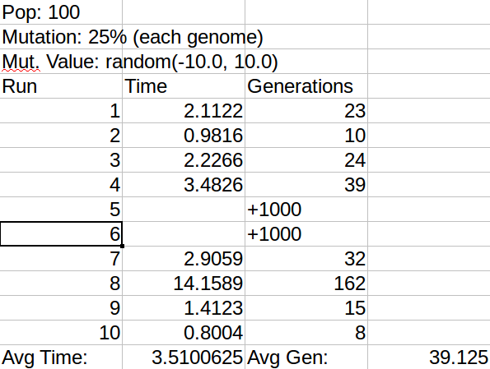

Important note
Runs with generations less than 5 have been discarded from records as ‘too random’
Last run still did not eliminate situation when algorithm got stuck in local optimum running for more than 1000 generations. In additional 20 runs it happened once so it greatly reduced the occurrence of such situations but did not solve the problem.

6. Comparison with other non-evolutionary methods
At first I have tried to use brute force with search step =0.5 (change of polynomial parameter) what required 40*40*40*40 = 2 560 000 comparisons. None of 10 runs found problem solving polynomial for separable points. Each took about 100 sec. Than I tried search step =0.1 but 200*200*200*200 = 1 800 000 000 comparisons needed to make and it was not possible to calculate it on my PC over 10 hours even using parallelism.

7. Used libraries
numpy – for matrix and numerical operations
http://www.numpy.org/
scipy – for calculation genetic “distance” between individuals
https://www.scipy.org/
matplotlib – for data visualization
https://matplotlib.org/
other libraries build-in Python3 package

I hereby confirm that whole implementation of presented algorithm and results showed above have been done by myself.

