PROI – project 3
creator: Michal Sulek 259686
teacher: Wiktor Kuśmirek

Description
Project simulates shop database. It stores data about employees, their salaries, names, about products, their prices and aditional information. Program also has a feature, that allows to measure company’s budget.

Project structure
Project contains of 5 classes:
- Product
- ProductTechnical
- ProductFood
- Employee
- Shop
Classes ProductTechnical and ProductFood inherit from class Product.
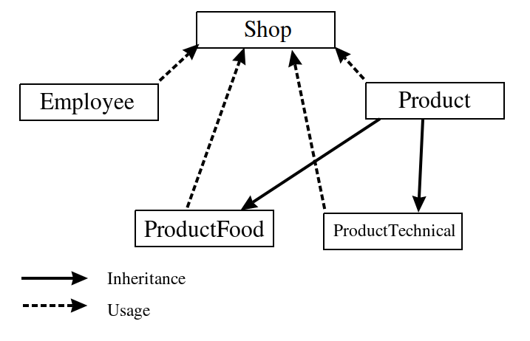

Class description

Product
Contains name (string) and price (int) – both protected.
Metods: default constructor, int change price (int), string getname(), int getPrice(), strin getInfo(), which is virtual and returns product info formated in a way that allows direct print while listing products.

ProductTechnical
Additionally contains informarion if product is inflammable (bool).
Metods: default constructor, string getInfo(), which is similar to that in Product but it adds information about inflammability.

ProductFood
Additionally contains information about expiryDate (unsigned).
Metods: default constructor, string getInfo(), which is similar to that in Product but it adds information about expiry date.

Emloyee
Stores information about name (string), age (int) and salary (int or unsigned).
Metods: default constructor, string getName(), int getAge(), int/unsigned getSalary(), int/unsigned setSalary(int/unsigned).

Shop
Stores information about shop’s name (string), adress (string), capital (short/int/long), products (vector of *Product), number of products (int), array of employees (int) alocated dynamically, number of employees (int).
Metods: default constructor, string printInfo(), int payEmployees(), Employee hireEmployee(const &Employee), int fireEmployee(string), void listEmployees(), void listEmployees(int), void listProducts(), Product buyProduct(const &Product), void sellProduct(string), void binProduct(string), destructor.
Class Shop cathes exceptions if memory is not allocated correctly or when an employee is younger than 18 years.

Tests
All metods of class Product was tested using Boost library.

